**DOCUMENTATION**

**«Store Sales Dataset Analysis»**

**By Teamwork:**

1. **Mohammed Ahmed Abo Elyazzed**
2. **Dina Anwar Ragaee**
3. **Nour Eldin Amgad Ezzat**
4. **Mona Abd Elsabour Ahmed**

Track: Data Analysis

**Under The supervision of :**

**Instructor: Eng/ Ahmed Samir**

2025/**20262025/2026**

**Table of contents**

|  |  |  |  |
| --- | --- | --- | --- |
| **s** | **Description** | | **Pages** |
| **1** | **INTRODUCTION** | | **3** |
| **2** | **Chapter 1 : Data Preparation& Transformation** | **Data Exploratory** | **5** |
| **Data Cleaning Data Collection & Importing** | **15** |
| **Data Preparation** | **22** |
| **Data Normalization** | **47** |
| **Descriptive Data &Insights Extraction** | **58** |
| **Trend Analysis** | **59** |
| **Statistical Analysis** | **68** |
| **Outlier Analysis** | **69** |
| **Geographic Insights** | **71** |
| **Data Modeling** | **76** |
| **3** | **Chapter 2 : Data Analysis**  **(Diagnosis)** | **Diagnostic Data** | **85** |
| **Using SQL Tool (Structured query language) -Jupyter Libraries for Analysis** | **86** |
| **Using Tableau Story for visualization** | **140** |
| **4** | **Chapter 3: Forecasting** | **Predictive Data& Forecasting** | **146** |
| **Feature Engineering** | **152** |
| **Forecasting Dashboard** | **154** |
| **5** | **Chapter 4: Data Recommendations** | **Prescriptive Data** | **155** |
| **Recommendations** | **156** |

**Introduction**

**Data analysis is the process of systematically inspecting, cleaning, transforming, and modeling data to uncover useful information, draw conclusions, and support decision-making. It involves several key steps:**

1. **Data Collection**: Gathering raw data from various sources for Store Sales.
2. **Exploratory Data Analysis (EDA):** Analyzing the data to summarize its main characteristics, often using statistical graphics and other visualization techniques.
3. **Data Cleaning:** Identifying and correcting errors, inconsistencies, Anomalies, Duplication and Redundancy or missing values in the data.
4. **Data Transformation:** Manipulating the data of Sales into a suitable format or structure for analysis.
5. **Data Modeling:** Applying statistical, machine learning, or other mathematical techniques to the data to make predictions or classify patterns.
6. **Interpretation:** Drawing conclusions & Projections from the results of the analysis to inform decisions or solve problems.
7. **Recommendation:** Delivering personalized suggestions that align with individual tastes or needs, improving engagement and satisfaction.

**Data Diagnosis ( analysis** )can be performed using various tools and techniques depending on the complexity of the data and the specific goals of the analysis   
like**( SQL Server- Python /Jupyter notebook libraries – Tableau& Power Bi Visualization Tools ).** The insights gained can help businesses and organizations optimize operations, improve strategies, and enhance performance

**Data Prediction (Forecasting)** is predicting future values or trends based on historical data and patterns. It helps in making informed decisions by projecting outcomes, such as sales, demand, or market trends, to guide strategies and planning.

**Data Prescription(Recommendation)**refers to the process of providing actionable recommendations based on data insights. It goes beyond identifying patterns or trends

**Chapter 1: Data Transformation**

**Data Exploratory**

**Exploratory Data Analysis (EDA)** is the initial step in data analysis where datasets are visually and statistically examined to summarize their main characteristics. The goal is to uncover patterns, detect anomalies, identify relationships, and test assumptions.

3.1. Summary Statistics

|  |  |  |  |
| --- | --- | --- | --- |
| *# Sales distribution by category*  print(df.groupby('category')['sales'].describe())   |  |  | | --- | --- | | 50% \  category | count mean std min 25% |   Furniture 2077.0 350.822617 501.626947 1.892 47.12182.550 Office Supplies 5909.0 119.381001 383.761427 0.444 11.7627.360 Technology 1813.0 456.401474 1116.818701 0.990 67.98167.944  75% max category Furniture 435.999 4416.174Office Supplies 79.470 9892.740Technology 453.576 22638.480  C:\Users\Aboelyazzed\AppData\Local\Temp\ipykernel_7360\656462362.py:2:FutureWarning: The default of observed=False is deprecated and will bechanged to True in a future version of pandas. Pass observed=False to retain current behavior or observed=True to adopt the future defaultand silence this warning.   |  | | --- | | print(df.groupby('category')['sales'].describe()) | |

3.2. Visualize Outliers

*# Boxplot (fixed syntax for Seaborn v0.14.0+)*   
plt.figure(figsize=(12, 6))   
sns.boxplot(x='category', y='sales', data=df, palette="Set2", hue='category', legend=False)   
plt.title("Sales Distribution by Category")

plt.xticks(rotation=45)   
plt.show()

*# Violin plot (fixed syntax for Seaborn v0.14.0+)*   
plt.figure(figsize=(12, 6))   
sns.violinplot(x='category', y='sales', data=df, palette="Set2", hue='category', legend=False)   
plt.title("Sales Distribution by Category (Violin Plot)")   
plt.xticks(rotation=45)   
plt.show()

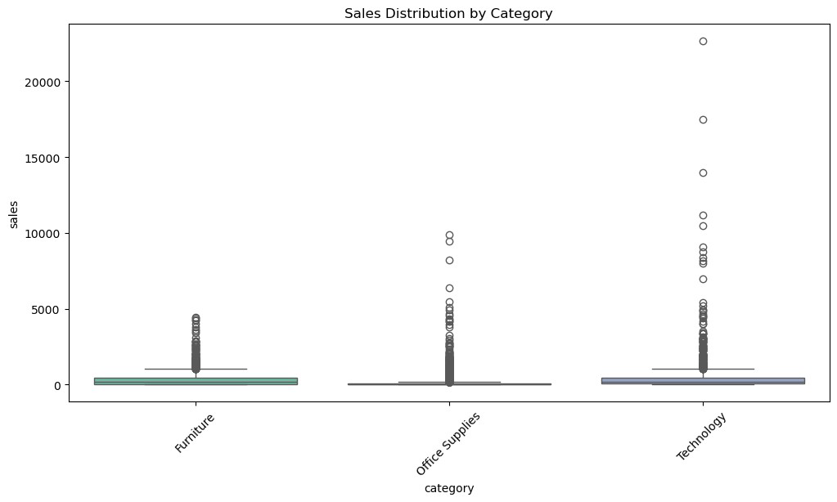

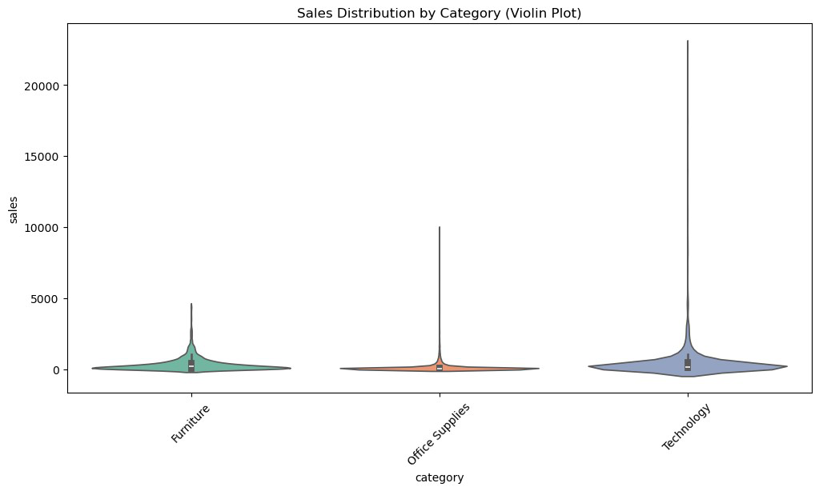

3.3. Deeper Insights

*# Summary statistics for sales*   
print(df['sales'].describe())

*# Total and average sales*   
total_sales = df['sales'].sum()   
average_sales = df['sales'].mean()   
print(f"Total Sales: ${total_sales:,.2f}") print(f"Average Sales: ${average_sales:,.2f}")

count 9799.000000   
mean 230.792610   
std 626.692409   
min 0.444000   
25% 17.248000   
50% 54.480000   
75% 210.572000   
max 22638.480000   
Name: sales, dtype: float64   
Total Sales: $2,261,536.78   
Average Sales: $230.79

*# Sales by region (replace 'region' with 'state' if available)* regional_sales = df.groupby('region')   
['sales'].sum().sort_values(ascending=False)   
print(regional_sales)

|  |  |
| --- | --- |
| region  west 710219.6845  east 669518.7260  central 492646.9132  south 389151.4590  Name: sales, dtype: float64  *# Sales by product category*  category_sales = df.groupby('category')  ['sales'].sum().sort_values(ascending=False) print(category_sales)  category  Technology 827455.8730  Furniture 728658.5757  Office Supplies 705422.3340  Name: sales, dtype: float64  C:\Users\Aboelyazzed\AppData\Local\Temp\  ipykernel_7360\3352670558.py:2: FutureWarning: The default of observed=False is deprecated and will be changed to True in a futureversion of pandas. Pass observed=False to retain current behavior orobserved=True to adopt the future default and silence this warning.   |  | | --- | | category_sales = df.groupby('category') |   ['sales'].sum().sort_values(ascending=False) |

3.4. visualizations

import plotly.express as px   
*# Mapping of standardized state names to abbreviations*   
state_abbreviations = {   
 'alabama': 'AL', 'alaska': 'AK', 'arizona': 'AZ', 'arkansas': 'AR',   
 'california': 'CA', 'colorado': 'CO', 'connecticut': 'CT', 'delaware': 'DE',   
 'florida': 'FL', 'georgia': 'GA', 'hawaii': 'HI', 'idaho': 'ID', 'illinois': 'IL',   
 'indiana': 'IN', 'iowa': 'IA', 'kansas': 'KS', 'kentucky': 'KY', 'louisiana': 'LA',   
 'maine': 'ME', 'maryland': 'MD', 'massachusetts': 'MA',   
'michigan': 'MI',   
 'minnesota': 'MN', 'mississippi': 'MS', 'missouri': 'MO',   
'montana': 'MT',   
 'nebraska': 'NE', 'nevada': 'NV', 'new_hampshire': 'NH',   
'new_jersey': 'NJ',   
 'new_mexico': 'NM', 'new_york': 'NY', 'north_carolina': 'NC', 'north_dakota': 'ND',   
 'ohio': 'OH', 'oklahoma': 'OK', 'oregon': 'OR', 'pennsylvania': 'PA', 'rhode_island': 'RI',   
 'south_carolina': 'SC', 'south_dakota': 'SD', 'tennessee': 'TN',

'texas': 'TX',   
 'utah': 'UT', 'vermont': 'VT', 'virginia': 'VA', 'washington': 'WA', 'west_virginia': 'WV',   
 'wisconsin': 'WI', 'wyoming': 'WY', 'district_of_columbia': 'DC' }

*# Convert full state names to abbreviations*   
df['state'] = df['state'].map(state_abbreviations)

*# Ensure all states are present*   
all_states = pd.DataFrame({'state': ['AL', 'AK', 'AZ', 'AR', 'CA', 'CO', 'CT', 'DE', 'FL', 'GA', 'HI', 'ID', 'IL', 'IN', 'IA', 'KS', 'KY', 'LA', 'ME', 'MD', 'MA', 'MI', 'MN', 'MS', 'MO', 'MT', 'NE', 'NV', 'NH', 'NJ', 'NM', 'NY', 'NC', 'ND', 'OH', 'OK', 'OR', 'PA', 'RI', 'SC', 'SD', 'TN', 'TX', 'UT', 'VT', 'VA', 'WA', 'WV', 'WI', 'WY']})

*# Aggregate sales by state*   
state_sales = df.groupby('state')['sales'].sum().reset_index()

*# Merge to include all states, filling missing values with 0* state_sales = all_states.merge(state_sales, on='state', how='left').fillna(0)

*# Create the choropleth map*   
fig = px.choropleth(  
 state_sales,  
 locations='state',  
 locationmode='USA-states',  
 color='sales',  
 scope="usa",  
 title='Sales Distribution by State (USA)',  
 color_continuous_scale="Viridis"   
)   
fig.update_geos(showland=True, landcolor="lightgray", showlakes=True, lakecolor="blue")   
fig.show()

{"config":{"plotlyServerURL":"https://plot.ly"},"data":   
[{"coloraxis":"coloraxis","geo":"geo","hovertemplate":"state=%   
{location}<br>sales=%{z}<extra></extra>","locationmode":"USA-  
states","locations":   
["AL","AK","AZ","AR","CA","CO","CT","DE","FL","GA","HI","ID","IL","IN" ,"IA","KS","KY","LA","ME","MD","MA","MI","MN","MS","MO","MT","NE","NV" ,"NH","NJ","NM","NY","NC","ND","OH","OK","OR","PA","RI","SC","SD","TN" ,"TX","UT","VT","VA","WA","WV","WI","WY"],"name":"","type":"choropleth ","z":   
[19510.64,0,35272.657,11678.13,446306.4635,31841.597999999998,13384.35 7,27322.999,88436.532,48219.11,0,4382.486,79236.517,48718.4,4443.56,29 14.31,36458.39,9131.05,1270.53,23705.523,28634.434,76136.074,29863.15,

10771.34,22205.15,5589.352,7464.93,16729.102,7292.524,34610.972,4783.5 22,306361.147,55165.964,919.91,75130.35,19683.39,17284.462,116276.65,2 2525.026,8481.71,1315.56,30661.873,168572.5322,11220.056,8929.36999999 9999,70636.72,135206.85,1209.824,31173.43,1603.136]}],"layout":   
{"autosize":true,"coloraxis":{"colorbar":{"title":   
{"text":"sales"}},"colorscale":[[0,"#440154"],   
[0.1111111111111111,"#482878"],[0.2222222222222222,"#3e4989"],   
[0.3333333333333333,"#31688e"],[0.4444444444444444,"#26828e"],   
[0.5555555555555556,"#1f9e89"],[0.6666666666666666,"#35b779"],   
[0.7777777777777778,"#6ece58"],[0.8888888888888888,"#b5de2b"],   
[1,"#fde725"]]},"geo":{"center":{},"domain":{"x":[0,1],"y":   
[0,1]},"lakecolor":"blue","landcolor":"lightgray","scope":"usa","showl akes":true,"showland":true},"legend":{"tracegroupgap":0},"template": {"data":{"bar":[{"error_x":{"color":"#2a3f5f"},"error_y":   
{"color":"#2a3f5f"},"marker":{"line":   
{"color":"#E5ECF6","width":0.5},"pattern":   
{"fillmode":"overlay","size":10,"solidity":0.2}},"type":"bar"}],"barpo lar":[{"marker":{"line":{"color":"#E5ECF6","width":0.5},"pattern": {"fillmode":"overlay","size":10,"solidity":0.2}},"type":"barpolar"}]," carpet":[{"aaxis":   
{"endlinecolor":"#2a3f5f","gridcolor":"white","linecolor":"white","min orgridcolor":"white","startlinecolor":"#2a3f5f"},"baxis":   
{"endlinecolor":"#2a3f5f","gridcolor":"white","linecolor":"white","min orgridcolor":"white","startlinecolor":"#2a3f5f"},"type":"carpet"}],"ch oropleth":[{"colorbar":   
{"outlinewidth":0,"ticks":""},"type":"choropleth"}],"contour":   
[{"colorbar":{"outlinewidth":0,"ticks":""},"colorscale":   
[[0,"#0d0887"],[0.1111111111111111,"#46039f"],   
[0.2222222222222222,"#7201a8"],[0.3333333333333333,"#9c179e"],   
[0.4444444444444444,"#bd3786"],[0.5555555555555556,"#d8576b"],   
[0.6666666666666666,"#ed7953"],[0.7777777777777778,"#fb9f3a"],   
[0.8888888888888888,"#fdca26"],   
[1,"#f0f921"]],"type":"contour"}],"contourcarpet":[{"colorbar": {"outlinewidth":0,"ticks":""},"type":"contourcarpet"}],"heatmap": [{"colorbar":{"outlinewidth":0,"ticks":""},"colorscale":   
[[0,"#0d0887"],[0.1111111111111111,"#46039f"],   
[0.2222222222222222,"#7201a8"],[0.3333333333333333,"#9c179e"],   
[0.4444444444444444,"#bd3786"],[0.5555555555555556,"#d8576b"],   
[0.6666666666666666,"#ed7953"],[0.7777777777777778,"#fb9f3a"],   
[0.8888888888888888,"#fdca26"],   
[1,"#f0f921"]],"type":"heatmap"}],"heatmapgl":[{"colorbar":   
{"outlinewidth":0,"ticks":""},"colorscale":[[0,"#0d0887"],   
[0.1111111111111111,"#46039f"],[0.2222222222222222,"#7201a8"],   
[0.3333333333333333,"#9c179e"],[0.4444444444444444,"#bd3786"],   
[0.5555555555555556,"#d8576b"],[0.6666666666666666,"#ed7953"],   
[0.7777777777777778,"#fb9f3a"],[0.8888888888888888,"#fdca26"],   
[1,"#f0f921"]],"type":"heatmapgl"}],"histogram":[{"marker":{"pattern": {"fillmode":"overlay","size":10,"solidity":0.2}},"type":"histogram"}], "histogram2d":[{"colorbar":{"outlinewidth":0,"ticks":""},"colorscale":

[[0,"#0d0887"],[0.1111111111111111,"#46039f"],   
[0.2222222222222222,"#7201a8"],[0.3333333333333333,"#9c179e"],   
[0.4444444444444444,"#bd3786"],[0.5555555555555556,"#d8576b"],   
[0.6666666666666666,"#ed7953"],[0.7777777777777778,"#fb9f3a"],   
[0.8888888888888888,"#fdca26"],   
[1,"#f0f921"]],"type":"histogram2d"}],"histogram2dcontour":   
[{"colorbar":{"outlinewidth":0,"ticks":""},"colorscale":   
[[0,"#0d0887"],[0.1111111111111111,"#46039f"],   
[0.2222222222222222,"#7201a8"],[0.3333333333333333,"#9c179e"],   
[0.4444444444444444,"#bd3786"],[0.5555555555555556,"#d8576b"],   
[0.6666666666666666,"#ed7953"],[0.7777777777777778,"#fb9f3a"],   
[0.8888888888888888,"#fdca26"],   
[1,"#f0f921"]],"type":"histogram2dcontour"}],"mesh3d":[{"colorbar": {"outlinewidth":0,"ticks":""},"type":"mesh3d"}],"parcoords":[{"line": {"colorbar":{"outlinewidth":0,"ticks":""}},"type":"parcoords"}],"pie": [{"automargin":true,"type":"pie"}],"scatter":[{"fillpattern":   
{"fillmode":"overlay","size":10,"solidity":0.2},"type":"scatter"}],"sc atter3d":[{"line":{"colorbar":{"outlinewidth":0,"ticks":""}},"marker": {"colorbar":   
{"outlinewidth":0,"ticks":""}},"type":"scatter3d"}],"scattercarpet": [{"marker":{"colorbar":   
{"outlinewidth":0,"ticks":""}},"type":"scattercarpet"}],"scattergeo": [{"marker":{"colorbar":   
{"outlinewidth":0,"ticks":""}},"type":"scattergeo"}],"scattergl": [{"marker":{"colorbar":   
{"outlinewidth":0,"ticks":""}},"type":"scattergl"}],"scattermapbox": [{"marker":{"colorbar":   
{"outlinewidth":0,"ticks":""}},"type":"scattermapbox"}],"scatterpolar" :[{"marker":{"colorbar":   
{"outlinewidth":0,"ticks":""}},"type":"scatterpolar"}],"scatterpolargl ":[{"marker":{"colorbar":   
{"outlinewidth":0,"ticks":""}},"type":"scatterpolargl"}],"scatterterna ry":[{"marker":{"colorbar":   
{"outlinewidth":0,"ticks":""}},"type":"scatterternary"}],"surface": [{"colorbar":{"outlinewidth":0,"ticks":""},"colorscale":   
[[0,"#0d0887"],[0.1111111111111111,"#46039f"],   
[0.2222222222222222,"#7201a8"],[0.3333333333333333,"#9c179e"],   
[0.4444444444444444,"#bd3786"],[0.5555555555555556,"#d8576b"],   
[0.6666666666666666,"#ed7953"],[0.7777777777777778,"#fb9f3a"],   
[0.8888888888888888,"#fdca26"],   
[1,"#f0f921"]],"type":"surface"}],"table":[{"cells":{"fill":   
{"color":"#EBF0F8"},"line":{"color":"white"}},"header":{"fill":   
{"color":"#C8D4E3"},"line":   
{"color":"white"}},"type":"table"}]},"layout":{"annotationdefaults": {"arrowcolor":"#2a3f5f","arrowhead":0,"arrowwidth":1},"autotypenumbers ":"strict","coloraxis":{"colorbar":   
{"outlinewidth":0,"ticks":""}},"colorscale":{"diverging":   
[[0,"#8e0152"],[0.1,"#c51b7d"],[0.2,"#de77ae"],[0.3,"#f1b6da"], [0.4,"#fde0ef"],[0.5,"#f7f7f7"],[0.6,"#e6f5d0"],[0.7,"#b8e186"],

[0.8,"#7fbc41"],[0.9,"#4d9221"],[1,"#276419"]],"sequential":   
[[0,"#0d0887"],[0.1111111111111111,"#46039f"],   
[0.2222222222222222,"#7201a8"],[0.3333333333333333,"#9c179e"],   
[0.4444444444444444,"#bd3786"],[0.5555555555555556,"#d8576b"],   
[0.6666666666666666,"#ed7953"],[0.7777777777777778,"#fb9f3a"],   
[0.8888888888888888,"#fdca26"],[1,"#f0f921"]],"sequentialminus": [[0,"#0d0887"],[0.1111111111111111,"#46039f"],   
[0.2222222222222222,"#7201a8"],[0.3333333333333333,"#9c179e"],   
[0.4444444444444444,"#bd3786"],[0.5555555555555556,"#d8576b"],   
[0.6666666666666666,"#ed7953"],[0.7777777777777778,"#fb9f3a"],   
[0.8888888888888888,"#fdca26"],[1,"#f0f921"]]},"colorway":   
["#636efa","#EF553B","#00cc96","#ab63fa","#FFA15A","#19d3f3","#FF6692" ,"#B6E880","#FF97FF","#FECB52"],"font":{"color":"#2a3f5f"},"geo": {"bgcolor":"white","lakecolor":"white","landcolor":"#E5ECF6","showlake s":true,"showland":true,"subunitcolor":"white"},"hoverlabel":   
{"align":"left"},"hovermode":"closest","mapbox":   
{"style":"light"},"paper_bgcolor":"white","plot_bgcolor":"#E5ECF6","po lar":{"angularaxis":   
{"gridcolor":"white","linecolor":"white","ticks":""},"bgcolor":"#E5ECF 6","radialaxis":   
{"gridcolor":"white","linecolor":"white","ticks":""}},"scene":   
{"xaxis":   
{"backgroundcolor":"#E5ECF6","gridcolor":"white","gridwidth":2,"lineco lor":"white","showbackground":true,"ticks":"","zerolinecolor":"white"} ,"yaxis":   
{"backgroundcolor":"#E5ECF6","gridcolor":"white","gridwidth":2,"lineco lor":"white","showbackground":true,"ticks":"","zerolinecolor":"white"} ,"zaxis":   
{"backgroundcolor":"#E5ECF6","gridcolor":"white","gridwidth":2,"lineco lor":"white","showbackground":true,"ticks":"","zerolinecolor":"white"} },"shapedefaults":{"line":{"color":"#2a3f5f"}},"ternary":{"aaxis": {"gridcolor":"white","linecolor":"white","ticks":""},"baxis":   
{"gridcolor":"white","linecolor":"white","ticks":""},"bgcolor":"#E5ECF 6","caxis":   
{"gridcolor":"white","linecolor":"white","ticks":""}},"title":   
{"x":5.0e-2},"xaxis":   
{"automargin":true,"gridcolor":"white","linecolor":"white","ticks":"", "title":   
{"standoff":15},"zerolinecolor":"white","zerolinewidth":2},"yaxis": {"automargin":true,"gridcolor":"white","linecolor":"white","ticks":"", "title":   
{"standoff":15},"zerolinecolor":"white","zerolinewidth":2}}},"title": {"text":"Sales Distribution by State (USA)"}}}

df['shipping_time_days'] = (df['ship_date'] -   
df['order_date']).dt.days   
*# Scatter plot*   
plt.figure(figsize=(10, 6))   
sns.scatterplot(x='shipping_time_days', y='sales', data=df, alpha=0.5) plt.title("Sales vs. Shipping Time (Days)")

plt.xlabel("Shipping Time (Days)")   
plt.ylabel("Sales")   
plt.show()

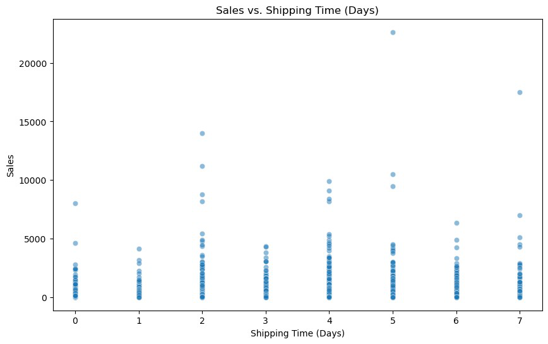

*# Scatter plot for shipping_time_days vs sales*   
plt.figure(figsize=(10, 6))   
sns.scatterplot(x='shipping_time_days', y='sales', data=df, hue='category')   
plt.title("Shipping Time vs Sales")   
plt.xlabel("Shipping Time (Days)")   
plt.ylabel("Sales")   
plt.show()

*# Box plot for shipping_time_days vs sales by region*   
plt.figure(figsize=(12, 6))   
sns.boxplot(x='region', y='sales', hue='shipping_time_days', data=df) plt.title("Sales Distribution by Region and Shipping Time")   
plt.xticks(rotation=45)   
plt.show()

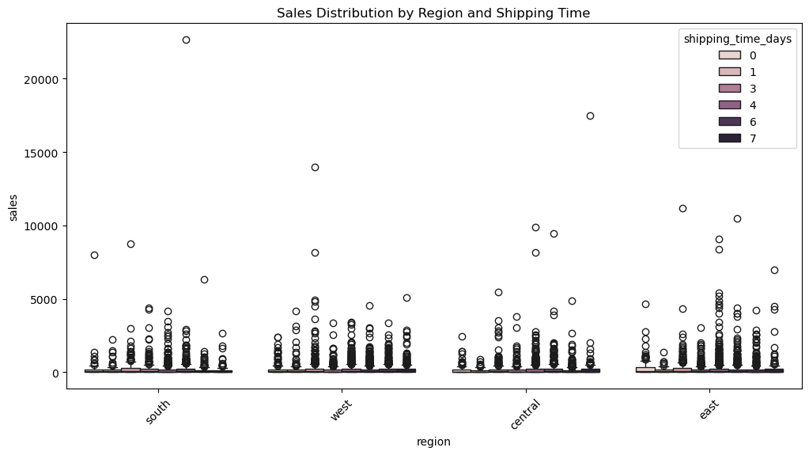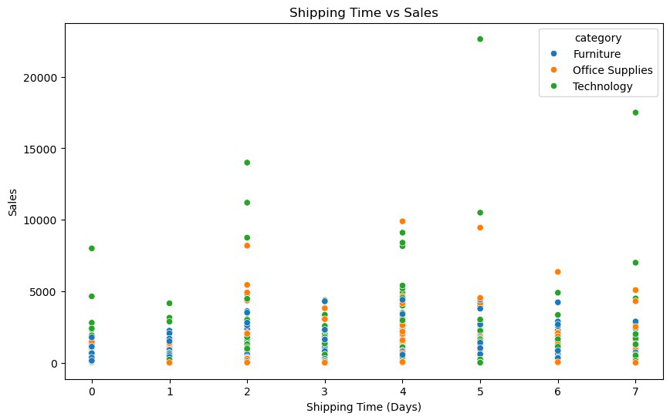

**Data Cleaning:**

Data cleaning in data analysis is the process of identifying and correcting errors or inconsistencies in a dataset to ensure its quality and accuracy. It involves tasks such as handling missing values, removing duplicates, correcting data entry errors, standardizing formats, and dealing with outliers. The goal of data cleaning is to improve the reliability of the data, ensuring that it is suitable for analysis and producing valid, meaningful insights.

1.1. Import Necessary Libraries

|  |
| --- |
| import pandas as pd *# Importing pandas for data manipulation*  import matplotlib.pyplot as plt *# Importing Matplotlib for*  *visualization*  import seaborn as sns *# Importing Seaborn for advanced visualizations* |

1.3. Inspect the Dataset

df.drop('Row ID', axis=1, inplace=True)

*# Get a summary of dataset columns, data types, and non-null values* df.info()

<class 'pandas.core.frame.DataFrame'>   
RangeIndex: 9800 entries, 0 to 9799   
Data columns (total 17 columns):  
 # Column Non-Null Count Dtype--- ------ -------------- ----- 0 Order ID 9800 non-null object 1 Order Date 9800 non-null object 2 Ship Date 9800 non-null object 3 Ship Mode 9800 non-null object 4 Customer ID 9800 non-null object 5 Customer Name 9800 non-null object 6 Segment 9800 non-null object 7 Country 9800 non-null object 8 City 9800 non-null object 9 State 9800 non-null object 10 Postal Code 9789 non-null float64 11 Region 9800 non-null object 12 Product ID 9800 non-null object 13 Category 9800 non-null object 14 Sub-Category 9800 non-null object 15 Product Name 9800 non-null object 16 Sales 9800 non-null float64 dtypes: float64(2), object(15)   
memory usage: 1.3+ MB

1.2. Load the Dataset

|  |  |
| --- | --- |
| *# Load CSV file*  df = pd.read_csv("Superstore Sales Dataset.csv")  *# Display first 5 rows*  print(df.head())  Row ID Order ID Order Date Ship Date Ship Mode Customer ID \  0 1 CA-2017-152156 08/11/2017 11/11/2017 Second ClassCG-12520 1 2 CA-2017-152156 08/11/2017 11/11/2017 Second ClassCG-12520 2 3 CA-2017-138688 12/06/2017 16/06/2017 Second ClassDV-13045 3 4 US-2016-108966 11/10/2016 18/10/2016 Standard ClassSO-20335 4 5 US-2016-108966 11/10/2016 18/10/2016 Standard ClassSO-20335  Customer Name Segment Country CityState \  0 Claire Gute Consumer United States HendersonKentucky 1 Claire Gute Consumer United States HendersonKentucky 2 Darrin Van Huff Corporate United States Los AngelesCalifornia 3 Sean O'Donnell Consumer United States Fort LauderdaleFlorida  4 Sean O'Donnell Consumer United States Fort LauderdaleFlorida   |  | | --- | | Postal Code Region Product ID Category Sub- |   Category \  0 42420.0 South FUR-BO-10001798 Furniture Bookcases |

1 42420.0 South FUR-CH-10000454 Furniture Chairs

2 90036.0 West OFF-LA-10000240 Office Supplies Labels

3 33311.0 South FUR-TA-10000577 Furniture Tables

4 33311.0 South OFF-ST-10000760 Office Supplies Storage

Product Name Sales 0 Bush Somerset Collection Bookcase 261.9600 1 Hon Deluxe Fabric Upholstered Stacking Chairs,... 731.9400 2 Self-Adhesive Address Labels for Typewriters b... 14.6200 3 Bretford CR4500 Series Slim Rectangular Table 957.5775 4 Eldon Fold 'N Roll Cart System 22.3680

*# Get statistical summary of numerical columns* df.describe()

Postal Code Sales count 9789.000000 9800.000000 mean 55273.322403 230.769059 std 32041.223413 626.651875 min 1040.000000 0.444000 25% 23223.000000 17.248000 50% 58103.000000 54.490000 75% 90008.000000 210.605000 max 99301.000000 22638.480000

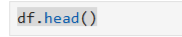

**Output:**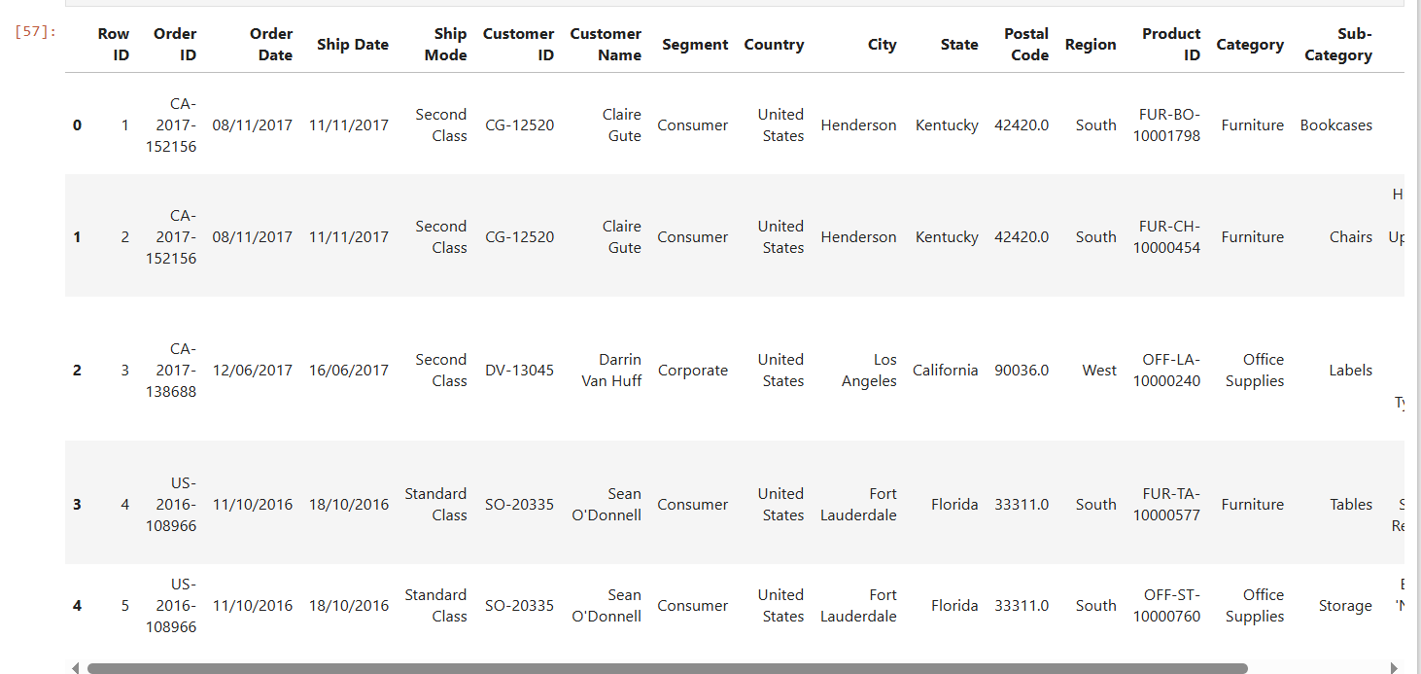

**Explanation:**

* **Importing Pandas Library:** Pandas is a powerful data manipulation tool that helps in loading and analyzing datasets.
* **Reading the CSV File:** The dataset is stored as a CSV file, which is loaded into a DataFrame using pd.read_csv().
* **Displaying First Few Rows:** The head() function is used to preview the first five rows, helping us understand the dataset structure.

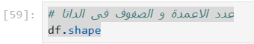**Code:** **Checking the Dimensions of the Dataset**

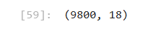**Output:**

**Explanation:**

* **Checking Dataset Dimensions:** The shape function returns the number of rows and columns, helping us understand the dataset size.
* Useful before **applying transformations** like **removing duplicates or splitting tables**.

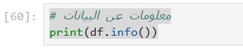**Code:** **Checking Dataset Information**

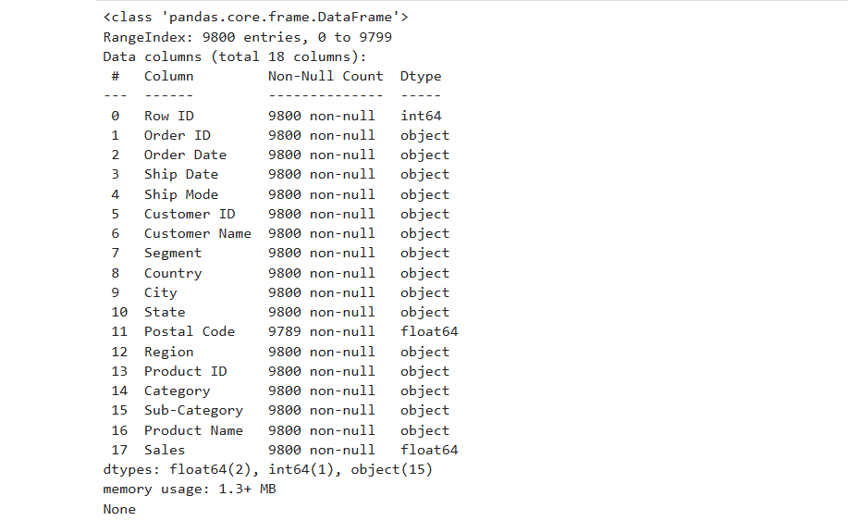**Output**:

**Explanation:**

* **Retrieving Dataset Information:** The info() function provides details such as column names, data types, and the number of non-null values.
* Helps identify missing data and data type mismatches.

**Code:** **General Statistics of the Dataset**

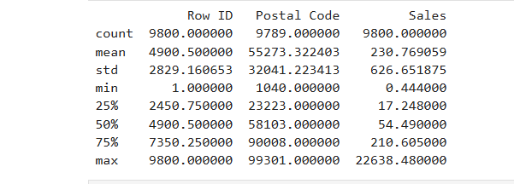**Output**:

**Explanation:**

* **Generating Statistical Summary:** The describe() function provides key statistics (mean, median, standard deviation, etc.) for numerical columns, helping in data distribution analysis.
* **Min Sales:** $0.44
* **Max Sales:** $22,638.48

**Code:**

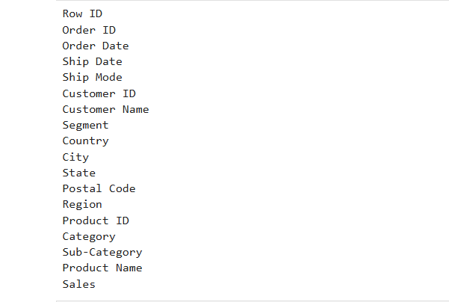**Output:**

**Explanation:**

* This loop iterates over all columns in the df DataFrame and prints their names.
* This helps in understanding the current structure of the dataset before making modifications.

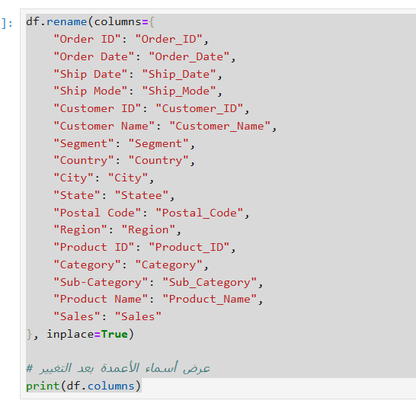**Code:** **Rename Columns for Consistency**

**Explanation:**

* Rename Columns for Consistency
* This renames multiple columns in the dataset to make them more structured and SQL-friendly.
* Changes applied:
* Spaces replaced with underscores (_) → Makes them easier to reference in Python & SQL.
* State changed to Statee → To avoid conflicts with SQL reserved words.
* inplace=True ensures that changes are applied directly to df without needing reassignment.

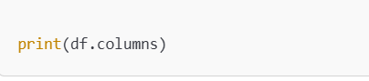**Code:**

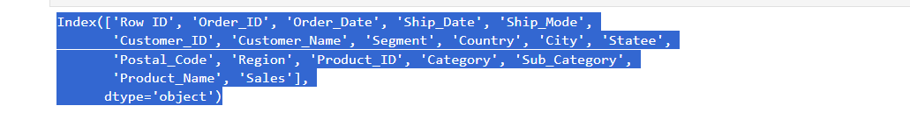**Output:**

**Explanation:**

* This prints the new column names after renaming.
* Confirms that all columns were renamed correctly and consistently.

**Code: Date Conversion in Python**

**Explanation:**

* Converts Order_Date and Ship_Date from string format (object) to datetime64 format.
* The format '%d/%m/%Y' ensures that the day (%d), month (%m), and year (%Y) are correctly interpreted.
* This allows for accurate date-based calculations (e.g., filtering by date, computing shipping duration).

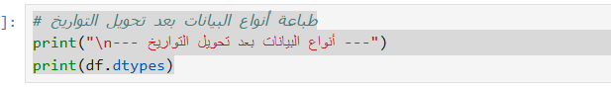**Code: Convert Date Columns to Datetime Format**

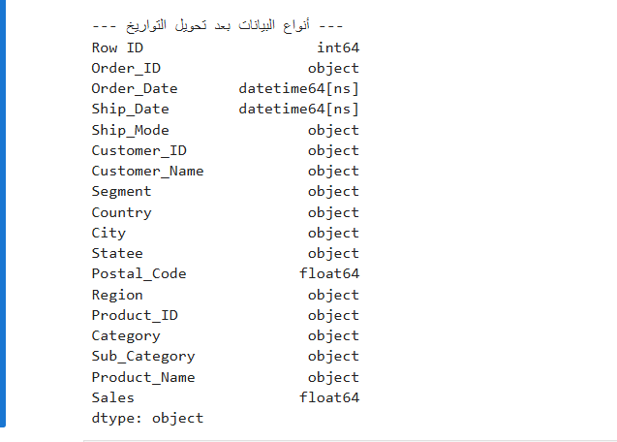**Output:**

**Explanation:**

* The Order_Date and Ship_Date columns are now successfully converted to datetime64[ns].
* This ensures that operations like sorting, filtering, and date arithmetic (e.g., Ship_Date - Order_Date) will work correctly.
* Other columns remain unchanged, ensuring data integrity.

1.4. Checking Missing Values

|  |  |
| --- | --- |
| *# Count missing values in each column* missing_values = df.isnull().sum() print(missing_values)   |  | | --- | | Order ID 0 Order Date 0 Ship Date 0 Ship Mode 0 Customer ID 0 Customer Name 0 Segment 0 Country 0 City 0 State 0 Postal Code 11 Region 0 Product ID 0 Category 0 Sub-Category 0 Product Name 0 Sales 0 dtype: int64 | |

2. Data Preparation

2.1. Convert Columns Data Type Format

2.2. Handle Missing Values

*# Convert 'Order Date' and 'Ship Date' columns to datetime format* df['Order Date'] = pd.to_datetime(df['Order Date'], dayfirst=True) df['Ship Date'] = pd.to_datetime(df['Ship Date'], dayfirst=True)

*# Convert 'Category' column to categorical data type* df['Category'] = df['Category'].astype('category')

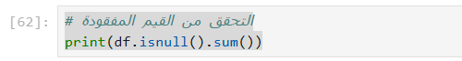

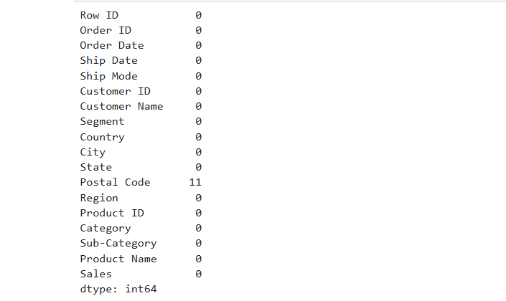

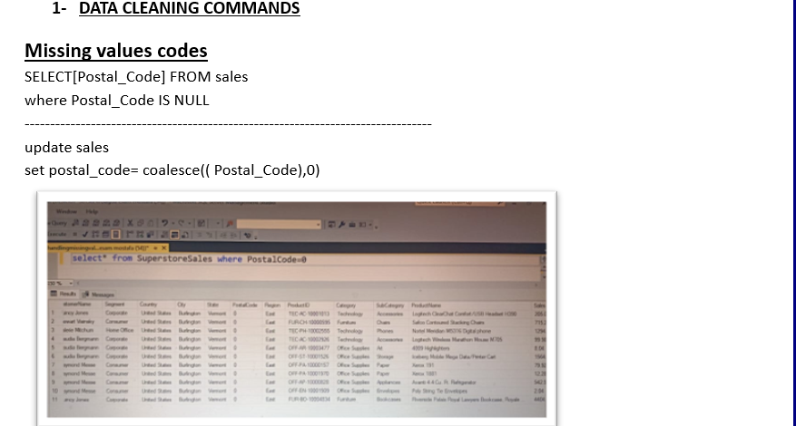

|  |  |  |  |  |
| --- | --- | --- | --- | --- |
| *# Show missing values*  print(df[df['Postal Code'].isnull()])   |  |  |  |  | | --- | --- | --- | --- | | |  | | --- | | \ | | |  | | --- | | Order ID Order Date Ship Date Ship Mode Customer ID | |   2234 CA-2018-104066 2018-12-05 2018-12-10 Standard Class QJ-19255  5274 CA-2016-162887 2016-11-07 2016-11-09 Second Class SV-20785  8798 US-2017-150140 2017-04-06 2017-04-10 Standard Class VM-21685  9146 US-2017-165505 2017-01-23 2017-01-27 Standard Class CB-12535  9147 US-2017-165505 2017-01-23 2017-01-27 Standard Class CB-12535  9148 US-2017-165505 2017-01-23 2017-01-27 Standard Class CB-12535  9386 US-2018-127292 2018-01-19 2018-01-23 Standard Class RM-19375  9387 US-2018-127292 2018-01-19 2018-01-23 Standard Class RM-19375  9388 US-2018-127292 2018-01-19 2018-01-23 Standard Class RM-19375  9389 US-2018-127292 2018-01-19 2018-01-23 Standard Class RM-19375  9741 CA-2016-117086 2016-11-08 2016-11-12 Standard Class QJ-19255  Customer Name Segment Country City State \  2234 Quincy Jones Corporate United States BurlingtonVermont  5274 Stewart Visinsky Consumer United States BurlingtonVermont 8798 Valerie Mitchum Home Office United States BurlingtonVermont 9146 Claudia Bergmann Corporate United States BurlingtonVermont  9147 Claudia Bergmann Corporate United States BurlingtonVermont  9148 Claudia Bergmann Corporate United States BurlingtonVermont 9386 Raymond Messe Consumer United States BurlingtonVermont 9387 Raymond Messe Consumer United States BurlingtonVermont 9388 Raymond Messe Consumer United States BurlingtonVermont  9389 Raymond Messe Consumer United States Burlington |

|  |  |
| --- | --- |
| Vermont 9741 Quincy Jones Corporate United States BurlingtonVermont   |  | | --- | | Postal Code Region Product ID Category Sub- |   Category \  2234 NaN East TEC-AC-10001013 TechnologyAccessories 5274 NaN East FUR-CH-10000595 FurnitureChairs 8798 NaN East TEC-PH-10002555 TechnologyPhones 9146 NaN East TEC-AC-10002926 TechnologyAccessories 9147 NaN East OFF-AR-10003477 Office SuppliesArt 9148 NaN East OFF-ST-10001526 Office SuppliesStorage 9386 NaN East OFF-PA-10000157 Office SuppliesPaper 9387 NaN East OFF-PA-10001970 Office SuppliesPaper 9388 NaN East OFF-AP-10000828 Office SuppliesAppliances 9389 NaN East OFF-EN-10001509 Office SuppliesEnvelopes 9741 NaN East FUR-BO-10004834 FurnitureBookcases  Product Name Sales 2234 Logitech ClearChat Comfort/USB Headset H390 205.03 5274 Safco Contoured Stacking Chairs 715.20 8798 Nortel Meridian M5316 Digital phone 1294.75 9146 Logitech Wireless Marathon Mouse M705 99.98 9147 4009 Highlighters 8.04 9148 Iceberg Mobile Mega Data/Printer Cart 1564.29 9386 Xerox 191 79.92 9387 Xerox 1881 12.28 9388 Avanti 4.4 Cu. Ft. Refrigerator 542.94 9389 Poly String Tie Envelopes 2.04 9741 Riverside Palais Royal Lawyers Bookcase, Royal... 4404.90  *# Alternatively, fill missing Postal Code values with 5001* df['Postal Code'] = df['Postal Code'].fillna(5001) |

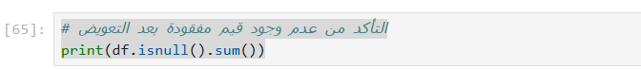

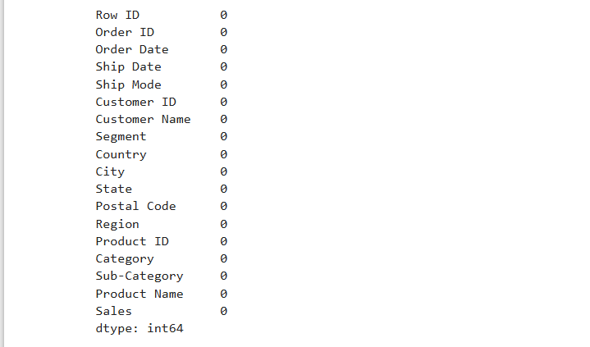**Output**:

**Explanation:**

**Verifying Missing Values Removal:** Rechecking the dataset to ensure all missing values have been handled.

2.3. Standardize Text

2.3.1. Standardize Column Names

*# Convert column names to lowercase and replace spaces with*   
*underscores*   
df.columns = df.columns.str.strip().str.lower().str.replace(' ', '_')

2.3.2. Standardize Text Columns

|  |  |  |  |  |  |  |  |
| --- | --- | --- | --- | --- | --- | --- | --- |
| *# Function to standardize and format text columns*  def standardize_text(text):   ifisinstance(text, str):   return'_'.join(text.strip().lower().split()) *# Convert to lowercase, remove extra spaces, replace spaces with "_"*   return text  *# Apply standardization to all string columns*  string_columns = df.select_dtypes(include=['object']).columns df[string_columns] = df[string_columns].applymap(standardize_text)  C:\Users\Aboelyazzed\AppData\Local\Temp\  ipykernel_7360\3450330121.py:9: FutureWarning: DataFrame.applymap hasbeen deprecated. Use DataFrame.map instead.   |  | | --- | | df[string_columns] = df[string_columns].applymap(standardize_text) |   *# Print Columns names After Standardize* print (df.columns)  Index(['order_id', 'order_date', 'ship_date', 'ship_mode','customer_id',   |  | | --- | | 'customer_name', 'segment', 'country', 'city', 'state', | | 'postal_code',  'region', 'product_id', 'category', 'sub-category', | | 'product_name',   |  | | --- | | 'sales'], | | | |  | | --- | | dtype='object') | | |

2.3.3. Use fuzzy matching to find similar product names

from rapidfuzz import process, fuzz

*# Convert product names to lowercase and strip extra spaces for consistency*   
df['product_name'] = df['product_name'].str.strip().str.lower()

*# Count unique Product IDs for each Product Name* product_name_check = df.groupby('product_name') ['product_id'].nunique()

*# Filter Product Names that have multiple Product IDs*   
potential_issues = product_name_check[product_name_check > 1].index.tolist()

*# Use fuzzy matching to find similar product names with different IDs* similar_names = {}   
for name in potential_issues:  
 matches = process.extract(name, df['product_name'].unique(), limit=5, scorer=fuzz.partial_ratio)  
 similar_names[name] = [match[0] for match in matches if match[0] !

= name and match[1] > 85] *# Threshold set to 85*

*# Display Results*   
ifany(similar_names.values()): *# Check if there are matches*   
 for name, matches in similar_names.items():   
 if matches:   
 print(f"⚠️ Possible duplicate product names for '{name}': {matches}")   
else:   
 print("✅ No similar product names with different IDs were found.")

⚠️ Possible duplicate product names for '#10-  
_4_1/8"_x_9_1/2"_recycled_envelopes': ['colored_envelopes']  
⚠️ Possible duplicate product names for 'avery_non-stick_binders':['avery_5', 'avery_51', 'avery_48', 'avery_52']  
⚠️ Possible duplicate product names for 'easy-staple_paper':   
['staples']  
⚠️ Possible duplicate product names for 'okidata_c610n_printer':['okidata_c331dn_printer', 'okidata_mb760_printer']  
⚠️ Possible duplicate product names for 'staple-based_wall_hangings':['staples']  
⚠️ Possible duplicate product names for 'staple_envelope': ['staples']⚠️ Possible duplicate product names for 'staple_holder': ['staples']⚠️ Possible duplicate product names for 'staple_magnet': ['staples']⚠️ Possible duplicate product names for 'staple_remover': ['staples']⚠️ Possible duplicate product names for 'staples':   
['staples_in_misc._colors', 'staple_envelope', 'staple-  
based_wall_hangings', 'staple_remover']  
⚠️ Possible duplicate product names for 'staples_in_misc._colors': ['staples']

Remove Duplicate Rows

1. Check if Each Product Name Has One Product ID

*# Step 1: Count the number of unique Product IDs for each Product Name* product_name_check = df.groupby('product_name')   
['product_id'].nunique()

*# Step 2: Find product names that have more than one unique Product ID* multiple_ids = product_name_check[product_name_check > 1]

*# Step 3: Display results of the initial check*   
if multiple_ids.empty:   
 print("✅ Each Product Name has only one Product ID.") else:   
 print("⚠️ Some Product Names have multiple Product IDs:") print(multiple_ids)

⚠️ Some Product Names have multiple Product IDs: product_name   
#10-_4_1/8"_x_9_1/2"_recycled_envelopes 2 avery_non-stick_binders 2 easy-staple_paper 8 eldon_wave_desk_accessories 2 ki_adjustable-height_table 2 okidata_c610n_printer 2 peel_&_seel_recycled_catalog_envelopes,_brown 2 prang_drawing_pencil_set 2 staple-based_wall_hangings 2 staple_envelope 9 staple_holder 3 staple_magnet 2 staple_remover 3 staples 10 staples_in_misc._colors 7 storex_dura_pro_binders 2 Name: product_id, dtype: int64

*# Step 1: Get the most frequent Product ID for each Product Name* most_frequent_ids = (  
 df.groupby('product_name')['product_id']  
 .agg(lambda x: x.value_counts().idxmax()) *# Select the most common Product ID*   
)

*# Step 2: Map the most frequent Product ID to a new column* df['most_frequent_product_id'] =   
df['product_name'].map(most_frequent_ids)

*# Step 3: Investigate problematic products*   
ifnot multiple_ids.empty:   
 print("\nInvestigating problematic products...")

*# Ensure required columns exist; add placeholders if necessary* if'category'notin df.columns:  
 df['category'] = "Unknown"   
if'sub_category'notin df.columns:

df['sub_category'] = "Unknown"

problematic_products = df[  
 df['product_name'].isin(multiple_ids.index)  
 ][['product_name', 'product_id', 'category', 'sub_category']] *# Include relevant columns for context*

*# Save problematic products to a CSV file for review*  
 problematic_products.to_csv("problematic_products.csv",   
index=False)   
 print("Problematic products saved to 'problematic_products.csv'.")

*# Step 4: Resolve inconsistencies (merge IDs using the most frequent ID)*   
print("\nResolving inconsistencies by merging IDs...")   
df['product_id'] = df['product_name'].map(most_frequent_ids)

*# Step 5: Re-check the number of unique Product IDs for each Product Name*   
product_name_check_after = df.groupby('product_name')   
['product_id'].nunique()   
multiple_ids_after = product_name_check_after[product_name_check_after > 1]

*# Step 6: Display final results*   
if multiple_ids_after.empty:   
 print("\n✅ All inconsistencies resolved. Each Product Name now has only one Product ID.")   
else:   
 print("\n⚠️ Some Product Names still have multiple Product IDs after resolution:")   
 print(multiple_ids_after)

Investigating problematic products...

Problematic products saved to 'problematic_products.csv'.

Resolving inconsistencies by merging IDs...

✅ All inconsistencies resolved. Each Product Name now has only oneProduct ID.

print(df.info()) *# Verify column names and non-null counts* print(df.head()) *# Inspect the first few rows of the DataFrame* print(df['most_frequent_product_id'].isna().sum()) *# Check for missing values in the new column*

<class 'pandas.core.frame.DataFrame'>   
RangeIndex: 9800 entries, 0 to 9799   
Data columns (total 19 columns):  
 # Column Non-Null Count Dtype

|  |  |  |  |
| --- | --- | --- | --- |
| |  |  |  | | --- | --- | --- | | --- ------ -------------- -----  0 order_id 9800 non-null object  1 order_date 9800 non-null datetime64[ns] 2 ship_date 9800 non-null datetime64[ns] 3 ship_mode 9800 non-null object  4 customer_id 9800 non-null object  5 customer_name 9800 non-null object  6 segment 9800 non-null object  7 country 9800 non-null object  8 city 9800 non-null object  9 state 9800 non-null object  10 postal_code 9800 non-null float64  11 region 9800 non-null object  12 product_id 9800 non-null object  13 category 9800 non-null category 14 sub-category 9800 non-null object  15 product_name 9800 non-null object  16 sales 9800 non-null float64  17 most_frequent_product_id 9800 non-null object  18 sub_category 9800 non-null object dtypes: category(1), datetime64[ns](2), float64(2), object(14) memory usage: 1.4+ MB  None   |  | | --- | | order_id order_date ship_date ship_mode customer_id \ |   0 ca-2017-152156 2017-11-08 2017-11-11 second_class cg-125201 ca-2017-152156 2017-11-08 2017-11-11 second_class cg-125202 ca-2017-138688 2017-06-12 2017-06-16 second_class dv-130453 us-2016-108966 2016-10-11 2016-10-18 standard_class so-203354 us-2016-108966 2016-10-11 2016-10-18 standard_class so-20335  customer_name segment country citystate \  0 claire_gute consumer united_states hendersonkentucky 1 claire_gute consumer united_states hendersonkentucky 2 darrin_van_huff corporate united_states los_angelescalifornia 3 sean_o'donnell consumer united_states fort_lauderdaleflorida 4 sean_o'donnell consumer united_states fort_lauderdaleflorida   |  | | --- | | postal_code region product_id category sub- |   category \  0 42420.0 south fur-bo-10001798 Furniture bookcases  1 42420.0 south fur-ch-10000454 Furniture chairs  2 90036.0 west off-la-10000240 Office Supplies labels | |

|  |  |  |  |
| --- | --- | --- | --- |
| 3 33311.0 south fur-ta-10000577 Furniture tables  4 33311.0 south off-st-10000760 Office Supplies storage   |  | | --- | | product_name sales \ 0 bush_somerset_collection_bookcase 261.9600 1 hon_deluxe_fabric_upholstered_stacking_chairs,... 731.9400 2 self-adhesive_address_labels_for_typewriters_b... 14.6200 3 bretford_cr4500_series_slim_rectangular_table 957.5775 4 eldon_fold_'n_roll_cart_system 22.3680 |   most_frequent_product_id sub_category0 fur-bo-10001798 Unknown1 fur-ch-10000454 Unknown2 off-la-10000240 Unknown3 fur-ta-10000577 Unknown4 off-st-10000760 Unknown   |  | | --- | | 0 |   *# Replace 'product_id' with 'most_frequent_product_id'* df['product_id'] = df['most_frequent_product_id']  *# Drop the 'most_frequent_product_id' column if no longer needed* df.drop(columns=['most_frequent_product_id'], inplace=True)  *# Verify the change*  print(df[['product_name', 'product_id']].head())   |  | | --- | | product_name product_id 0 bush_somerset_collection_bookcase fur-bo-10001798 1 hon_deluxe_fabric_upholstered_stacking_chairs,... fur-ch-10000454 2 self-adhesive_address_labels_for_typewriters_b... off-la-10000240 3 bretford_cr4500_series_slim_rectangular_table fur-ta-10000577 4 eldon_fold_'n_roll_cart_system off-st-10000760 | |

2.4.2 Check if Each Product ID is Assigned to Only One Product Name

*# Count the number of unique Product Names for each Product ID*   
product_id_check = df.groupby('product_id')['product_name'].nunique()

*# Find Product IDs that have more than one unique Product Name* multiple_names = product_id_check[product_id_check > 1]

*# Display results*   
if multiple_names.empty:   
 print("✅ Each Product ID is linked to only one Product Name.") else:   
 print("⚠️ Some Product IDs are assigned to multiple Product

Names:")   
 print(multiple_names)

⚠️ Some Product IDs are assigned to multiple Product Names: product_id   
fur-bo-10002213 2   
fur-ch-10001146 2   
fur-fu-10001473 2   
fur-fu-10004017 2   
fur-fu-10004091 2   
fur-fu-10004270 2   
fur-fu-10004848 2   
fur-fu-10004864 2   
off-ap-10000576 2   
off-ar-10001149 2   
off-bi-10002026 2   
off-bi-10004632 2   
off-bi-10004654 2   
off-pa-10000357 2   
off-pa-10000477 2   
off-pa-10000659 2   
off-pa-10001166 2   
off-pa-10001970 2   
off-pa-10002195 2   
off-pa-10002377 2   
off-pa-10003022 2   
off-st-10001228 2   
off-st-10004950 2   
tec-ac-10002049 2   
tec-ac-10002550 2   
tec-ac-10003832 2   
tec-ma-10001148 2   
tec-ph-10001530 2   
tec-ph-10001795 2   
tec-ph-10002200 2   
tec-ph-10002310 2   
tec-ph-10004531 2   
Name: product_name, dtype: int64

*# Step 1: Identify Product IDs assigned to multiple Product Names* product_id_check = df.groupby('product_id')['product_name'].nunique() multiple_names = product_id_check[product_id_check > 1]

*# Step 2: Display initial results*   
if multiple_names.empty:   
 print("✅ Each Product ID is Assigned to Only One Product Name.") else:   
 print("⚠️ Some Product IDs are Assigned to Multiple Product Names:")   
 print(multiple_names)

*# Step 3: Investigate problematic Product IDs*   
ifnot multiple_names.empty:   
 print("\nInvestigating problematic Product IDs...")

*# Ensure required columns exist; add placeholders if necessary* if'category'notin df.columns:  
 df['category'] = "Unknown"   
if'sub_category'notin df.columns:  
 df['sub_category'] = "Unknown"

problematic_products = df[  
 df['product_id'].isin(multiple_names.index)  
 ][['product_id', 'product_name', 'category', 'sub_category']] *# Include relevant columns for context*

*# Save problematic products to a CSV file for review*  
 problematic_products.to_csv("problematic_product_ids.csv", index=False)   
 print("Problematic Product IDs saved to   
'problematic_product_ids.csv'.")

*# Step 4: Resolve inconsistencies (merge names using the most frequent name)*   
print("\nResolving inconsistencies by merging Product Names...")

*# Get the most frequent Product Name for each Product ID*   
most_frequent_names = (  
 df.groupby('product_id')['product_name']  
 .agg(lambda x: x.value_counts().idxmax()) *# Select the most common Product Name*   
)

*# Map the most frequent Product Name back to the DataFrame* df['product_name'] = df['product_id'].map(most_frequent_names)

*# Step 5: Re-check the number of unique Product Names for each Product ID*   
product_id_check_after = df.groupby('product_id')   
['product_name'].nunique()   
multiple_names_after = product_id_check_after[product_id_check_after > 1]

*# Step 6: Display final results*   
if multiple_names_after.empty:   
 print("\n✅ All inconsistencies resolved. Each Product ID is Assigned to Only One Product Name.")   
else:   
 print("\n⚠️ Some Product IDs are still Assigned to Multiple Product

Names:")   
 print(multiple_names_after)

⚠️ Some Product IDs are Assigned to Multiple Product Names: product_id   
fur-bo-10002213 2   
fur-ch-10001146 2   
fur-fu-10001473 2   
fur-fu-10004017 2   
fur-fu-10004091 2   
fur-fu-10004270 2   
fur-fu-10004848 2   
fur-fu-10004864 2   
off-ap-10000576 2   
off-ar-10001149 2   
off-bi-10002026 2   
off-bi-10004632 2   
off-bi-10004654 2   
off-pa-10000357 2   
off-pa-10000477 2   
off-pa-10000659 2   
off-pa-10001166 2   
off-pa-10001970 2   
off-pa-10002195 2   
off-pa-10002377 2   
off-pa-10003022 2   
off-st-10001228 2   
off-st-10004950 2   
tec-ac-10002049 2   
tec-ac-10002550 2   
tec-ac-10003832 2   
tec-ma-10001148 2   
tec-ph-10001530 2   
tec-ph-10001795 2   
tec-ph-10002200 2   
tec-ph-10002310 2   
tec-ph-10004531 2   
Name: product_name, dtype: int64

Investigating problematic Product IDs...

Problematic Product IDs saved to 'problematic_product_ids.csv'.

Resolving inconsistencies by merging Product Names...

✅ All inconsistencies resolved. Each Product ID is Assigned to OnlyOne Product Name.

print(df.info()) *# Verify column names and non-null counts* print(df.head()) *# Inspect the first few rows of the DataFrame*

|  |  |  |
| --- | --- | --- |
| print(df['product_id'].isna().sum()) *# Check for missing values in the new column*  <class 'pandas.core.frame.DataFrame'>  RangeIndex: 9800 entries, 0 to 9799  Data columns (total 18 columns):  # Column Non-Null Count Dtype --- ------ -------------- -----  0 order_id 9800 non-null object  1 order_date 9800 non-null datetime64[ns]  2 ship_date 9800 non-null datetime64[ns]  3 ship_mode 9800 non-null object  4 customer_id 9800 non-null object  5 customer_name 9800 non-null object  6 segment 9800 non-null object  7 country 9800 non-null object  8 city 9800 non-null object  9 state 9800 non-null object  10 postal_code 9800 non-null float64  11 region 9800 non-null object  12 product_id 9800 non-null object  13 category 9800 non-null category  14 sub-category 9800 non-null object   15 product_name 9800 non-null object  16 sales 9800 non-null float64  17 sub_category 9800 non-null object dtypes: category(1), datetime64[ns](2), float64(2), object(13) memory usage: 1.3+ MB  None   |  | | --- | | order_id order_date ship_date ship_mode customer_id \ |   0 ca-2017-152156 2017-11-08 2017-11-11 second_class cg-125201 ca-2017-152156 2017-11-08 2017-11-11 second_class cg-125202 ca-2017-138688 2017-06-12 2017-06-16 second_class dv-130453 us-2016-108966 2016-10-11 2016-10-18 standard_class so-203354 us-2016-108966 2016-10-11 2016-10-18 standard_class so-20335  customer_name segment country citystate \  0 claire_gute consumer united_states hendersonkentucky 1 claire_gute consumer united_states hendersonkentucky 2 darrin_van_huff corporate united_states los_angelescalifornia 3 sean_o'donnell consumer united_states fort_lauderdaleflorida 4 sean_o'donnell consumer united_states fort_lauderdaleflorida   |  | | --- | | postal_code region product_id category sub- | |

|  |  |  |  |  |  |
| --- | --- | --- | --- | --- | --- |
| |  |  |  |  |  | | --- | --- | --- | --- | --- | | category \  0 42420.0 south fur-bo-10001798 Furniture bookcases1 42420.0 south fur-ch-10000454 Furniture chairs2 90036.0 west off-la-10000240 Office Supplies labels3 33311.0 south fur-ta-10000577 Furniture tables4 33311.0 south off-st-10000760 Office Supplies storage   |  |  |  |  | | --- | --- | --- | --- | | s 0 U 1 U 2 U 3 U 4 U   |  | | --- | | 0 | | |  | | --- | | product_name sales |   s ub_category  0 bush_somerset_collection_bookcase 261.9600 U nknown  1 hon_deluxe_fabric_upholstered_stacking_chairs,... 731.9400 U nknown  2 self-adhesive_address_labels_for_typewriters_b... 14.6200 U nknown  3 bretford_cr4500_series_slim_rectangular_table 957.5775 U nknown  4 eldon_fold_'n_roll_cart_system 22.3680 Unknown | | |

2.4.3 Check Row Duplicate

*# Check for duplicate rows*   
duplicates = df.duplicated().sum()   
print(f"Number of duplicate rows: {duplicates}")

if duplicates > 0:   
 print("Aggregating duplicate rows...")

*# Identify all duplicate rows (including the original and copies)* duplicated_rows = df[df.duplicated(keep=False)]

*# Define aggregation rules for each column*  
 aggregation_rules = {   
 'order_date': 'first', *# Keep the first order date*  'ship_date': 'last', *# Keep the last ship date*   
 'ship_mode': 'first', *# Keep the first shipping mode*  'customer_name': 'first', *# Keep the first customer name*  'segment': 'first', *# Keep the first segment*   
 'country': 'first', *# Keep the first country*   
 'city': 'first', *# Keep the first city*   
 'state': 'first', *# Keep the first state*   
 'postal_code': 'first', *# Keep the first postal code*  'region': 'first', *# Keep the first region*

'category': 'first', *# Keep the first category*   
 'sub-category': 'first', *# Keep the first sub-category*  'product_name': lambda x: ', '.join(x.unique()), *# Concatenate unique product names*   
 'sales': 'sum', *# Sum up sales for duplicate rows* }

*# Group by unique identifiers and apply aggregation only on duplicate rows*  
 aggregated_duplicates = duplicated_rows.groupby(['order_id', 'customer_id', 'product_id'], as_index=False).agg(aggregation_rules)

*# Remove all duplicate rows from the original DataFrame* df_cleaned = df.drop_duplicates(keep=False)

*# Concatenate the cleaned DataFrame with the aggregated duplicates* df = pd.concat([df_cleaned, aggregated_duplicates],   
ignore_index=True)

print(f"Duplicate rows aggregated. New DataFrame shape: {df.shape}")   
else:   
 print("No duplicate rows found.")

Number of duplicate rows: 1   
Aggregating duplicate rows...

Duplicate rows aggregated. New DataFrame shape: (9799, 18)

print(df.info())

<class 'pandas.core.frame.DataFrame'>   
RangeIndex: 9799 entries, 0 to 9798   
Data columns (total 18 columns):  
 # Column Non-Null Count Dtype  
--- ------ -------------- -----  
 0 order_id 9799 non-null object  
 1 order_date 9799 non-null datetime64[ns] 2 ship_date 9799 non-null datetime64[ns] 3 ship_mode 9799 non-null object  
 4 customer_id 9799 non-null object  
 5 customer_name 9799 non-null object  
 6 segment 9799 non-null object  
 7 country 9799 non-null object  
 8 city 9799 non-null object  
 9 state 9799 non-null object  
 10 postal_code 9799 non-null float64  
 11 region 9799 non-null object  
 12 product_id 9799 non-null object  
 13 category 9799 non-null category 14 sub-category 9799 non-null object

15 product_name 9799 non-null object  
 16 sales 9799 non-null float64  
 17 sub_category 9798 non-null object  
dtypes: category(1), datetime64[ns](2), float64(2), object(13) memory usage: 1.3+ MB   
None

2.5 Filter out outliers

*# Define a function to remove outliers using IQR* def remove_outliers_iqr(df, column):  
 Q1 = df[column].quantile(0.25) *# First quartile* Q3 = df[column].quantile(0.75) *# Third quartile* IQR = Q3 - Q1 *# Interquartile range*  
 lower_bound = Q1 - 1.5 * IQR *# Lower limit* upper_bound = Q3 + 1.5 * IQR *# Upper limit*

*# Filter out rows with outliers*  
 df_cleaned = df[(df[column] >= lower_bound) & (df[column] <= upper_bound)]

return df_cleaned

*# Apply the function to the 'sales' column* df_cleaned = remove_outliers_iqr(df, 'sales')

*# Check summary statistics before applying outlier removal* print("Before Outlier Removal:")   
print(df['sales'].describe())

*# Check summary statistics after applying outlier removal* print("\nAfter Outlier Removal:")   
print(df_cleaned['sales'].describe())

Before Outlier Removal:   
count 9799.000000   
mean 230.792610   
std 626.692409   
min 0.444000   
25% 17.248000   
50% 54.480000   
75% 210.572000   
max 22638.480000   
Name: sales, dtype: float64

After Outlier Removal:   
count 8653.000000   
mean 93.169840   
std 114.670861   
min 0.444000

25% 15.008000   
50% 40.784000   
75% 124.360000   
max 500.240000   
Name: sales, dtype: float64

*# Function to calculate the IQR for each category and filter products exceeding the upper bound*   
def identify_outliers_by_category(df):   
 *# Group by category and calculate Q1, Q3, and IQR for each category*  
 outliers = []   
 for category, group in df.groupby('category'):  
 Q1 = group['sales'].quantile(0.25)  
 Q3 = group['sales'].quantile(0.75)  
 IQR = Q3 - Q1  
 upper_bound = Q3 + 1.5 * IQR

*# Identify products with sales above the upper bound for each category*  
 outliers_in_category = group[group['sales'] > upper_bound] outliers_in_category = outliers_in_category[['product_name', 'sales', 'category']]

*# Remove rows with NaN in product_name*  
 outliers_in_category =   
outliers_in_category.dropna(subset=['product_name'])

*# Append the results*  
 outliers.append(outliers_in_category)

*# Concatenate the results for all categories* return pd.concat(outliers)

*# Apply the function to find outliers*   
outliers = identify_outliers_by_category(df)

*# Check if there are outliers*   
if outliers.empty:   
 print("✅ No products exceed the upper bound in any category.") else:   
 *# Sort outliers by sales in descending order*  
 outliers_sorted = outliers.sort_values(by='sales',   
ascending=False)

print("⚠️ Products with sales higher than the upper bound in their respective categories:")   
 print(outliers_sorted)

|  |  |  |
| --- | --- | --- |
| ⚠️ Products with sales higher than the upper bound in their respective categories:   |  | | --- | | product_name sales \ |   2697 cisco_telepresence_system_ex90_videoconferenci... 22638.4806824 canon_imageclass_2200_advanced_copier 17499.9508151 canon_imageclass_2200_advanced_copier 13999.9602623 canon_imageclass_2200_advanced_copier 11199.9684188 canon_imageclass_2200_advanced_copier 10499.970... ... ...3419 xerox_1991 182.7205289 snap-a-way_black_print_carbonless_ruled_speed_... 182.1127262 boston_1799_powerhouse_electric_pencil_sharpener 181.8603174 boston_1799_powerhouse_electric_pencil_sharpener 181.8603317 boston_19500_mighty_mite_electric_pencil_sharp... 181.350  category 2697 Technology 6824 Technology 8151 Technology 2623 Technology 4188 Technology ... ... 3419 Office Supplies 5289 Office Supplies 7262 Office Supplies 3174 Office Supplies 3317 Office Supplies  [1134 rows x 3 columns]  C:\Users\Aboelyazzed\AppData\Local\Temp\  ipykernel_7360\1535412655.py:5: FutureWarning: The default of observed=False is deprecated and will be changed to True in a futureversion of pandas. Pass observed=False to retain current behavior orobserved=True to adopt the future default and silence this warning.   |  | | --- | | for category, group in df.groupby('category'): | |

**Code:**

**Output:**

**Explanation:**

* **Identifying Fully Duplicated Rows:** The duplicated().sum() function counts rows with identical values across all columns.

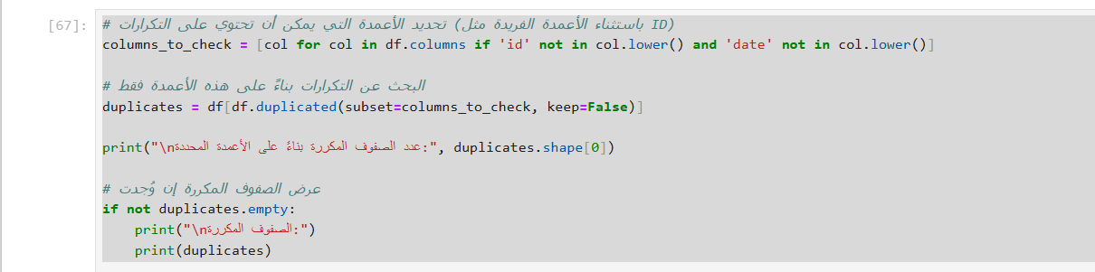**Code:**

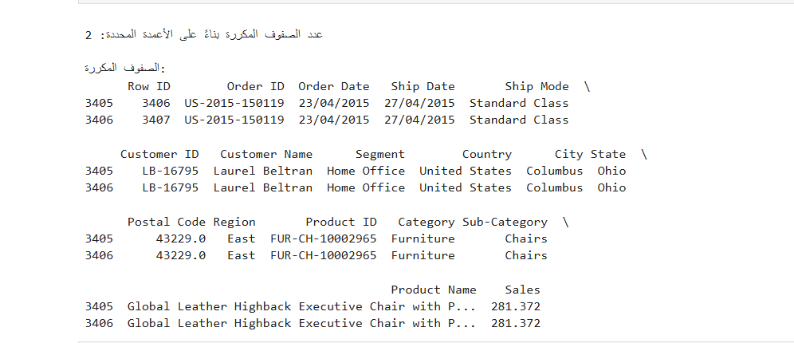**Output:**

**Explanation:**

* **Detecting Partial Duplicates:** Excludes unique identifiers (IDs and Dates) when checking for duplicates, focusing on other attributes.

**Code:**

**Explanation:**

* **Merging Duplicate Rows:** If duplicate entries exist, their Sales values are summed, and redundant rows are removed.

**Code:**

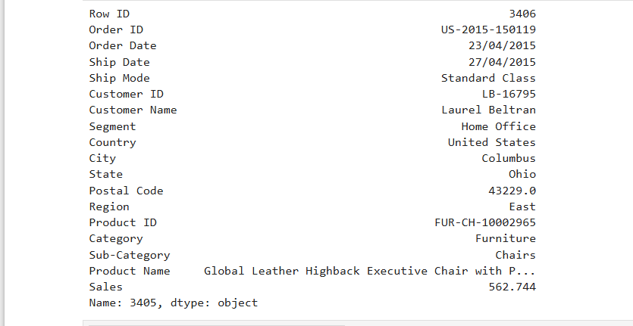**Output:**

**Explanation:**

* Row 3405 is displayed to confirm the successful merge**.**

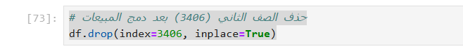**Code:**

**Explanation:**

* **Deleting the Duplicate Row**: Row 3406 is removed as it is no longer needed after merging.

**Code:**

**Explanation:**

* **Resetting Index:** The index is reset after deletion to maintain table consistency.

**Code:**

**Output:**

**Explanation:**

* Row 3405 is displayed to confirm the successful merge.

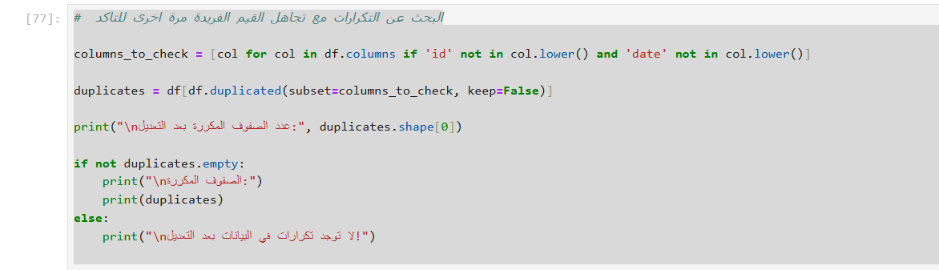**Code:**

**Output:**

**Explanation:**

* **Select Columns for Duplicate Check :** Exclude columns containing 'id' or 'date'.
* **Identify Duplicate Rows :** Use df.duplicated(subset=columns_to_check, keep=False).
* **Print Results :** Show the number of duplicates and display them if found.
* **Ensures**: that no duplicates remain in the dataset.

**Data Normalization**

. Normalize or Standardize Numeric Columns

|  |  |
| --- | --- |
| from sklearn.preprocessing import MinMaxScaler  *# Initialize the scaler*  scaler = MinMaxScaler()  *# Normalize the 'sales' column*  df['sales_normalized'] = scaler.fit_transform(df[['sales']])  *# Display the normalized values*  print(df[['sales', 'sales_normalized']].head())   |  | | --- | | sales sales_normalized 0 261.9600 0.011552 1 731.9400 0.032313 2 14.6200 0.000626 3 957.5775 0.042280 4 22.3680 0.000968 | |

4.4. Encode Categorical Variables

|  |  |
| --- | --- |
| *# One-hot encode categorical columns*  df_encoded = pd.get_dummies(df, columns=['category', 'sub-category', 'region'], drop_first=True)  *# Display the encoded DataFrame*  print(df_encoded.head())   |  | | --- | | order_id order_date ship_date ship_mode customer_id \ 0 ca-2017-152156 2017-11-08 2017-11-11 second_class cg-12520 1 ca-2017-152156 2017-11-08 2017-11-11 second_class cg-12520 2 ca-2017-138688 2017-06-12 2017-06-16 second_class dv-13045 3 us-2016-108966 2016-10-11 2016-10-18 standard_class so-20335 4 us-2016-108966 2016-10-11 2016-10-18 standard_class so-20335 |   customer_name segment country city state ... \  0 claire_gute consumer united_states hendersonKY ...  1 claire_gute consumer united_states hendersonKY ...  2 darrin_van_huff corporate united_states los_angeles |

|  |  |  |  |
| --- | --- | --- | --- |
| CA ...  3 sean_o'donnell consumer united_states fort_lauderdaleFL ...  4 sean_o'donnell consumer united_states fort_lauderdaleFL ...   |  | | --- | | sub-category_labels sub-category_machines sub-category_paper \ 0 False False False 1 False False False 2 True False False 3 False False False 4 False False False |  |  | | --- | | sub-category_phones sub-category_storage sub-category_supplies \ 0 False False False 1 False False False 2 False False False 3 False False False 4 False True False |   sub-category_tables region_east region_south region_west0 False False True False1 False False True False2 False False False True3 True False True False4 False False True False  [5 rows x 42 columns]  from sklearn.preprocessing import LabelEncoder  *# Initialize the encoder*  encoder = LabelEncoder()  *# Encode the 'segment' column*  df['segment_encoded'] = encoder.fit_transform(df['segment'])  *# Display the encoded column*  print(df[['segment', 'segment_encoded']].head())   |  | | --- | | segment segment_encoded 0 consumer 0 1 consumer 0 2 corporate 1 3 consumer 0 4 consumer 0 | |

4.5. Aggregate Data for Insights

|  |  |
| --- | --- |
| *# Total sales by category*  category_sales = df.groupby('category')['sales'].sum().reset_index() category_sales.rename(columns={'sales': 'total_category_sales'}, inplace=True)  *# Total sales by region*  region_sales = df.groupby('region')['sales'].sum().reset_index() region_sales.rename(columns={'sales': 'total_region_sales'}, inplace=True)  *# Merge aggregated features back into the main DataFrame* df = df.merge(category_sales, on='category', how='left') df = df.merge(region_sales, on='region', how='left')  *# Display the new aggregated features*  print(df[['category', 'total_category_sales', 'region', 'total_region_sales']].head())   |  | | --- | | category total_category_sales region total_region_sales 0 Furniture 728658.5757 south 389151.4590 1 Furniture 728658.5757 south 389151.4590 2 Office Supplies 705422.3340 west 710219.6845 3 Furniture 728658.5757 south 389151.4590 4 Office Supplies 705422.3340 south 389151.4590 |   C:\Users\Aboelyazzed\AppData\Local\Temp\  ipykernel_7360\2394340360.py:2: FutureWarning:  The default of observed=False is deprecated and will be changed toTrue in a future version of pandas. Pass observed=False to retain current behavior or observed=True to adopt the future default andsilence this warning. |

4.6. Handle Outliers

def remove_outliers_iqr(df, column):  
 Q1 = df[column].quantile(0.25)  
 Q3 = df[column].quantile(0.75)  
 IQR = Q3 - Q1  
 lower_bound = Q1 - 1.5 * IQR  
 upper_bound = Q3 + 1.5 * IQR   
 return df[(df[column] >= lower_bound) & (df[column] <= upper_bound)]

*# Remove outliers from 'shipping_time_days'*   
df_cleaned = remove_outliers_iqr(df, 'shipping_time_days')

*# Compare before and after outlier removal*   
print("Before Outlier Removal:")   
print(df['shipping_time_days'].describe())   
print("\nAfter Outlier Removal:")   
print(df_cleaned['shipping_time_days'].describe())

Before Outlier Removal:   
count 9799.000000   
mean 3.961118   
std 1.749703   
min 0.000000   
25% 3.000000   
50% 4.000000   
75% 5.000000   
max 7.000000   
Name: shipping_time_days, dtype: float64

After Outlier Removal:   
count 9799.000000   
mean 3.961118   
std 1.749703   
min 0.000000   
25% 3.000000   
50% 4.000000   
75% 5.000000   
max 7.000000   
Name: shipping_time_days, dtype: float64

4.7. Split Data into Training and Testing Sets

from sklearn.model_selection import train_test_split

*# Define features (X) and target variable (y)*   
X = df[['order_year', 'order_month', 'shipping_time_days', 'total_customer_sales']]   
y = df['sales']

*# Split into training and testing sets (80% train, 20% test)* X_train, X_test, y_train, y_test = train_test_split(X, y, test_size=0.2, random_state=42)

*# Display shapes of the splits*   
print(f"Training set size: {X_train.shape}") print(f"Testing set size: {X_test.shape}")

Training set size: (7839, 4)   
Testing set size: (1960, 4)

*# Detecting Outliers in Sales*

plt**.**figure(figsize**=**(8, 5))

sns**.**boxplot(x**=**df['Sales'])

plt**.**title("Sales Outliers Detection")

plt**.**show()

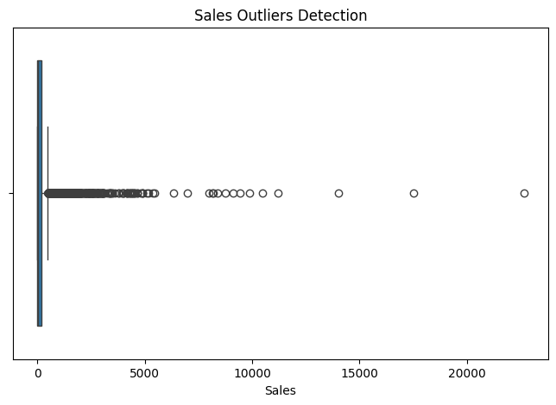

Q1 **=** df['Sales']**.**quantile(0.25)

Q3 **=** df['Sales']**.**quantile(0.75)

IQR **=** Q3 **-** Q1

lower_bound **=** Q1 **-** 1.5 **\*** IQR

upper_bound **=** Q3 **+** 1.5 **\*** IQR

outliers **=** df[(df['Sales'] **<** lower_bound) **|** (df['Sales'] **>** upper_bound)]

print(outliers)

Order_ID Product_ID Sales Order_Date Ship_Date \

1 CA-2015-100090 FUR-TA-10003715 502.488 2015-07-08 2015-07-12

24 CA-2015-100916 FUR-TA-10004607 591.320 2015-10-21 2015-10-26

40 CA-2015-101602 FUR-CH-10004675 763.280 2015-12-15 2015-12-18

44 CA-2015-101931 FUR-BO-10001337 616.998 2015-10-28 2015-10-31

52 CA-2015-102274 OFF-PA-10004359 629.100 2015-11-21 2015-11-26

... ... ... ... ... ...

9766 US-2018-167402 OFF-SU-10002881 4164.050 2018-01-13 2018-01-18

9774 US-2018-167920 TEC-CO-10001046 1399.980 2018-12-09 2018-12-12

9776 US-2018-168116 TEC-MA-10004125 7999.980 2018-11-04 2018-11-04

9790 US-2018-169551 TEC-AC-10003033 527.920 2018-07-07 2018-07-09

9791 US-2018-169551 TEC-PH-10001363 683.988 2018-07-07 2018-07-09

Ship_Mode Customer_ID Customer_Name Segment Country \

1 Standard Class EB-13705 Ed Braxton Corporate United States

24 Standard Class FH-14275 Frank Hawley Corporate United States

40 First Class MC-18100 Mick Crebagga Consumer United States

44 First Class TS-21370 Todd Sumrall Corporate United States

52 Standard Class DH-13075 Dave Hallsten Corporate United States

... ... ... ... ... ...

9766 Second Class CP-12085 Cathy Prescott Corporate United States

9774 Second Class JL-15835 John Lee Consumer United States

9776 Same Day GT-14635 Grant Thornton Corporate United States

9790 First Class RL-19615 Rob Lucas Consumer United States

9791 First Class RL-19615 Rob Lucas Consumer United States

City Statee Postal_Code Region Category \

1 San Francisco California 94122.0 West Furniture

24 Newport News Virginia 23602.0 South Furniture

40 El Paso Texas 79907.0 Central Furniture

44 Los Angeles California 90049.0 West Furniture

52 Richmond Kentucky 40475.0 South Office Supplies

... ... ... ... ... ...

9766 Springfield Missouri 65807.0 Central Office Supplies

9774 Richmond Kentucky 40475.0 South Technology

9776 Burlington North Carolina 27217.0 South Technology

9790 Philadelphia Pennsylvania 19120.0 East Technology

9791 Philadelphia Pennsylvania 19120.0 East Technology

Sub_Category Product_Name

1 Tables Hon 2111 Invitation Series Corner Table

24 Tables Hon 2111 Invitation Series Straight Table

40 Chairs Lifetime Advantage Folding Chairs, 4/Carton

44 Bookcases O'Sullivan Living Dimensions 2-Shelf Bookcases

52 Paper Multicolor Computer Printout Paper

... ... ...

9766 Supplies Martin Yale Chadless Opener Electric Letter Op...

9774 Copiers Canon Imageclass D680 Copier / Fax

9776 Machines Cubify CubeX 3D Printer Triple Head Print

9790 Accessories Plantronics CS510 - Over-the-Head monaural Wir...

9791 Phones Apple iPhone 5S

[1146 rows x 17 columns]

outliers['Product_Name']**.**value_counts()**.**head(10)

Product_Name

Logitech G19 Programmable Gaming Keyboard 11

GBC DocuBind TL300 Electric Binding System 11

Bretford Rectangular Conference Table Tops 10

Fellowes PB500 Electric Punch Plastic Comb Binding Machine with Manual Bind 10

Tennsco Double-Tier Lockers 10

SAFCO Arco Folding Chair 10

Global Troy Executive Leather Low-Back Tilter 9

Plantronics CS510 - Over-the-Head monaural Wireless Headset System 9

Hon Deluxe Fabric Upholstered Stacking Chairs, Rounded Back 9

Hot File 7-Pocket, Floor Stand 9

Name: count, dtype: int64

*# هل تؤثر هذه القيم على المتوسطات والمجموع الكلي*

print(f"Total Sales (With Outliers): {df['Sales']**.**sum()}")

print(f"Total Sales (Without Outliers): {df[**~**df**.**index**.**isin(outliers**.**index)]['Sales']**.**sum()}")

Total Sales (With Outliers): 2261536.7827

Total Sales (Without Outliers): 805211.5418

print(f"Outliers Percentage: {len(outliers) **/** len(df) **\*** 100:.2f}%")

Outliers Percentage: 11.70%

outliers**.**groupby('Customer_Name')['Sales']**.**sum()**.**sort_values(ascending**=False**)**.**head(10)

Customer_Name

Sean Miller 24649.302

Tamara Chand 18235.930

Raymond Buch 13999.960

Tom Ashbrook 13599.568

Hunter Lopez 12267.840

Sanjit Chand 11847.850

Adrian Barton 11818.590

Christopher Conant 11199.936

Ken Lonsdale 10803.538

Sanjit Engle 10683.916

Name: Sales, dtype: float64

outliers**.**groupby('Customer_Name')['Sales']**.**agg(['count', 'sum'])**.**sort_values(by**=**'sum', ascending**=False**)**.**head(10)

| **count** | **sum** |
| --- | --- |
| **Customer_Name** |  |  |
| **Sean Miller** | 4 | 24649.302 |
| **Tamara Chand** | 2 | 18235.930 |
| **Raymond Buch** | 1 | 13999.960 |
| **Tom Ashbrook** | 2 | 13599.568 |
| **Hunter Lopez** | 3 | 12267.840 |
| **Sanjit Chand** | 3 | 11847.850 |
| **Adrian Barton** | 3 | 11818.590 |
| **Christopher Conant** | 2 | 11199.936 |
| **Ken Lonsdale** | 3 | 10803.538 |
| **Sanjit Engle** | 3 | 10683.916 |

top_products **=** df**.**groupby("Product_Name")["Sales"]**.**sum()**.**sort_values(ascending**=False**)**.**head(10)

print(top_products)

Product_Name

Canon imageCLASS 2200 Advanced Copier 61599.824

Fellowes PB500 Electric Punch Plastic Comb Binding Machine with Manual Bind 27453.384

Cisco TelePresence System EX90 Videoconferencing Unit 22638.480

HON 5400 Series Task Chairs for Big and Tall 21870.576

GBC DocuBind TL300 Electric Binding System 19823.479

GBC Ibimaster 500 Manual ProClick Binding System 19024.500

Hewlett Packard LaserJet 3310 Copier 18839.686

HP Designjet T520 Inkjet Large Format Printer - 24" Color 18374.895

GBC DocuBind P400 Electric Binding System 17965.068

High Speed Automatic Electric Letter Opener 17030.312

Name: Sales, dtype: float64

top_cities **=** df**.**groupby("City")["Sales"]**.**sum()**.**sort_values(ascending**=False**)**.**head(10)

print(top_cities)

City

New York City 252462.5470

Los Angeles 173420.1810

Seattle 116106.3220

San Francisco 109041.1200

Philadelphia 108841.7490

Houston 63956.1428

Chicago 47820.1330

San Diego 47521.0290

Jacksonville 44713.1830

Detroit 42446.9440

Name: Sales, dtype: float64

df['Order_Date'] **=** pd**.**to_datetime(df['Order_Date'], errors**=**'coerce')

print(df['Order_Date']**.**dtype) *# تأكد أن الناتج: datetime64[ns]*

print(df['Order_Date']**.**head())

datetime64[ns]

0 2015-09-07

1 2015-07-08

2 2015-07-08

3 2015-03-14

4 2015-01-28

Name: Order_Date, dtype: datetime64[ns]

*# What is the highest, lowest, and average sales value?*

max_sales **=** df["Sales"]**.**max()

min_sales **=** df["Sales"]**.**min()

avg_sales **=** df["Sales"]**.**mean()

print(f"Highest Sales: {max_sales}")

print(f"Lowest Sales: {min_sales}")

print(f"Average Sales: {avg_sales}")

Highest Sales: 22638.48

Lowest Sales: 0.444

Average Sales: 230.9575962724673

*# Bar chart*

plt**.**figure(figsize**=**(8, 5))

plt**.**bar(["Max Sales", "Min Sales", "Avg Sales"], [max_sales, min_sales, avg_sales], color**=**['green', 'red', 'blue'])

plt**.**ylabel("Sales Value ($)")

plt**.**title("Highest, Lowest, and Average Sales")

*# Display values*

**for** i, value **in** enumerate([max_sales, min_sales, avg_sales]):

plt**.**text(i, value **+** 100, f"${value:,.2f}", ha**=**'center', fontsize**=**12, fontweight**=**'bold')

plt**.**show()

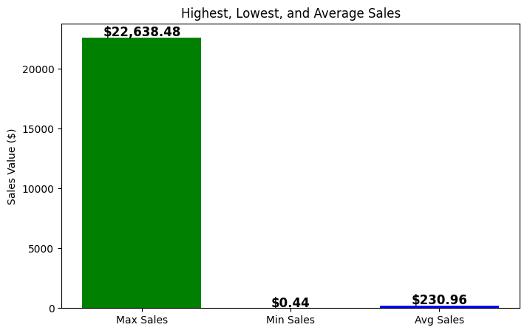

**Descriptive Data & Insights Extraction(What Happened)**

refers to data that summarizes or describes the main features of a dataset. It helps us understand what has happened by providing simple summaries about the sample and measures

Key Performance Indicators (KPIs)

1. Total Sales

total_sales = df['sales'].sum()   
print(f"Total Sales: ${total_sales:,.2f}")

Total Sales: $2,261,536.78

1. Average Sales

average_sales = df['sales'].mean()   
print(f"Average Sales: ${average_sales:,.2f}")

Average Sales: $230.79

1. Top-Selling Products

top_products = df.groupby('product_name')   
['sales'].sum().sort_values(ascending=False).head(10) print("Top 10 Products by Sales:")   
print(top_products)

Top 10 Products by Sales:   
product_name   
canon_imageclass_2200_advanced_copier  
61599.824   
fellowes_pb500_electric_punch_plastic_comb_binding_machine_with_manual _bind 27453.384   
cisco_telepresence_system_ex90_videoconferencing_unit  
22638.480   
hon_5400_series_task_chairs_for_big_and_tall  
21870.576   
gbc_docubind_tl300_electric_binding_system  
19823.479   
gbc_ibimaster_500_manual_proclick_binding_system  
19024.500   
hewlett_packard_laserjet_3310_copier  
18839.686   
hp_designjet_t520_inkjet_large_format_printer_-_24"_color  
18374.895   
gbc_docubind_p400_electric_binding_system  
17965.068   
high_speed_automatic_electric_letter_opener  
17030.312   
Name: sales, dtype: float64

1. Regional Sales Breakdown

|  |
| --- |
| region_sales = df.groupby('region')  ['sales'].sum().sort_values(ascending=False) print("Sales by Region:")  print(region_sales)  Sales by Region:  region  west 710219.6845  east 669518.7260  central 492646.9132  south 389151.4590  Name: sales, dtype: float64 |

1. Customer Segment Analysis

|  |
| --- |
| segment_sales = df.groupby('segment')  ['sales'].sum().sort_values(ascending=False) print("Sales by Customer Segment:")  print(segment_sales)  Sales by Customer Segment:  segment  consumer 1.148061e+06  corporate 6.884941e+05  home_office 4.249822e+05  Name: sales, dtype: float64 |

|  |
| --- |
| *# Ensure 'order_date' is in datetime format*  df['order_date'] = pd.to_datetime(df['order_date'])  *# Extract year and month*  df['order_year'] = df['order_date'].dt.year df['order_month'] = df['order_date'].dt.month  *# Monthly sales trend*  monthly_sales = df.groupby(['order_year', 'order_month']) ['sales'].sum().reset_index()  print(monthly_sales)  *# Visualize monthly sales trend*  import plotly.express as px  fig = px.line(monthly_sales, x='order_month', y='sales', color='order_year', title="Monthly Sales Trend")  fig.show() |

2. Trend Analysis

2.1. Sales Over Time

|  |
| --- |
| order_year order_month sales 0 2015 1 14205.7070 1 2015 2 4519.8920 2 2015 3 55205.7970 3 2015 4 27906.8550 4 2015 5 23644.3030 5 2015 6 34322.9356 6 2015 7 33781.5430 7 2015 8 27117.5365 8 2015 9 81623.5268 9 2015 10 31453.3930 10 2015 11 77907.6607 11 2015 12 68167.0585 12 2016 1 18066.9576 13 2016 2 11951.4110 14 2016 3 32339.3184 15 2016 4 34154.4685 16 2016 5 29959.5305 17 2016 6 23599.3740 18 2016 7 28608.2590 19 2016 8 36818.3422 20 2016 9 63133.6060 21 2016 10 31011.7375 22 2016 11 75249.3995 23 2016 12 74543.6012 24 2017 1 18542.4910 25 2017 2 22978.8150 26 2017 3 51165.0590 27 2017 4 38679.7670 28 2017 5 56656.9080 29 2017 6 39724.4860 30 2017 7 38320.7830 31 2017 8 30542.2003 32 2017 9 69193.3909 33 2017 10 59583.0330 34 2017 11 79066.4958 35 2017 12 95739.1210 36 2018 1 43476.4740 37 2018 2 19920.9974 38 2018 3 58863.4128 39 2018 4 35541.9101 40 2018 5 43825.9822 41 2018 6 48190.7277 42 2018 7 44825.1040 43 2018 8 62837.8480 44 2018 9 86152.8880 45 2018 10 77448.1312 46 2018 11 117938.1550 47 2018 12 83030.3888 |

|  |
| --- |
| {"config":{"plotlyServerURL":"https://plot.ly"},"data":  [{"hovertemplate":"order_year=2015<br>order_month=%{x}<br>sales=% {y}<extra></extra>","legendgroup":"2015","line":  {"color":"#636efa","dash":"solid"},"marker":  {"symbol":"circle"},"mode":"lines","name":"2015","orientation":"v","sh owlegend":true,"type":"scatter","x":  [1,2,3,4,5,6,7,8,9,10,11,12],"xaxis":"x","y":  [14205.707,4519.892,55205.797,27906.855,23644.303,34322.9356,33781.543 ,27117.5365,81623.5268,31453.393,77907.66070000001,68167.0585],"yaxis" :"y"},{"hovertemplate":"order_year=2016<br>order_month=%{x}<br>sales=% {y}<extra></extra>","legendgroup":"2016","line":  {"color":"#EF553B","dash":"solid"},"marker":  {"symbol":"circle"},"mode":"lines","name":"2016","orientation":"v","sh owlegend":true,"type":"scatter","x":  [1,2,3,4,5,6,7,8,9,10,11,12],"xaxis":"x","y":  [18066.9576,11951.411,32339.3184,34154.4685,29959.5305,23599.374,28608 .259000000002,36818.3422,63133.606,31011.7375,75249.3995,74543.6012]," yaxis":"y"},{"hovertemplate":"order_year=2017<br>order_month=%  {x}<br>sales=%{y}<extra></extra>","legendgroup":"2017","line":  {"color":"#00cc96","dash":"solid"},"marker":  {"symbol":"circle"},"mode":"lines","name":"2017","orientation":"v","sh owlegend":true,"type":"scatter","x":  [1,2,3,4,5,6,7,8,9,10,11,12],"xaxis":"x","y":  [18542.490999999998,22978.815,51165.059,38679.767,56656.908,39724.486, 38320.783,30542.2003,69193.3909,59583.033,79066.4958,95739.121],"yaxis ":"y"},{"hovertemplate":"order_year=2018<br>order_month=%{x}<br>sales= %{y}<extra></extra>","legendgroup":"2018","line":  {"color":"#ab63fa","dash":"solid"},"marker":  {"symbol":"circle"},"mode":"lines","name":"2018","orientation":"v","sh owlegend":true,"type":"scatter","x":  [1,2,3,4,5,6,7,8,9,10,11,12],"xaxis":"x","y":  [43476.474,19920.9974,58863.4128,35541.9101,43825.9822,48190.7277,4482 5.104,62837.848,86152.888,77448.1312,117938.155,83030.3888],"yaxis":"y "}],"layout":{"autosize":true,"legend":{"title":  {"text":"order_year"},"tracegroupgap":0},"template":{"data":{"bar": [{"error_x":{"color":"#2a3f5f"},"error_y":  {"color":"#2a3f5f"},"marker":{"line":  {"color":"#E5ECF6","width":0.5},"pattern":  {"fillmode":"overlay","size":10,"solidity":0.2}},"type":"bar"}],"barpo lar":[{"marker":{"line":{"color":"#E5ECF6","width":0.5},"pattern": {"fillmode":"overlay","size":10,"solidity":0.2}},"type":"barpolar"}]," carpet":[{"aaxis":  {"endlinecolor":"#2a3f5f","gridcolor":"white","linecolor":"white","min orgridcolor":"white","startlinecolor":"#2a3f5f"},"baxis":  {"endlinecolor":"#2a3f5f","gridcolor":"white","linecolor":"white","min orgridcolor":"white","startlinecolor":"#2a3f5f"},"type":"carpet"}],"ch oropleth":[{"colorbar":  {"outlinewidth":0,"ticks":""},"type":"choropleth"}],"contour":  [{"colorbar":{"outlinewidth":0,"ticks":""},"colorscale":  [[0,"#0d0887"],[0.1111111111111111,"#46039f"], |

|  |
| --- |
| [0.2222222222222222,"#7201a8"],[0.3333333333333333,"#9c179e"],  [0.4444444444444444,"#bd3786"],[0.5555555555555556,"#d8576b"],  [0.6666666666666666,"#ed7953"],[0.7777777777777778,"#fb9f3a"],  [0.8888888888888888,"#fdca26"],  [1,"#f0f921"]],"type":"contour"}],"contourcarpet":[{"colorbar": {"outlinewidth":0,"ticks":""},"type":"contourcarpet"}],"heatmap": [{"colorbar":{"outlinewidth":0,"ticks":""},"colorscale":  [[0,"#0d0887"],[0.1111111111111111,"#46039f"],  [0.2222222222222222,"#7201a8"],[0.3333333333333333,"#9c179e"],  [0.4444444444444444,"#bd3786"],[0.5555555555555556,"#d8576b"],  [0.6666666666666666,"#ed7953"],[0.7777777777777778,"#fb9f3a"],  [0.8888888888888888,"#fdca26"],  [1,"#f0f921"]],"type":"heatmap"}],"heatmapgl":[{"colorbar":  {"outlinewidth":0,"ticks":""},"colorscale":[[0,"#0d0887"],  [0.1111111111111111,"#46039f"],[0.2222222222222222,"#7201a8"],  [0.3333333333333333,"#9c179e"],[0.4444444444444444,"#bd3786"],  [0.5555555555555556,"#d8576b"],[0.6666666666666666,"#ed7953"],  [0.7777777777777778,"#fb9f3a"],[0.8888888888888888,"#fdca26"],  [1,"#f0f921"]],"type":"heatmapgl"}],"histogram":[{"marker":{"pattern": {"fillmode":"overlay","size":10,"solidity":0.2}},"type":"histogram"}], "histogram2d":[{"colorbar":{"outlinewidth":0,"ticks":""},"colorscale": [[0,"#0d0887"],[0.1111111111111111,"#46039f"],  [0.2222222222222222,"#7201a8"],[0.3333333333333333,"#9c179e"],  [0.4444444444444444,"#bd3786"],[0.5555555555555556,"#d8576b"],  [0.6666666666666666,"#ed7953"],[0.7777777777777778,"#fb9f3a"],  [0.8888888888888888,"#fdca26"],  [1,"#f0f921"]],"type":"histogram2d"}],"histogram2dcontour":  [{"colorbar":{"outlinewidth":0,"ticks":""},"colorscale":  [[0,"#0d0887"],[0.1111111111111111,"#46039f"],  [0.2222222222222222,"#7201a8"],[0.3333333333333333,"#9c179e"],  [0.4444444444444444,"#bd3786"],[0.5555555555555556,"#d8576b"],  [0.6666666666666666,"#ed7953"],[0.7777777777777778,"#fb9f3a"],  [0.8888888888888888,"#fdca26"],  [1,"#f0f921"]],"type":"histogram2dcontour"}],"mesh3d":[{"colorbar": {"outlinewidth":0,"ticks":""},"type":"mesh3d"}],"parcoords":[{"line": {"colorbar":{"outlinewidth":0,"ticks":""}},"type":"parcoords"}],"pie": [{"automargin":true,"type":"pie"}],"scatter":[{"fillpattern":  {"fillmode":"overlay","size":10,"solidity":0.2},"type":"scatter"}],"sc atter3d":[{"line":{"colorbar":{"outlinewidth":0,"ticks":""}},"marker": {"colorbar":  {"outlinewidth":0,"ticks":""}},"type":"scatter3d"}],"scattercarpet": [{"marker":{"colorbar":  {"outlinewidth":0,"ticks":""}},"type":"scattercarpet"}],"scattergeo": [{"marker":{"colorbar":  {"outlinewidth":0,"ticks":""}},"type":"scattergeo"}],"scattergl": [{"marker":{"colorbar":  {"outlinewidth":0,"ticks":""}},"type":"scattergl"}],"scattermapbox": [{"marker":{"colorbar":  {"outlinewidth":0,"ticks":""}},"type":"scattermapbox"}],"scatterpolar" :[{"marker":{"colorbar": |

|  |
| --- |
| {"outlinewidth":0,"ticks":""}},"type":"scatterpolar"}],"scatterpolargl ":[{"marker":{"colorbar":  {"outlinewidth":0,"ticks":""}},"type":"scatterpolargl"}],"scatterterna ry":[{"marker":{"colorbar":  {"outlinewidth":0,"ticks":""}},"type":"scatterternary"}],"surface": [{"colorbar":{"outlinewidth":0,"ticks":""},"colorscale":  [[0,"#0d0887"],[0.1111111111111111,"#46039f"],  [0.2222222222222222,"#7201a8"],[0.3333333333333333,"#9c179e"],  [0.4444444444444444,"#bd3786"],[0.5555555555555556,"#d8576b"],  [0.6666666666666666,"#ed7953"],[0.7777777777777778,"#fb9f3a"],  [0.8888888888888888,"#fdca26"],  [1,"#f0f921"]],"type":"surface"}],"table":[{"cells":{"fill":  {"color":"#EBF0F8"},"line":{"color":"white"}},"header":{"fill":  {"color":"#C8D4E3"},"line":  {"color":"white"}},"type":"table"}]},"layout":{"annotationdefaults": {"arrowcolor":"#2a3f5f","arrowhead":0,"arrowwidth":1},"autotypenumbers ":"strict","coloraxis":{"colorbar":  {"outlinewidth":0,"ticks":""}},"colorscale":{"diverging":  [[0,"#8e0152"],[0.1,"#c51b7d"],[0.2,"#de77ae"],[0.3,"#f1b6da"], [0.4,"#fde0ef"],[0.5,"#f7f7f7"],[0.6,"#e6f5d0"],[0.7,"#b8e186"], [0.8,"#7fbc41"],[0.9,"#4d9221"],[1,"#276419"]],"sequential":  [[0,"#0d0887"],[0.1111111111111111,"#46039f"],  [0.2222222222222222,"#7201a8"],[0.3333333333333333,"#9c179e"],  [0.4444444444444444,"#bd3786"],[0.5555555555555556,"#d8576b"],  [0.6666666666666666,"#ed7953"],[0.7777777777777778,"#fb9f3a"],  [0.8888888888888888,"#fdca26"],[1,"#f0f921"]],"sequentialminus": [[0,"#0d0887"],[0.1111111111111111,"#46039f"],  [0.2222222222222222,"#7201a8"],[0.3333333333333333,"#9c179e"],  [0.4444444444444444,"#bd3786"],[0.5555555555555556,"#d8576b"],  [0.6666666666666666,"#ed7953"],[0.7777777777777778,"#fb9f3a"],  [0.8888888888888888,"#fdca26"],[1,"#f0f921"]]},"colorway":  ["#636efa","#EF553B","#00cc96","#ab63fa","#FFA15A","#19d3f3","#FF6692" ,"#B6E880","#FF97FF","#FECB52"],"font":{"color":"#2a3f5f"},"geo": {"bgcolor":"white","lakecolor":"white","landcolor":"#E5ECF6","showlake s":true,"showland":true,"subunitcolor":"white"},"hoverlabel":  {"align":"left"},"hovermode":"closest","mapbox":  {"style":"light"},"paper_bgcolor":"white","plot_bgcolor":"#E5ECF6","po lar":{"angularaxis":  {"gridcolor":"white","linecolor":"white","ticks":""},"bgcolor":"#E5ECF 6","radialaxis":  {"gridcolor":"white","linecolor":"white","ticks":""}},"scene":  {"xaxis":  {"backgroundcolor":"#E5ECF6","gridcolor":"white","gridwidth":2,"lineco lor":"white","showbackground":true,"ticks":"","zerolinecolor":"white"} ,"yaxis":  {"backgroundcolor":"#E5ECF6","gridcolor":"white","gridwidth":2,"lineco lor":"white","showbackground":true,"ticks":"","zerolinecolor":"white"} ,"zaxis":  {"backgroundcolor":"#E5ECF6","gridcolor":"white","gridwidth":2,"lineco lor":"white","showbackground":true,"ticks":"","zerolinecolor":"white"} |

2.2. Product Category Trends

|  |
| --- |
| },"shapedefaults":{"line":{"color":"#2a3f5f"}},"ternary":{"aaxis": {"gridcolor":"white","linecolor":"white","ticks":""},"baxis":  {"gridcolor":"white","linecolor":"white","ticks":""},"bgcolor":"#E5ECF 6","caxis":  {"gridcolor":"white","linecolor":"white","ticks":""}},"title":  {"x":5.0e-2},"xaxis":  {"automargin":true,"gridcolor":"white","linecolor":"white","ticks":"", "title":  {"standoff":15},"zerolinecolor":"white","zerolinewidth":2},"yaxis": {"automargin":true,"gridcolor":"white","linecolor":"white","ticks":"", "title":  {"standoff":15},"zerolinecolor":"white","zerolinewidth":2}}},"title": {"text":"Monthly Sales Trend"},"xaxis":  {"anchor":"y","autorange":true,"domain":[0,1],"range":[1,12],"title": {"text":"order_month"},"type":"linear"},"yaxis":  {"anchor":"x","autorange":true,"domain":[0,1],"range":[- 1781.1226111111118,124239.16961111111],"title":  {"text":"sales"},"type":"linear"}}} |

|  |  |
| --- | --- |
| category_trends = df.groupby(['category', 'order_year']) ['sales'].sum().reset_index()  print(category_trends)  *# Visualize category trends*  fig = px.bar(category_trends, x='order_year', y='sales', color='category', title="Sales Trends by Category")  fig.show()   |  | | --- | | category order_year sales 0 Furniture 2015 156477.8811 1 Furniture 2016 164053.8674 2 Furniture 2017 195813.0400 3 Furniture 2018 212313.7872 4 Office Supplies 2015 149512.8200 5 Office Supplies 2016 133124.4070 6 Office Supplies 2017 182417.5660 7 Office Supplies 2018 240367.5410 8 Technology 2015 173865.5070 9 Technology 2016 162257.7310 10 Technology 2017 221961.9440 11 Technology 2018 269370.6910 |   C:\Users\Aboelyazzed\AppData\Local\Temp\ipykernel_7360\843351102.py:1:FutureWarning:  The default of observed=False is deprecated and will be changed toTrue in a future version of pandas. Pass observed=False to retain current behavior or observed=True to adopt the future default and |

silence this warning.

{"config":{"plotlyServerURL":"https://plot.ly"},"data":   
[{"alignmentgroup":"True","hovertemplate":"category=Furniture<br>order _year=%{x}<br>sales=%{y}<extra></   
extra>","legendgroup":"Furniture","marker":   
{"color":"#636efa","pattern":   
{"shape":""}},"name":"Furniture","offsetgroup":"Furniture","orientatio n":"v","showlegend":true,"textposition":"auto","type":"bar","x": [2015,2016,2017,2018],"xaxis":"x","y":   
[156477.8811,164053.8674,195813.04,212313.7872],"yaxis":"y"},   
{"alignmentgroup":"True","hovertemplate":"category=Office   
Supplies<br>order_year=%{x}<br>sales=%{y}<extra></extra>","legendgroup ":"Office Supplies","marker":{"color":"#EF553B","pattern":   
{"shape":""}},"name":"Office Supplies","offsetgroup":"Office   
Supplies","orientation":"v","showlegend":true,"textposition":"auto","t ype":"bar","x":[2015,2016,2017,2018],"xaxis":"x","y":   
[149512.82,133124.407,182417.566,240367.541],"yaxis":"y"},   
{"alignmentgroup":"True","hovertemplate":"category=Technology<br>order _year=%{x}<br>sales=%{y}<extra></   
extra>","legendgroup":"Technology","marker":   
{"color":"#00cc96","pattern":   
{"shape":""}},"name":"Technology","offsetgroup":"Technology","orientat ion":"v","showlegend":true,"textposition":"auto","type":"bar","x": [2015,2016,2017,2018],"xaxis":"x","y":   
[173865.507,162257.731,221961.94400000002,269370.691],"yaxis":"y"}],"l ayout":{"autosize":true,"barmode":"relative","legend":{"title":   
{"text":"category"},"tracegroupgap":0},"template":{"data":{"bar": [{"error_x":{"color":"#2a3f5f"},"error_y":   
{"color":"#2a3f5f"},"marker":{"line":   
{"color":"#E5ECF6","width":0.5},"pattern":   
{"fillmode":"overlay","size":10,"solidity":0.2}},"type":"bar"}],"barpo lar":[{"marker":{"line":{"color":"#E5ECF6","width":0.5},"pattern": {"fillmode":"overlay","size":10,"solidity":0.2}},"type":"barpolar"}]," carpet":[{"aaxis":   
{"endlinecolor":"#2a3f5f","gridcolor":"white","linecolor":"white","min orgridcolor":"white","startlinecolor":"#2a3f5f"},"baxis":   
{"endlinecolor":"#2a3f5f","gridcolor":"white","linecolor":"white","min orgridcolor":"white","startlinecolor":"#2a3f5f"},"type":"carpet"}],"ch oropleth":[{"colorbar":   
{"outlinewidth":0,"ticks":""},"type":"choropleth"}],"contour":   
[{"colorbar":{"outlinewidth":0,"ticks":""},"colorscale":   
[[0,"#0d0887"],[0.1111111111111111,"#46039f"],   
[0.2222222222222222,"#7201a8"],[0.3333333333333333,"#9c179e"],   
[0.4444444444444444,"#bd3786"],[0.5555555555555556,"#d8576b"],   
[0.6666666666666666,"#ed7953"],[0.7777777777777778,"#fb9f3a"],   
[0.8888888888888888,"#fdca26"],   
[1,"#f0f921"]],"type":"contour"}],"contourcarpet":[{"colorbar": {"outlinewidth":0,"ticks":""},"type":"contourcarpet"}],"heatmap":

|  |
| --- |
| [{"colorbar":{"outlinewidth":0,"ticks":""},"colorscale":  [[0,"#0d0887"],[0.1111111111111111,"#46039f"],  [0.2222222222222222,"#7201a8"],[0.3333333333333333,"#9c179e"],  [0.4444444444444444,"#bd3786"],[0.5555555555555556,"#d8576b"],  [0.6666666666666666,"#ed7953"],[0.7777777777777778,"#fb9f3a"],  [0.8888888888888888,"#fdca26"],  [1,"#f0f921"]],"type":"heatmap"}],"heatmapgl":[{"colorbar":  {"outlinewidth":0,"ticks":""},"colorscale":[[0,"#0d0887"],  [0.1111111111111111,"#46039f"],[0.2222222222222222,"#7201a8"],  [0.3333333333333333,"#9c179e"],[0.4444444444444444,"#bd3786"],  [0.5555555555555556,"#d8576b"],[0.6666666666666666,"#ed7953"],  [0.7777777777777778,"#fb9f3a"],[0.8888888888888888,"#fdca26"],  [1,"#f0f921"]],"type":"heatmapgl"}],"histogram":[{"marker":{"pattern": {"fillmode":"overlay","size":10,"solidity":0.2}},"type":"histogram"}], "histogram2d":[{"colorbar":{"outlinewidth":0,"ticks":""},"colorscale": [[0,"#0d0887"],[0.1111111111111111,"#46039f"],  [0.2222222222222222,"#7201a8"],[0.3333333333333333,"#9c179e"],  [0.4444444444444444,"#bd3786"],[0.5555555555555556,"#d8576b"],  [0.6666666666666666,"#ed7953"],[0.7777777777777778,"#fb9f3a"],  [0.8888888888888888,"#fdca26"],  [1,"#f0f921"]],"type":"histogram2d"}],"histogram2dcontour":  [{"colorbar":{"outlinewidth":0,"ticks":""},"colorscale":  [[0,"#0d0887"],[0.1111111111111111,"#46039f"],  [0.2222222222222222,"#7201a8"],[0.3333333333333333,"#9c179e"],  [0.4444444444444444,"#bd3786"],[0.5555555555555556,"#d8576b"],  [0.6666666666666666,"#ed7953"],[0.7777777777777778,"#fb9f3a"],  [0.8888888888888888,"#fdca26"],  [1,"#f0f921"]],"type":"histogram2dcontour"}],"mesh3d":[{"colorbar": {"outlinewidth":0,"ticks":""},"type":"mesh3d"}],"parcoords":[{"line": {"colorbar":{"outlinewidth":0,"ticks":""}},"type":"parcoords"}],"pie": [{"automargin":true,"type":"pie"}],"scatter":[{"fillpattern":  {"fillmode":"overlay","size":10,"solidity":0.2},"type":"scatter"}],"sc atter3d":[{"line":{"colorbar":{"outlinewidth":0,"ticks":""}},"marker": {"colorbar":  {"outlinewidth":0,"ticks":""}},"type":"scatter3d"}],"scattercarpet": [{"marker":{"colorbar":  {"outlinewidth":0,"ticks":""}},"type":"scattercarpet"}],"scattergeo": [{"marker":{"colorbar":  {"outlinewidth":0,"ticks":""}},"type":"scattergeo"}],"scattergl": [{"marker":{"colorbar":  {"outlinewidth":0,"ticks":""}},"type":"scattergl"}],"scattermapbox": [{"marker":{"colorbar":  {"outlinewidth":0,"ticks":""}},"type":"scattermapbox"}],"scatterpolar" :[{"marker":{"colorbar":  {"outlinewidth":0,"ticks":""}},"type":"scatterpolar"}],"scatterpolargl ":[{"marker":{"colorbar":  {"outlinewidth":0,"ticks":""}},"type":"scatterpolargl"}],"scatterterna ry":[{"marker":{"colorbar":  {"outlinewidth":0,"ticks":""}},"type":"scatterternary"}],"surface": |

|  |
| --- |
| [{"colorbar":{"outlinewidth":0,"ticks":""},"colorscale":  [[0,"#0d0887"],[0.1111111111111111,"#46039f"],  [0.2222222222222222,"#7201a8"],[0.3333333333333333,"#9c179e"],  [0.4444444444444444,"#bd3786"],[0.5555555555555556,"#d8576b"],  [0.6666666666666666,"#ed7953"],[0.7777777777777778,"#fb9f3a"],  [0.8888888888888888,"#fdca26"],  [1,"#f0f921"]],"type":"surface"}],"table":[{"cells":{"fill":  {"color":"#EBF0F8"},"line":{"color":"white"}},"header":{"fill":  {"color":"#C8D4E3"},"line":  {"color":"white"}},"type":"table"}]},"layout":{"annotationdefaults": {"arrowcolor":"#2a3f5f","arrowhead":0,"arrowwidth":1},"autotypenumbers ":"strict","coloraxis":{"colorbar":  {"outlinewidth":0,"ticks":""}},"colorscale":{"diverging":  [[0,"#8e0152"],[0.1,"#c51b7d"],[0.2,"#de77ae"],[0.3,"#f1b6da"], [0.4,"#fde0ef"],[0.5,"#f7f7f7"],[0.6,"#e6f5d0"],[0.7,"#b8e186"], [0.8,"#7fbc41"],[0.9,"#4d9221"],[1,"#276419"]],"sequential":  [[0,"#0d0887"],[0.1111111111111111,"#46039f"],  [0.2222222222222222,"#7201a8"],[0.3333333333333333,"#9c179e"],  [0.4444444444444444,"#bd3786"],[0.5555555555555556,"#d8576b"],  [0.6666666666666666,"#ed7953"],[0.7777777777777778,"#fb9f3a"],  [0.8888888888888888,"#fdca26"],[1,"#f0f921"]],"sequentialminus": [[0,"#0d0887"],[0.1111111111111111,"#46039f"],  [0.2222222222222222,"#7201a8"],[0.3333333333333333,"#9c179e"],  [0.4444444444444444,"#bd3786"],[0.5555555555555556,"#d8576b"],  [0.6666666666666666,"#ed7953"],[0.7777777777777778,"#fb9f3a"],  [0.8888888888888888,"#fdca26"],[1,"#f0f921"]]},"colorway":  ["#636efa","#EF553B","#00cc96","#ab63fa","#FFA15A","#19d3f3","#FF6692" ,"#B6E880","#FF97FF","#FECB52"],"font":{"color":"#2a3f5f"},"geo": {"bgcolor":"white","lakecolor":"white","landcolor":"#E5ECF6","showlake s":true,"showland":true,"subunitcolor":"white"},"hoverlabel":  {"align":"left"},"hovermode":"closest","mapbox":  {"style":"light"},"paper_bgcolor":"white","plot_bgcolor":"#E5ECF6","po lar":{"angularaxis":  {"gridcolor":"white","linecolor":"white","ticks":""},"bgcolor":"#E5ECF 6","radialaxis":  {"gridcolor":"white","linecolor":"white","ticks":""}},"scene":  {"xaxis":  {"backgroundcolor":"#E5ECF6","gridcolor":"white","gridwidth":2,"lineco lor":"white","showbackground":true,"ticks":"","zerolinecolor":"white"} ,"yaxis":  {"backgroundcolor":"#E5ECF6","gridcolor":"white","gridwidth":2,"lineco lor":"white","showbackground":true,"ticks":"","zerolinecolor":"white"} ,"zaxis":  {"backgroundcolor":"#E5ECF6","gridcolor":"white","gridwidth":2,"lineco lor":"white","showbackground":true,"ticks":"","zerolinecolor":"white"} },"shapedefaults":{"line":{"color":"#2a3f5f"}},"ternary":{"aaxis": {"  gridcolor":"white","linecolor":"white","ticks":""},"baxis":  {"gridcolor":"white","linecolor":"white","ticks":""},"bgcolor":"#E5ECF 6","caxis": |

|  |
| --- |
| {"gridcolor":"white","linecolor":"white","ticks":""}},"title":  {"x":5.0e-2},"xaxis":  {"automargin":true,"gridcolor":"white","linecolor":"white","ticks":"", "title":  {"standoff":15},"zerolinecolor":"white","zerolinewidth":2},"yaxis": {"automargin":true,"gridcolor":"white","linecolor":"white","ticks":"", "title":  {"standoff":15},"zerolinecolor":"white","zerolinewidth":2}}},"title": {"text":"Sales Trends by Category"},"xaxis":  {"anchor":"y","autorange":true,"domain":[0,1],"range":  [2014.5,2018.5],"title":  {"text":"order_year"},"type":"linear"},"yaxis":  {"anchor":"x","autorange":true,"domain":[0,1],"range":  [0,760054.7570526316],"title":{"text":"sales"},"type":"linear"}}} |

* 1. Statistical Analysis
     1. Correlation Matrix

|  |  |
| --- | --- |
| numeric_columns = ['sales', 'shipping_time_days', 'postal_code'] if'profit'in df.columns:  numeric_columns.append('profit')  if'quantity'in df.columns:  numeric_columns.append('quantity')  corr_matrix = df[numeric_columns].corr() print(corr_matrix)   |  | | --- | | sales shipping_time_days postal_code sales 1.000000 -0.005711 -0.025615 shipping_time_days -0.005711 1.000000 -0.009376 postal_code -0.025615 -0.009376 1.000000 | |

|  |
| --- |
| from scipy.stats import f_oneway  *# Perform ANOVA test*  regions = df['region'].unique()  sales_by_region = [df[df['region'] == region]['sales'] for region in regions]  f_stat, p_value = f_oneway(*sales_by_region)  print(f"F-statistic: {f_stat}, p-value: {p_value}")  if p_value < 0.05:   print("There is a significant difference in sales between regions.")  else:   print("No significant difference in sales between regions.") |

5.3.2. Hypothesis Testing

|  |
| --- |
| F-statistic: 0.9011821229386157, p-value: 0.4396648653568087 No significant difference in sales between regions. |

5.4. Outlier Analysis   
5.4.1. Identify High-Value Transactions

|  |
| --- |
| high_value_sales = df[df['sales'] > df['sales'].quantile(0.99)] print("High-Value Transactions:")  print(high_value_sales[['product_name', 'sales', 'region']])  High-Value Transactions:  product_name sales region  27 riverside_palais_royal_lawyers_bookcase,_royal... 3083.430east  165 lexmark_mx611dhe_monochrome_laser_printer 8159.952central  251 logitech_p710e_mobile_speakerphone 3347.370west  262 lexmark_mx611dhe_monochrome_laser_printer 3059.982central  263 xerox_workcentre_6505dn_laser_multifunction_pr... 2519.958central  ... ... ......  9423 hon_5400_series_task_chairs_for_big_and_tall 3785.292east  9637 chromcraft_bull-nose_wood_oval_conference_tabl... 4297.644south  9647 dmi_eclipse_executive_suite_bookcases 3406.664west  9658 samsung_galaxy_mega_6.3 3023.928west  9739 riverside_palais_royal_lawyers_bookcase,_royal... 4404.900east  [98 rows x 3 columns] |

5.4.2. Analyze Shipping Times

|  |
| --- |
| shipping_time_analysis = df.groupby('shipping_time_days') ['sales'].mean().reset_index()  print(shipping_time_analysis)  *# Visualize relationship*  plt.figure(figsize=(10, 6))  sns.scatterplot(x='shipping_time_days', y='sales', data=df, alpha=0.5) plt.title("Sales vs. Shipping Time") |

|  |  |
| --- | --- |
| plt.xlabel("Shipping Time (Days)")  plt.ylabel("Sales")  plt.show()   |  | | --- | | shipping_time_days sales 0 0 236.894173 1 1 183.746874 2 2 277.107123 3 3 205.097288 4 4 228.759576 5 5 229.254844 6 6 201.461437 7 7 266.950228 | |

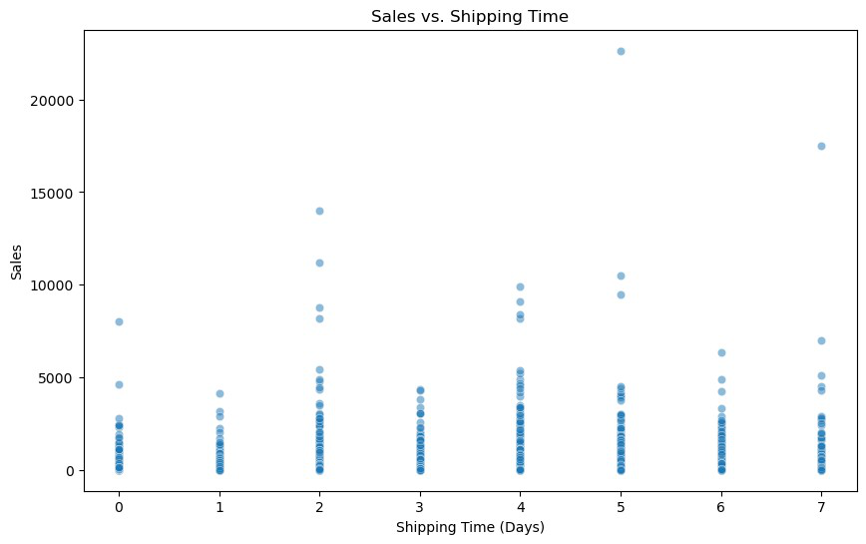

* 1. Geographic Insights

5.5.1. Sales by State

|  |
| --- |
| state_sales = df.groupby('state')  ['sales'].sum().sort_values(ascending=False) print("Sales by State:")  print(state_sales)  *# Visualize using a choropleth map*  fig = px.choropleth(state_sales.reset_index(), |

|  |  |
| --- | --- |
| fig.show() | locations='state',  locationmode='USA-states',  color='sales',  scope="usa",  title='Sales Distribution by State (USA)') |

|  |
| --- |
| Sales by State:  state  CA 446306.4635 NY 306361.1470 TX 168572.5322 WA 135206.8500 PA 116276.6500 FL 88436.5320 IL 79236.5170 MI 76136.0740 OH 75130.3500 VA 70636.7200 NC 55165.9640 IN 48718.4000 GA 48219.1100 KY 36458.3900 AZ 35272.6570 NJ 34610.9720 CO 31841.5980 WI 31173.4300 TN 30661.8730 MN 29863.1500 MA 28634.4340 DE 27322.9990 MD 23705.5230 RI 22525.0260 MO 22205.1500 OK 19683.3900 AL 19510.6400 OR 17284.4620 NV 16729.1020 CT 13384.3570 AR 11678.1300 UT 11220.0560 MS 10771.3400 LA 9131.0500 VT 8929.3700 SC 8481.7100 NE 7464.9300 NH 7292.5240 MT 5589.3520 NM 4783.5220 IA 4443.5600 |

|  |
| --- |
| ID 4382.4860  KS 2914.3100  DC 2865.0200  WY 1603.1360  SD 1315.5600  ME 1270.5300  WV 1209.8240  ND 919.9100  Name: sales, dtype: float64  {"config":{"plotlyServerURL":"https://plot.ly"},"data":  [{"coloraxis":"coloraxis","geo":"geo","hovertemplate":"state=%  {location}<br>sales=%{z}<extra></extra>","locationmode":"USA- states","locations":  ["CA","NY","TX","WA","PA","FL","IL","MI","OH","VA","NC","IN","GA","KY" ,"AZ","NJ","CO","WI","TN","MN","MA","DE","MD","RI","MO","OK","AL","OR" ,"NV","CT","AR","UT","MS","LA","VT","SC","NE","NH","MT","NM","IA","ID" ,"KS","DC","WY","SD","ME","WV","ND"],"name":"","type":"choropleth","z" :  [446306.4635,306361.147,168572.5322,135206.85,116276.65,88436.532,7923 6.517,76136.074,75130.35,70636.72,55165.964,48718.4,48219.11,36458.39, 35272.657,34610.972,31841.597999999998,31173.43,30661.873,29863.15,286 34.434,27322.999,23705.523,22525.026,22205.15,19683.39,19510.64,17284. 462,16729.102,13384.357,11678.13,11220.056,10771.34,9131.05,8929.36999 9999999,8481.71,7464.93,7292.524,5589.352,4783.522,4443.56,4382.486,29 14.31,2865.02,1603.136,1315.56,1270.53,1209.824,919.91]}],"layout": {"autosize":true,"coloraxis":{"colorbar":{"title":  {"text":"sales"}},"colorscale":[[0,"#0d0887"],  [0.1111111111111111,"#46039f"],[0.2222222222222222,"#7201a8"],  [0.3333333333333333,"#9c179e"],[0.4444444444444444,"#bd3786"],  [0.5555555555555556,"#d8576b"],[0.6666666666666666,"#ed7953"],  [0.7777777777777778,"#fb9f3a"],[0.8888888888888888,"#fdca26"],  [1,"#f0f921"]]},"geo":{"center":{"lat":74.42757131926979,"lon":-138.27891032690619},"domain":{"x":[0,1],"y":[0,1]},"projection": {"scale":0.4358791197685311},"scope":"usa"},"legend":  {"tracegroupgap":0},"template":{"data":{"bar":[{"error_x":  {"color":"#2a3f5f"},"error_y":{"color":"#2a3f5f"},"marker":{"line": {"color":"#E5ECF6","width":0.5},"pattern":  {"fillmode":"overlay","size":10,"solidity":0.2}},"type":"bar"}],"barpo lar":[{"marker":{"line":{"color":"#E5ECF6","width":0.5},"pattern": {"fillmode":"overlay","size":10,"solidity":0.2}},"type":"barpolar"}]," carpet":[{"aaxis":  {"endlinecolor":"#2a3f5f","gridcolor":"white","linecolor":"white","min orgridcolor":"white","startlinecolor":"#2a3f5f"},"baxis":  {"endlinecolor":"#2a3f5f","gridcolor":"white","linecolor":"white","min orgridcolor":"white","startlinecolor":"#2a3f5f"},"type":"carpet"}],"ch oropleth":[{"colorbar":  {"outlinewidth":0,"ticks":""},"type":"choropleth"}],"contour":  [{"colorbar":{"outlinewidth":0,"ticks":""},"colorscale":  [[0,"#0d0887"],[0.1111111111111111,"#46039f"], |

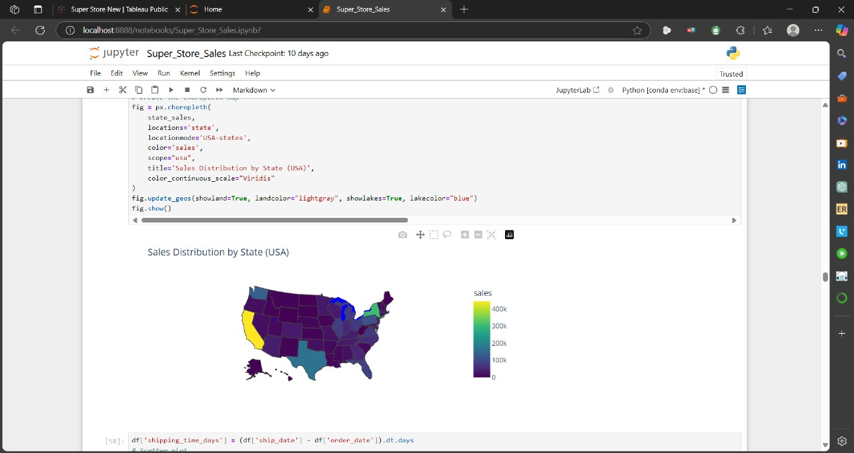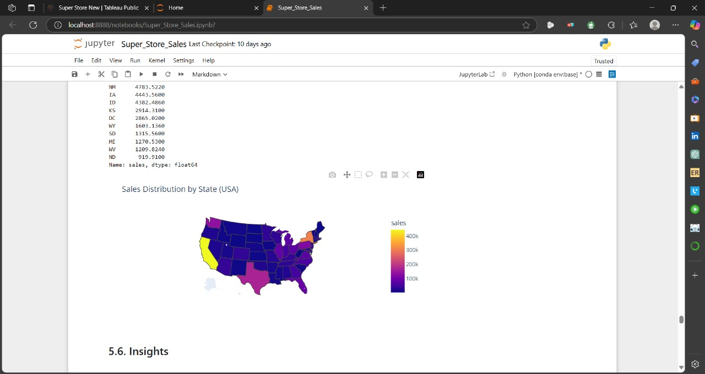

|  |  |  |
| --- | --- | --- |
| *# Example: Streamlit Dashboard (save as app.py)* import streamlit as st  import pandas as pd   * 1. Insights   1. Interactive Dashboard  st.title("Sales Analysis Dashboard")  st.write("## Monthly Sales Trend")  st.line_chart(monthly_sales)  st.write("## Regional Sales Performance") st.bar_chart(region_sales)  2025-04-05 07:58:16.584  Warning: to view this Streamlit app on a browser, run it with thefollowing   |  | | --- | | command: |  |  | | --- | | streamlit run C:\Users\Aboelyazzed\anaconda3\Lib\site-packages\ |   ipykernel_launcher.py [ARGUMENTS]  DeltaGenerator()  class DeltaGenerator:   def__init__(self, data, date_column, value_column): self.data = data   self.date_column = date_column   self.value_column = value_column  def calculate_deltas(self):  *# Sort data by date*  self.data = self.data.sort_values(by=self.date_column) |

|  |
| --- |
| *# Calculate the difference between consecutive rows* self.data['delta'] = self.data[self.value_column].diff() returnself.data  def plot_deltas(self):   import matplotlib.pyplot as plt  plt.figure(figsize=(10, 6))  plt.plot(self.data[self.date_column], self.data['delta'], marker='o')  plt.title("Change in Sales Over Time")  plt.xlabel("Date")  plt.ylabel("Delta (Change in Sales)")  plt.grid(True)  plt.show()  *# Example usage*  df['order_date'] = pd.to_datetime(df['order_date'])  delta_gen = DeltaGenerator(df, date_column='order_date', value_column='sales')  df_with_deltas = delta_gen.calculate_deltas()  delta_gen.plot_deltas() |

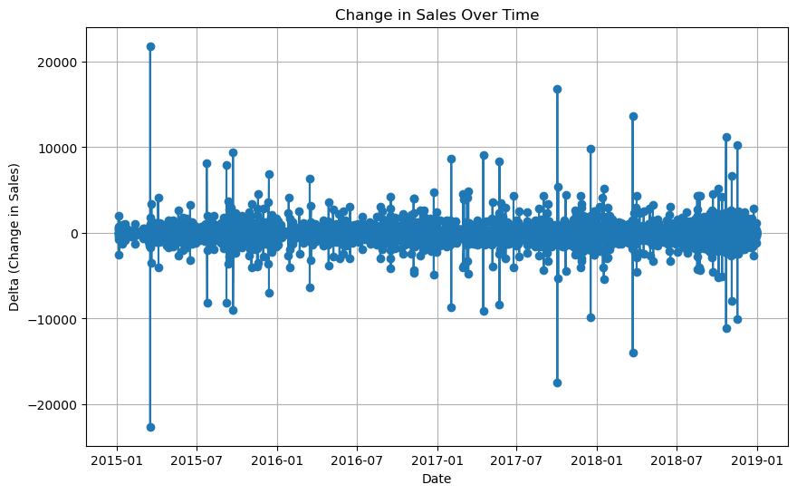

**Data Modeling**

1. **USING SQL (STRUCTURED QUERY LANGUAGES) TOOL:**

* **CREATE DATABASE SuperstoreDB;**

**USE SuperstoreDB;**

* **CREATE TABLE Locations (**

**City VARCHAR(255),**

**Statee VARCHAR(255),**

**Postal_Code VARCHAR(20),**

**Region VARCHAR(255),**

**Country VARCHAR(255),**

**location_id INT IDENTITY(1,1) PRIMARY KEY);**

* **CREATE TABLE Customers (**

**Customer_ID VARCHAR(50) PRIMARY KEY,**

**Customer_Name VARCHAR(255),**

**Segment VARCHAR(100) );**

* **CREATE TABLE Products (**

**Product_ID VARCHAR(50) PRIMARY KEY,**

**Product_Name VARCHAR(255),**

**Category VARCHAR(100),**

**Sub_Category VARCHAR(100));**

* **CREATE TABLE Orders (**

**Order_ID VARCHAR(50) PRIMARY KEY,**

**Order_Date DATE,**

**Ship_Date DATE,**

**Ship_Mode VARCHAR(100),**

**Customer_ID VARCHAR(50),**

**location_id INT,**

**FOREIGN KEY (Customer_ID) REFERENCES Customers(Customer_ID),**

**FOREIGN KEY (location_id) REFERENCES Locations(location_id));**

* **CREATE TABLE Order_Details (**

**Order_ID VARCHAR(50),**

**Product_ID VARCHAR(50),**

**Sales DECIMAL(10,2),**

**PRIMARY KEY (Order_ID, Product_ID),**

**FOREIGN KEY (Order_ID) REFERENCES Orders(Order_ID),**

**FOREIGN KEY (Product_ID) REFERENCES Products(Product_ID));**

* **INSERT DATA INTO TABLES TO ANALYSIS**

**1-BULK INSERT Locations**

**FROM 'E:/project-final/new/2/normalizations.files/locations.csv'**

**WITH (FIELDTERMINATOR = ',', FIRSTROW = 2, ROWTERMINATOR = '\n');**

**2- BULK INSERT Customers**

**FROM 'E:/project-final/new/2/normalizations.files/customers.csv'**

**WITH (FIELDTERMINATOR = ',', FIRSTROW = 2, ROWTERMINATOR = '\n');**

**3-BULK INSERT Products**

**FROM 'E:/project-final/new/2/normalizations.files/products.csv'**

**WITH (FIELDTERMINATOR = ',', FIRSTROW = 2, ROWTERMINATOR = '\n');**

**4-BULK INSERT Orders**

**FROM 'E:/project-final/new/2/normalizations.files/orders.csv'**

**WITH (FIELDTERMINATOR = ',', FIRSTROW = 2, ROWTERMINATOR = '\n');**

**5-BULK INSERT Order_Details**

**FROM 'E:/project-final/new/2/normalizations.files/order_details.csv'**

**WITH (FIELDTERMINATOR = ',', FIRSTROW = 2, ROWTERMINATOR = '\n');**

**select * from Customers**

**select * from Orders**

**select * from Order_Details**

**select * from Locations**

**select * from Products**

**Adding Constraints for Data base :**

* 1. **To achieve Data validity**
  2. **Specify Rules to control data Attributes**
  3. **Limit DataType**
  4. **Ensure Accuracy,Readability,Reliability**

ALTER TABLE [dbo].[order_details] WITH CHECK ADD CONSTRAINT [order_id_fk] FOREIGN KEY([order_id])

REFERENCES [dbo].[orders] ([order_id])

GO

ALTER TABLE [dbo].[order_details] CHECK CONSTRAINT [order_id_fk]

GO

ALTER TABLE [dbo].[order_details] WITH CHECK ADD CONSTRAINT [product_id_fk] FOREIGN KEY([product_id])

REFERENCES [dbo].[products] ([product_id])

GO

ALTER TABLE [dbo].[order_details] CHECK CONSTRAINT [product_id_fk]

GO

ALTER TABLE [dbo].[orders] WITH CHECK ADD CONSTRAINT [FK_orders_branches] FOREIGN KEY([loc_id])

REFERENCES [dbo].[branches] ([loc_id])

GO

ALTER TABLE [dbo].[orders] CHECK CONSTRAINT [FK_orders_branches]

GO

ALTER TABLE [dbo].[orders] WITH CHECK ADD CONSTRAINT [FK_orders_customers] FOREIGN KEY([customer_id])

REFERENCES [dbo].[customers] ([customer_id])

GO

ALTER TABLE [dbo].[orders] CHECK CONSTRAINT [FK_orders_customers]

GO

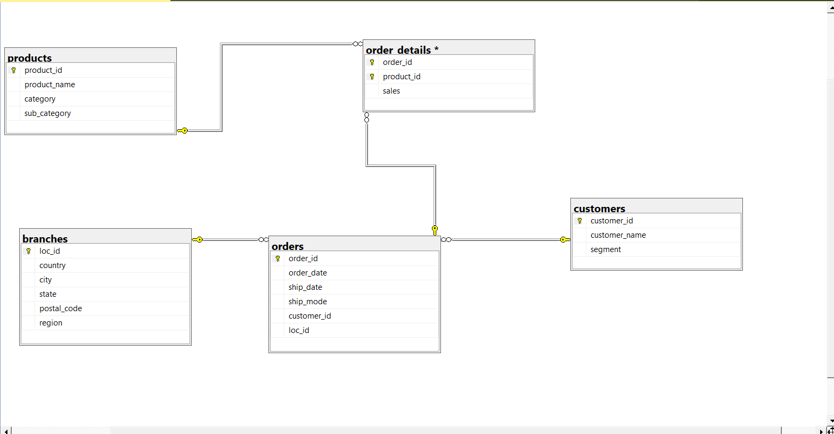A Schema of The Tables of Sales Store Analysis ( by SQL)

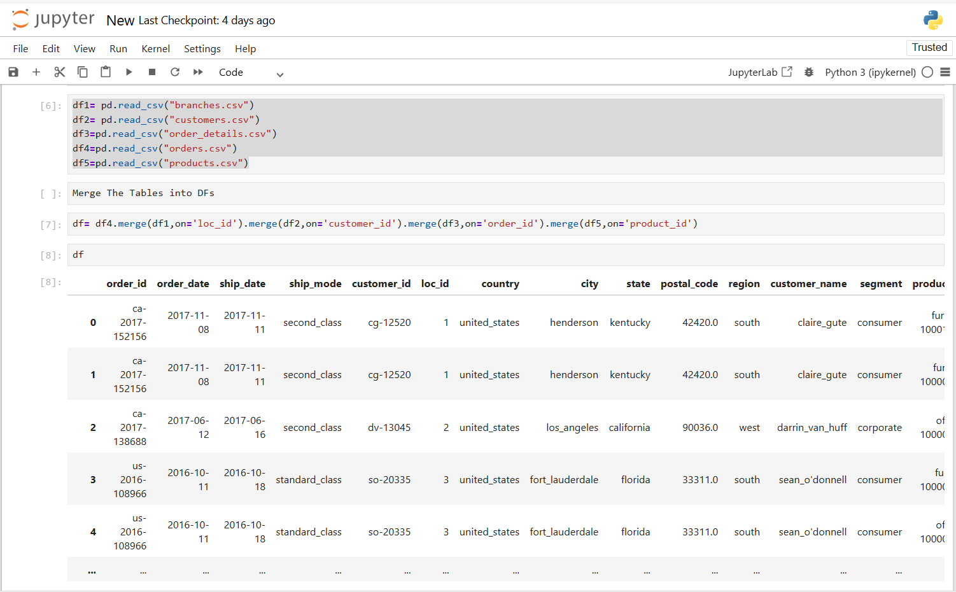**Data Modeling by Jupyter**

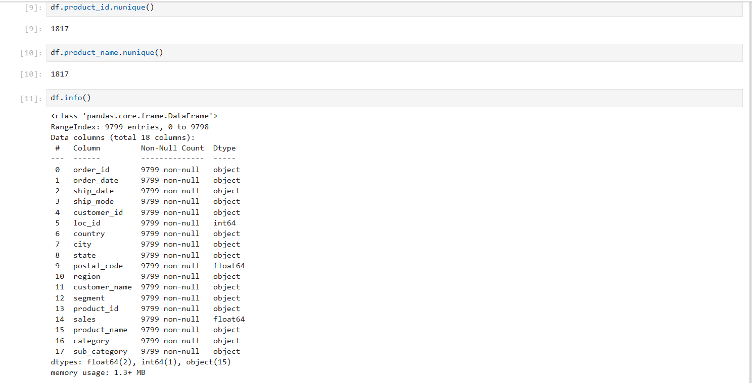



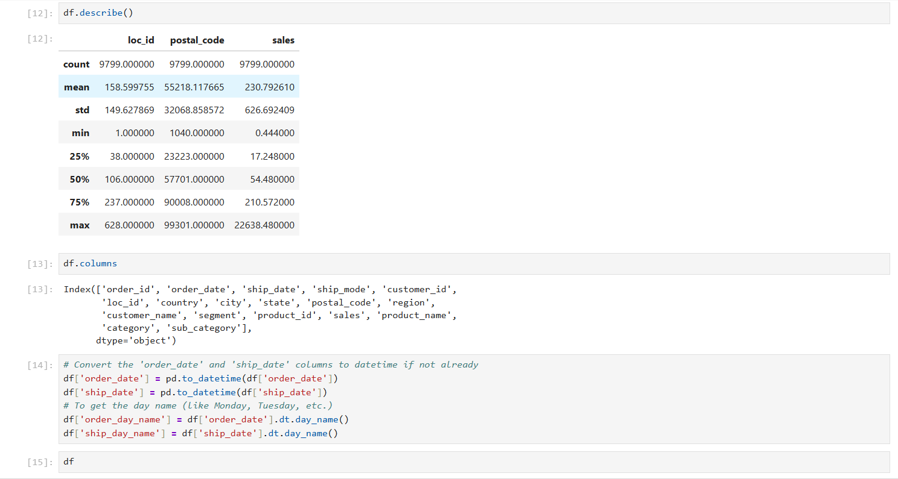

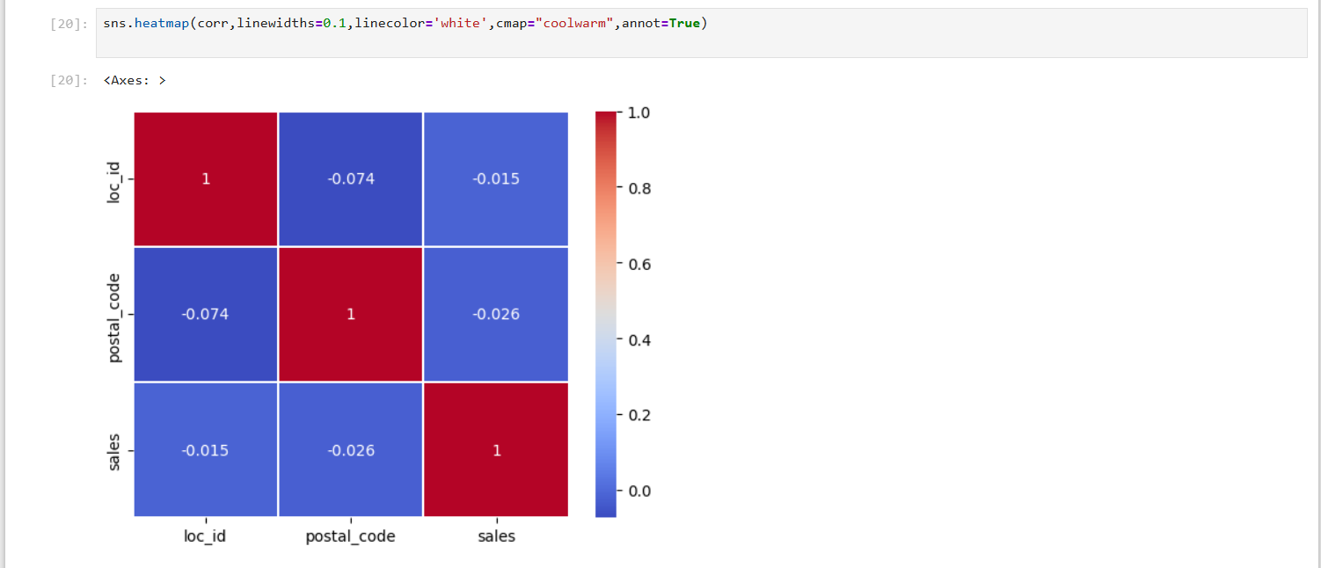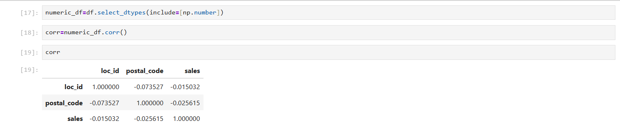**selected numeric columns into new numeric_df**

**Chapter 2: Data Diagnosis**



1. **Diagnostic Data (Why Happened)**

**Diagnostic data refers to information collected to understand the cause of a problem or issue, especially in systems, machines, or software. It's used to diagnose faults, errors, or unusual behavior by analyzing logs, system performance, and error messages.**

* **Using Analysis Tools (SQL- JUPYTER Libraries( Pandas- Numpy-Seaborn-Matplotlib – rapidfuzz-plotly- sklearn.preprocessing-datetime- streamlit- statsmodels.tsa.seasonal -Tableau)to Get Insights**
* **Structured Query Languages(SQL)**
* A group of relational data structured in Columns & Rows helps in retrieval & quick access to data . It allows analysts to query large datasets, perform aggregations, filter data, and join tables, making it essential for data exploration, cleaning, and reporting. SQL helps transform raw data into actionable insights efficiently.
* **Jupyter (Programming Tool)**
* Jupyter is an open-source tool widely used in data analysis that allows users to create and share documents containing live code, visualizations, and explanatory text. It supports multiple programming languages, including Python, and is popular for its interactive features, making it ideal for data exploration, visualization, and prototyping. Jupyter notebooks enable data analysts to write, test, and document their analysis in a single, easy-to-share environment.

1. **Mention the number of submitted orders for each subcategory**

**select sub_category ,count (r.order_id)as "# orders"**

**from products p join order_details o on o.product_id=p.product_id join orders r on o.order_id=r.order_id**

**group by sub_category**

**order by "# orders" desc**

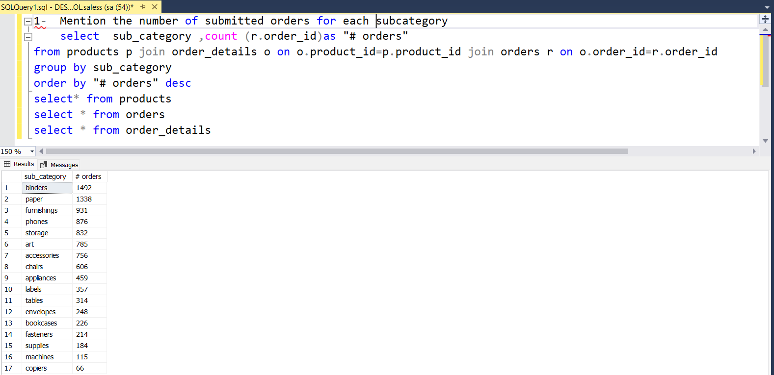

**What is the subcategory has the largest #orders?**

**Binders**

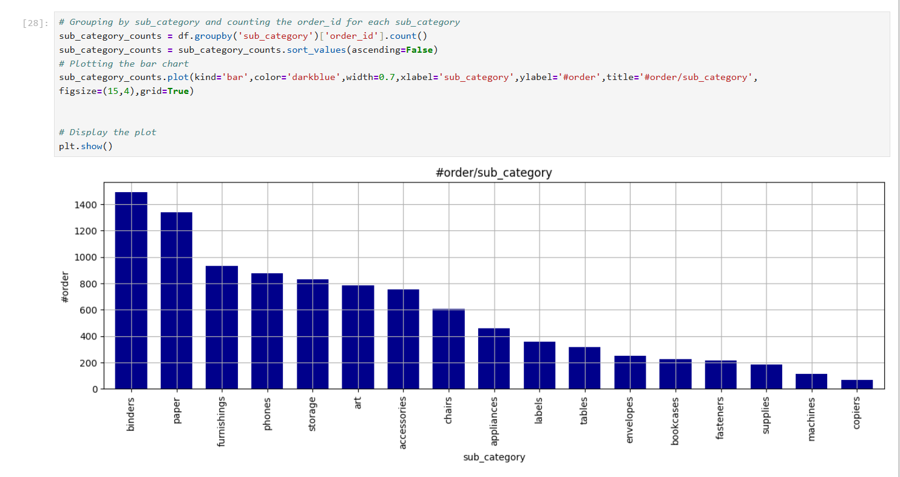

**2- Mention the number of submitted orders for each category .**

**select category,count (r.order_id)as "# orders"**

**from products p join order_details o on o.product_id=p.product_id join orders r on o.order_id=r.order_id**

**group by category**

**order by "# orders" desc**

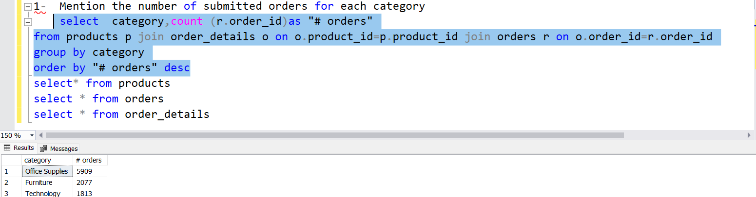

**What is the category has the largest #orders?**

**Office supplies**

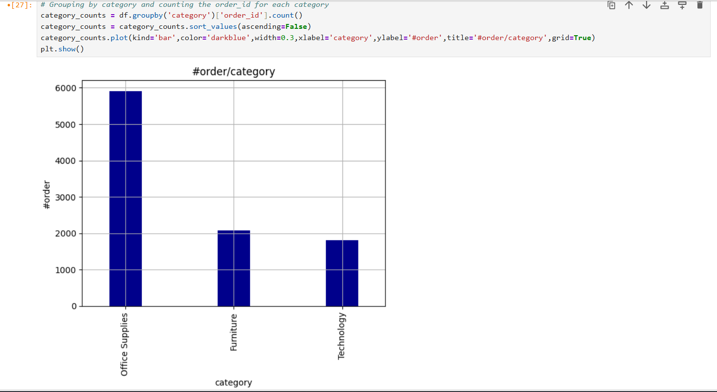

**3-what is the average of sales for each category of products?**

**select category,round (avg (coalesce(sales,0)),2)as "average_sales/category"from products p join order_details o on o.product_id=p.product_id**

**group by category**

**order by "average_sales/category" desc**

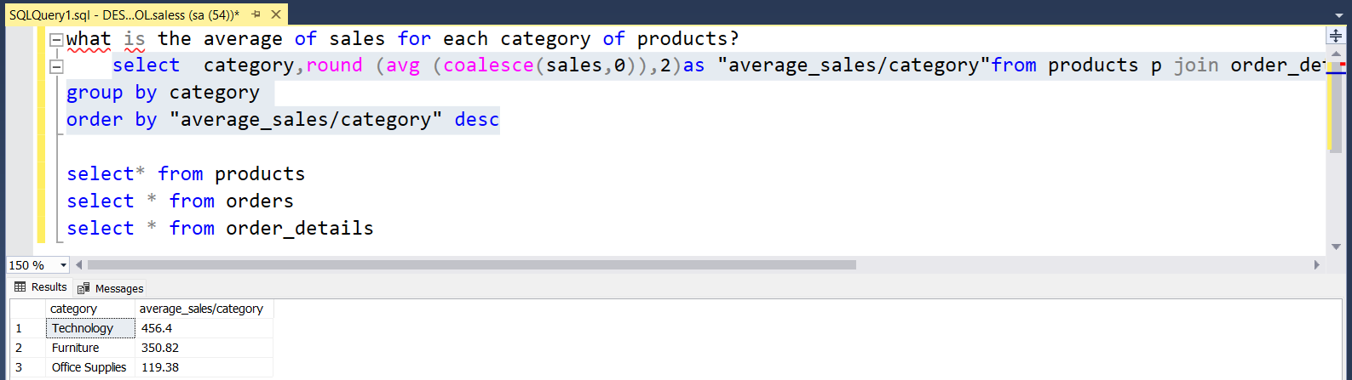

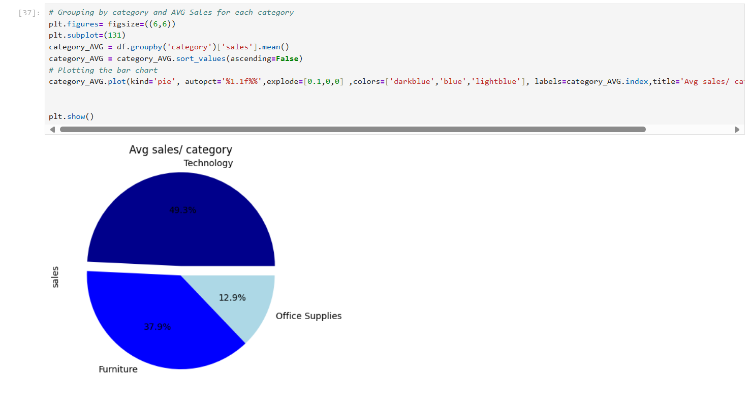

**4- what is the average of sales for each subcategory of products?**

**select sub_category,round (avg (coalesce(sales,0)),2)as "average_sales/sub_category"from**

**products p join order_details o on o.product_id=p.product_id**

**group by sub_category**

**order by "average_sales/sub_category" desc**

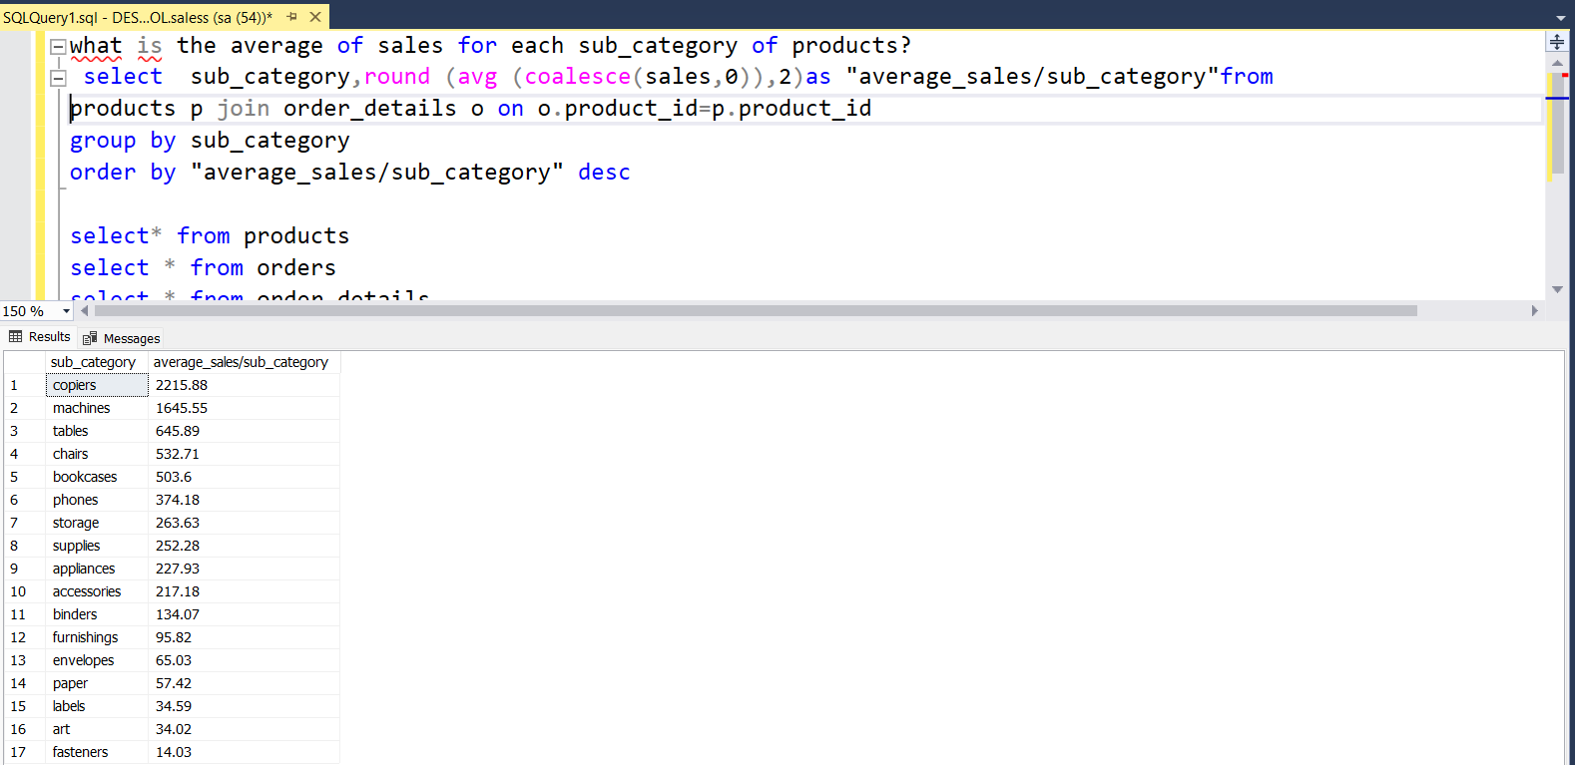

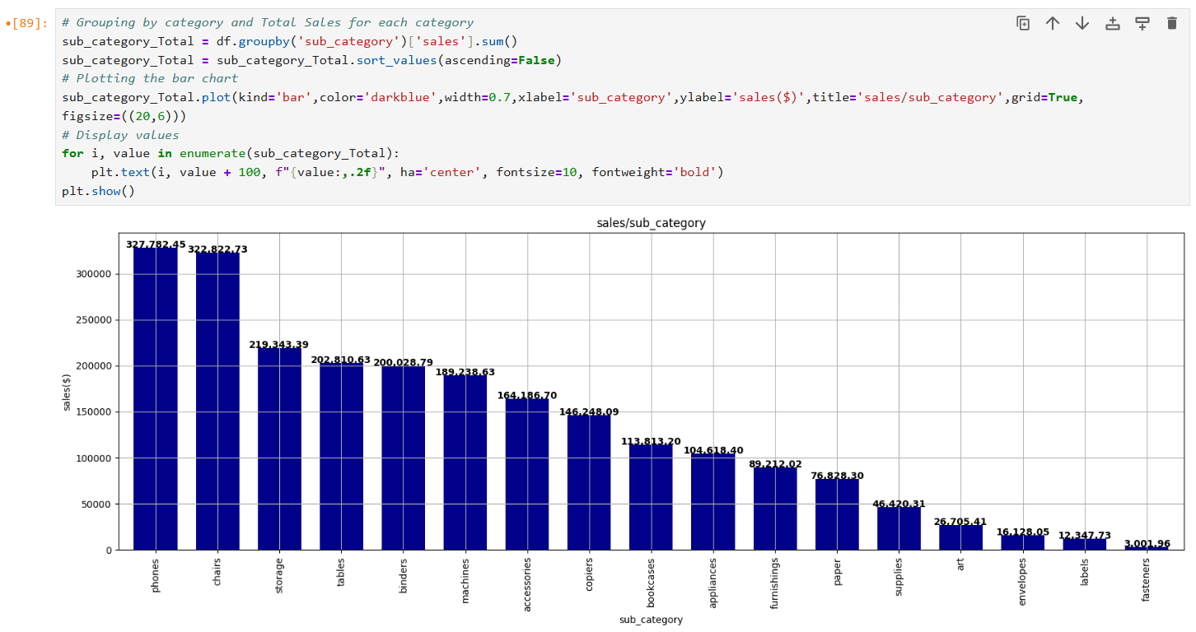

**5-Mention The highest sales by category.**

**select category,round (sum (coalesce(sales,0)),2)as "sales/category"from products p join order_details o on o.product_id=p.product_id**

**group by category**

**order by "sales/category" desc**

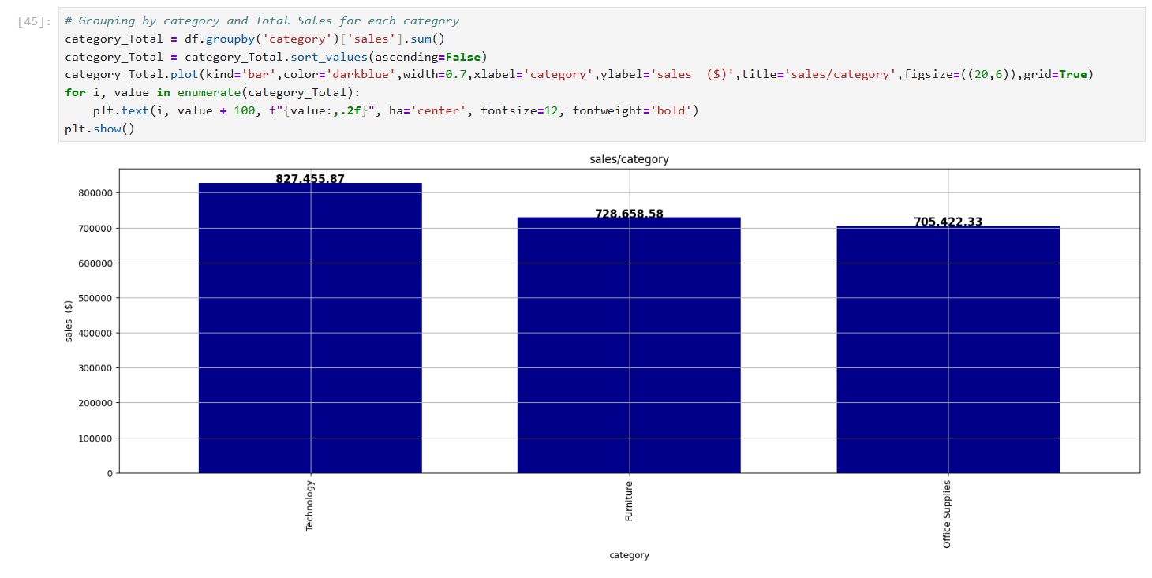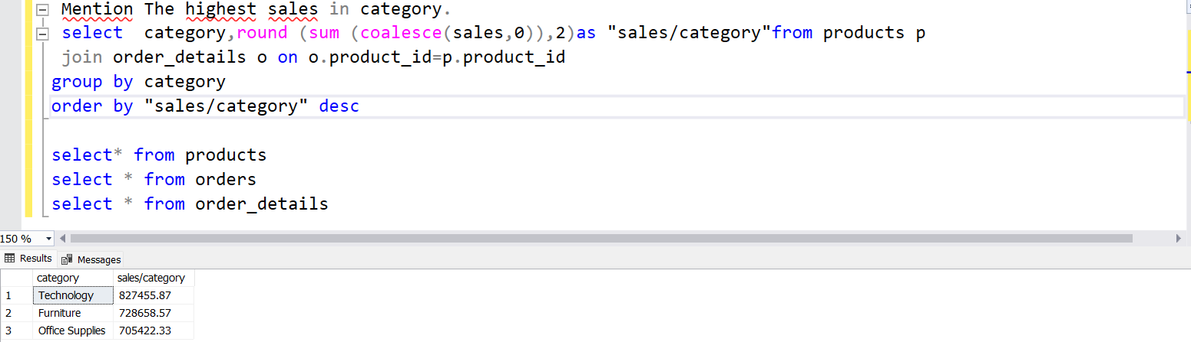

**6-Mention The highest sales by sub_category.**

**select sub_category,round (sum (coalesce(sales,0)),2)as "sales/sub_category"from products p join order_details o on o.product_id=p.product_id**

**group by sub_category**

**order by "sales/sub_category" desc**

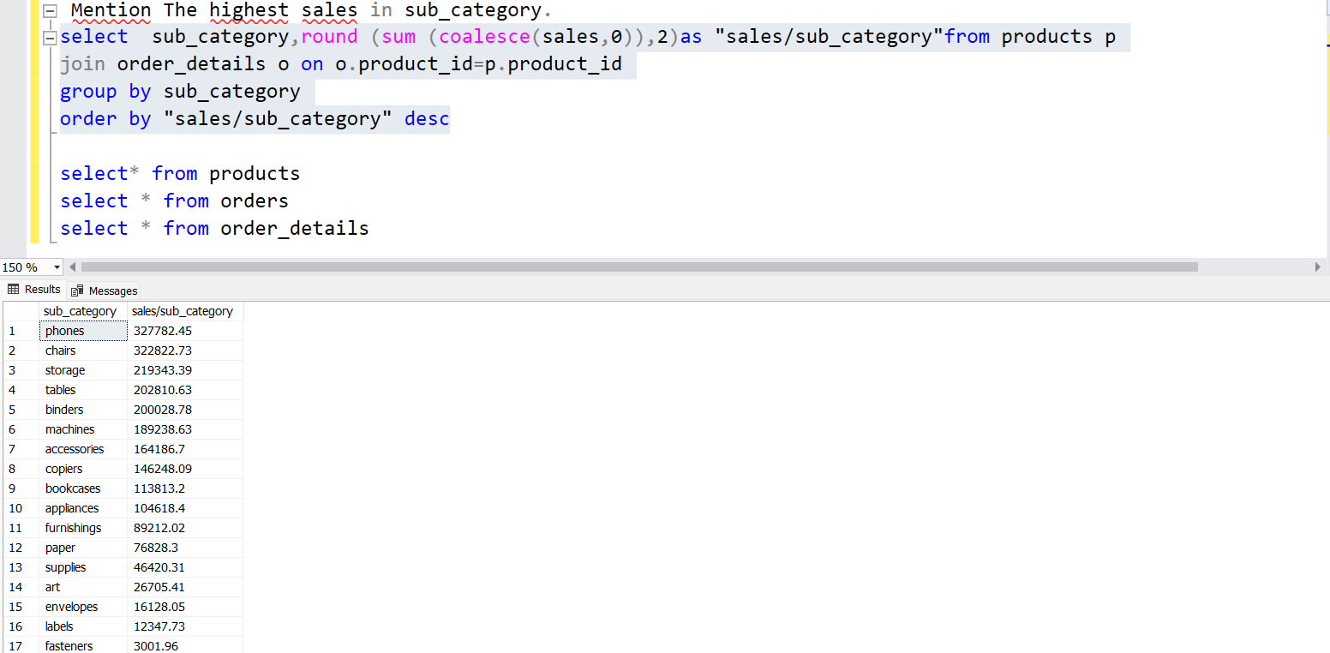



# Grouping by sub_category and AVG Sales for each sub_category

sub_category_AVG = df.groupby(['sub_category','category'])['sales'].mean()

sub_category_AVG = sub_category_AVG.sort_values(ascending=False)

sub_category_AVG.plot(kind='bar',color='darkblue',width=0.7,xlabel='sub_categoryand category',ylabel='AVG/SALES($)',title='Avgsales/sub_category',

figsize=(14,5),grid=True)

# Display values

for i, value in enumerate(sub_category_AVG):

plt.text(i, value + 100, f"{value:,.2f}", ha='center', fontsize=10, fontweight='bold')

plt.show()

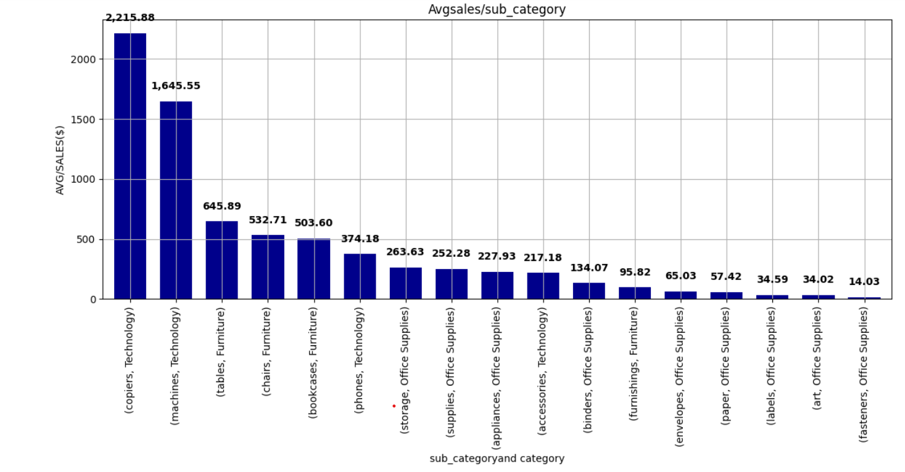

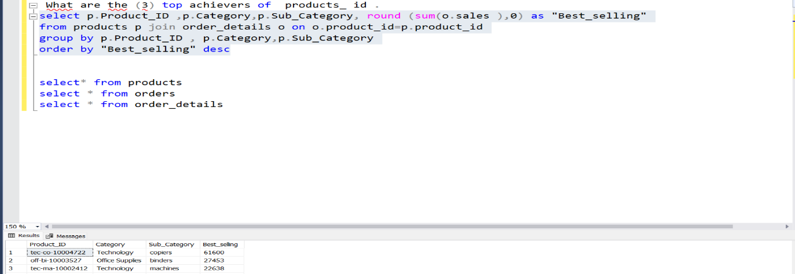**7-What are the (3) top achievers of products _id.**

# Grouping by sales for each Top 10 product_id

top_10_product_sales_counts = df.groupby(['product_id','sub_category'])['sales'].sum()

top_10_product_sales_counts = top_10_product_sales_counts.sort_values(ascending=False).head(10)

# Plotting the bar chart

top_10_product_sales_counts.plot(kind='bar',color='darkblue',width=0.7,xlabel='product_id and cateogry',ylabel='sales($)',title='sales($)/Top10 product_id',figsize=(12,4),grid=True)

# Display values

for i, value in enumerate(top_10_product_sales_counts):

plt.text(i, value + 100, f"{value:,.2f}", ha='center', fontsize=10, fontweight='bold')

# Display the plot

plt.show()

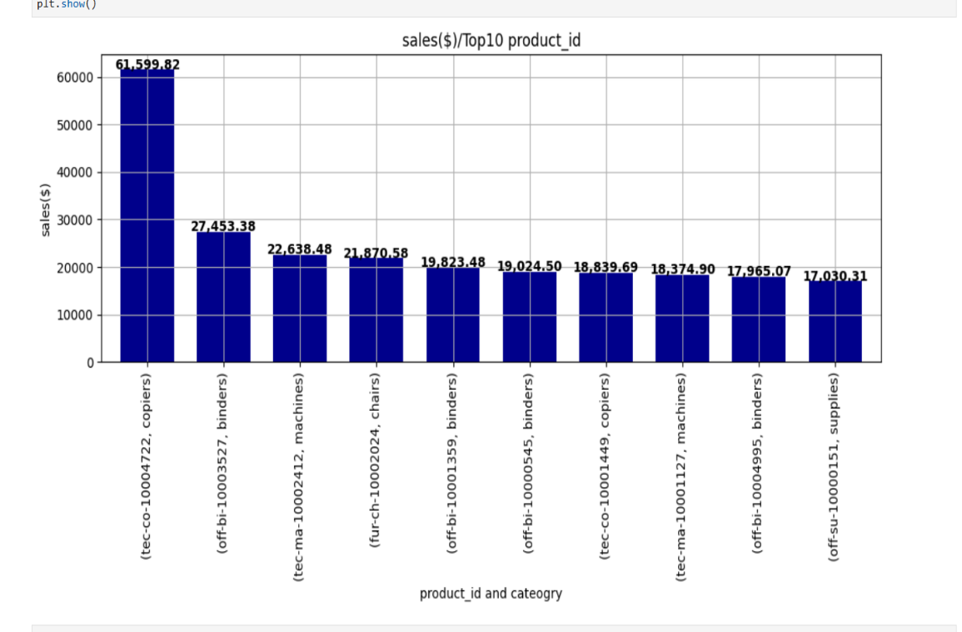

**8-Mention The Total number of orders for each product ( attached The category &subcategory of it.**

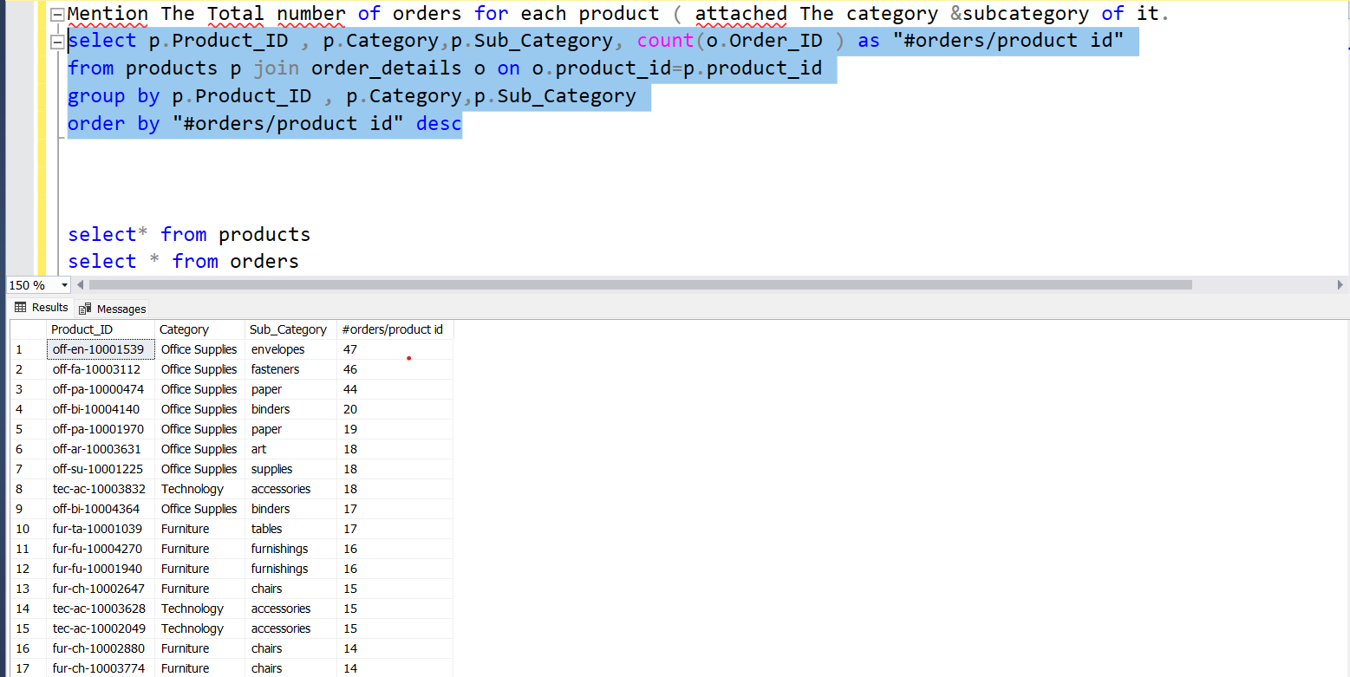

# Grouping by product_id and counting the order_id for each product_id

product_category_counts = df.groupby(['product_id','sub_category'])['order_id'].count()

top_10_product_category_counts = product_category_counts.sort_values(ascending=False).head(10)

# Plotting the bar chart

top_10_product_category_counts.plot(kind='bar',color='darkblue',width=0.7,xlabel='product_id and cateogry',ylabel='#order',

title='#order/Top10 product_id',grid=True)

# Display the plot

plt.show()

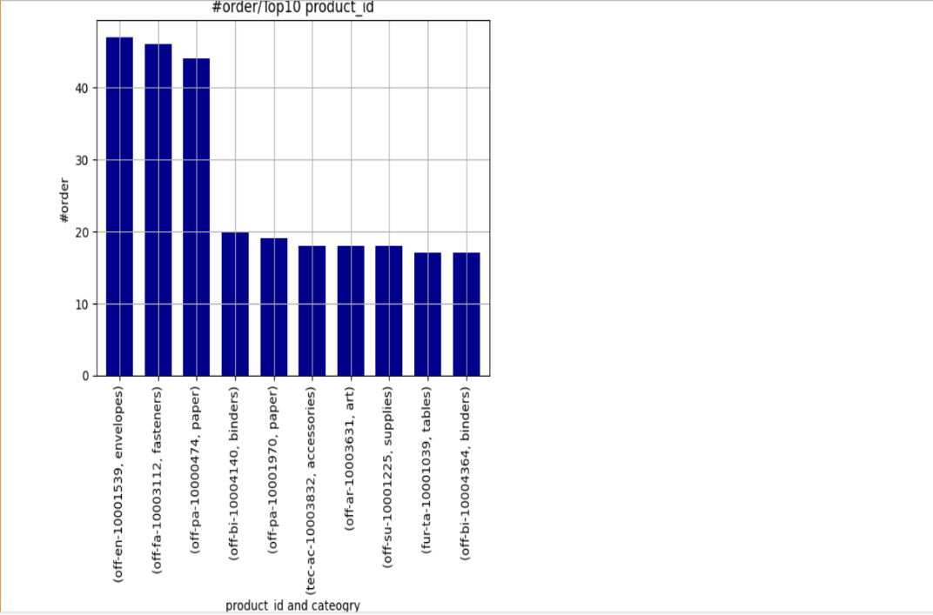

**9-Which category has The highest number of customer ?**

**select distinct p.Category, count(c.Customer_ID ) as "#customers/category"**

**from products p join order_details o on o.product_id=p.product_id join orders r on r.order_id=o.order_id join customers c on c.customer_id=r.customer_id**

**group by p.Category**

**order by "#customers/category" desc ( office supplies)**

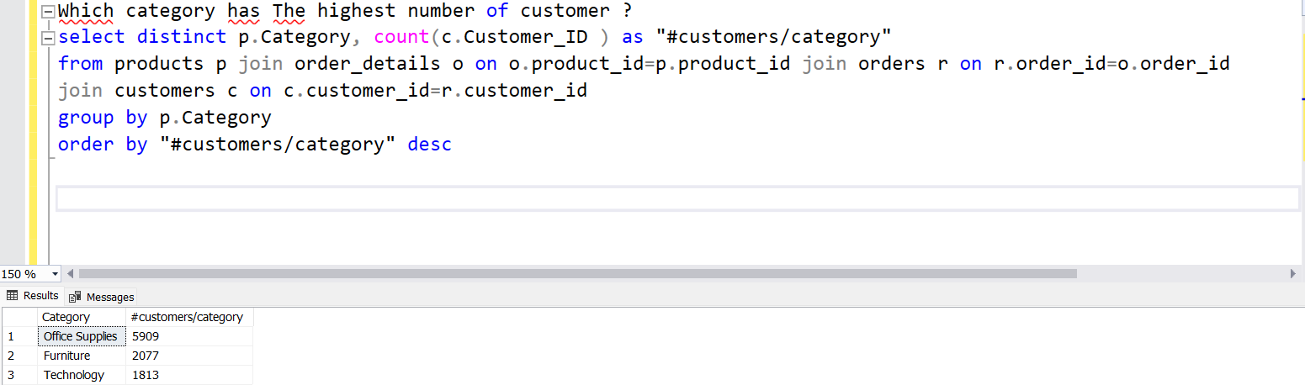

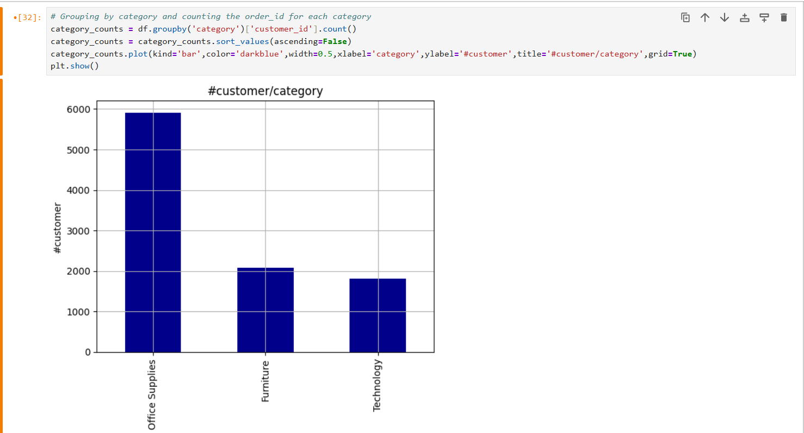

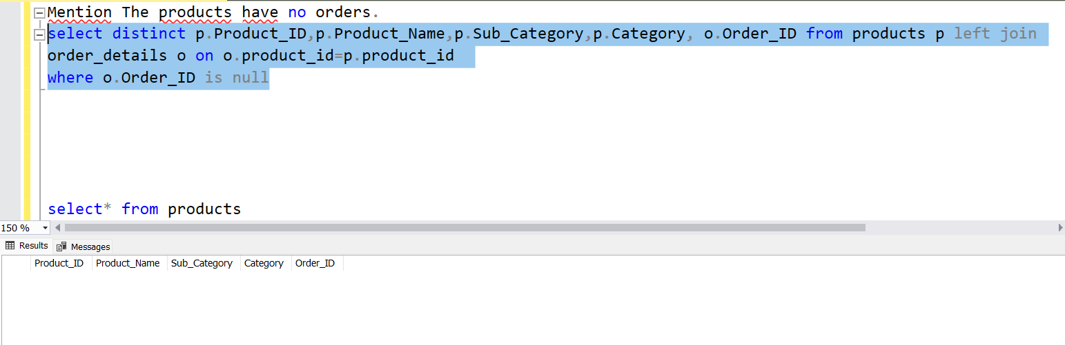**10-Mention The products have no orders.**

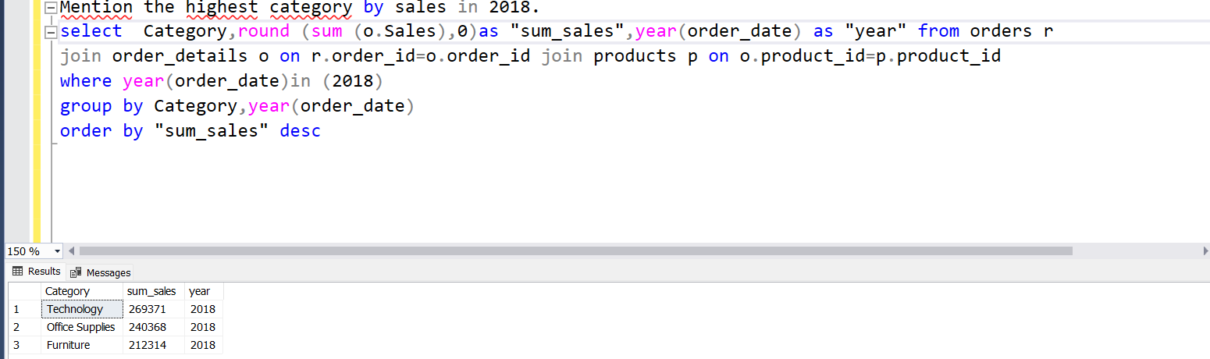**11- Mention the highest category by sales in 2018.**

# Assuming 'df' is your DataFrame with 'order_date' and 'sales' columns

# Convert the 'order_date' column to datetime if it's not already

df['order_date'] = pd.to_datetime(df['order_date'])

# Filter the data for only the year 2018

df_2018 = df[df['order_date'].dt.year == 2018]

# Group by 'category' and sum the sales for each category in 2018

category_total_2018 = df_2018.groupby('category')['sales'].sum().sort_values(ascending=False)

# Plotting the bar chart for the highest sales categories in 2018

category_total_2018.plot(kind='line', color='darkblue', linewidth=2,xlabel='cateogry',ylabel='sales ($)',title='sales/category in 2018',figsize=(12,7),grid=True)

# Display values

for i, value in enumerate(category_total_2018):

plt.text(i, value + 100, f"{value:,.2f}", ha='center', fontsize=10, fontweight='bold')

plt.show()

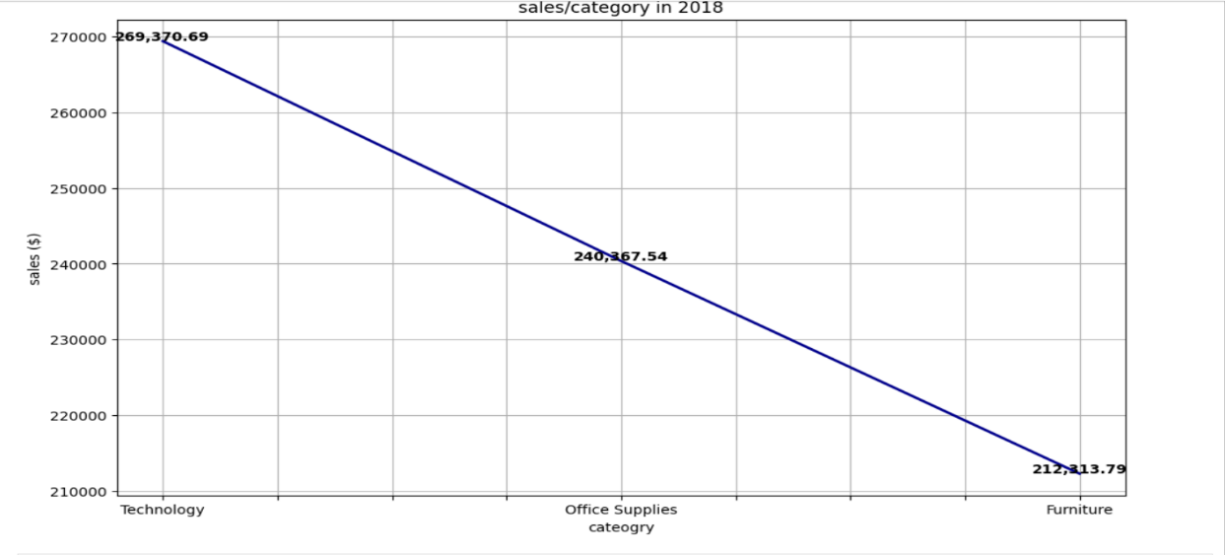

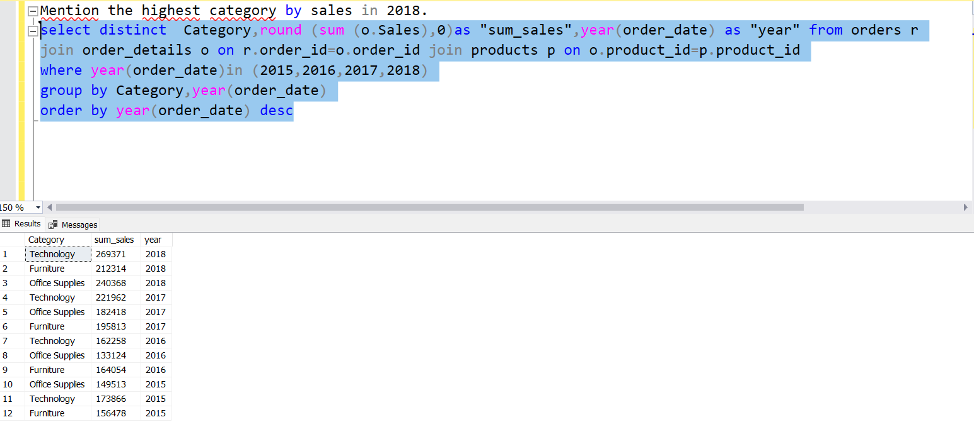**12-Show The difference for each category by sales within 2015-2016-2017-2018**

# Assuming 'df' is your DataFrame with 'order_date' and 'sales' columns

# Convert the 'order_date' column to datetime if it's not already

df['order_date'] = pd.to_datetime(df['order_date'])

df_filtered = df[df['order_date'].dt.year.isin ([2015,2016,2017,2018])]

# Group by 'category' and sum the sales for each category in 2015,2016,2017,2018

category_year_total = df_filtered.groupby(['category',df_filtered['order_date'].dt.year])['sales'].sum().unstack()

# Plotting the bar chart for the highest sales categories in 2015,2016,2017,2018

category_year_total.plot(kind='bar',width=0.7, color=['Aqua','blue','lightblue','darkblue'],xlabel='cateogry',ylabel='sales ($)',title='sales/category for 2015,2016,2017, 2018',figsize=(17,7),grid=True)

plt.show()

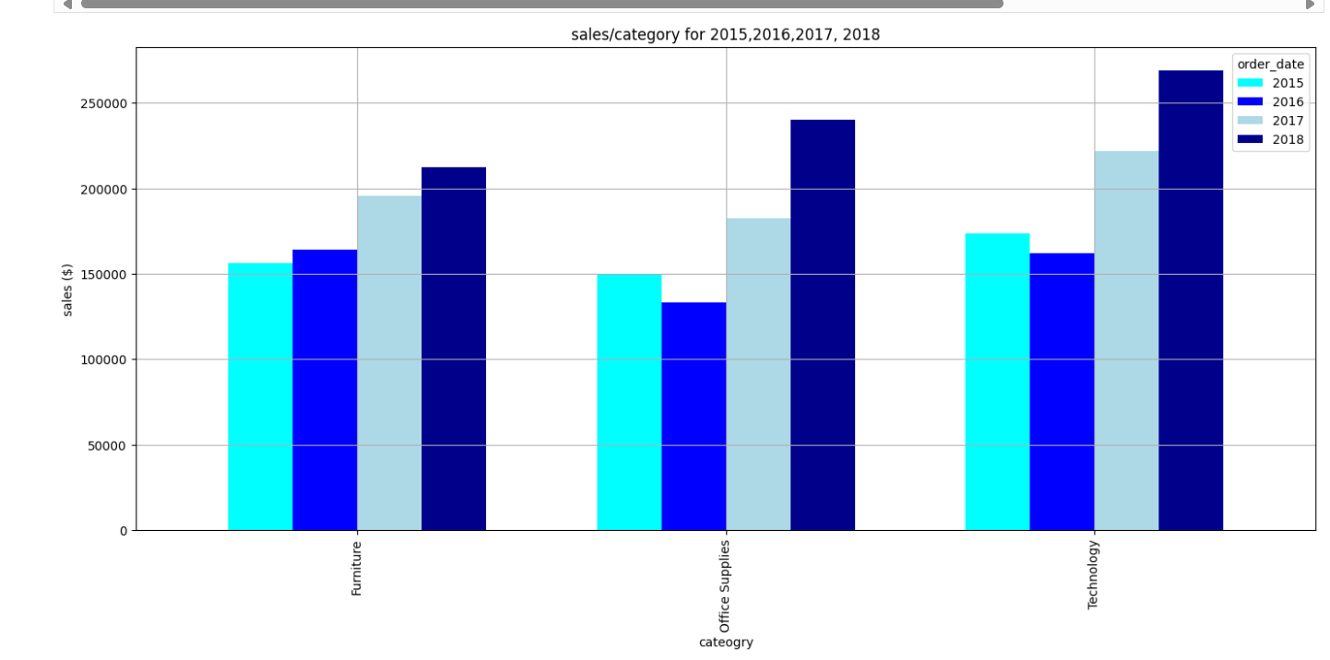

#Redundant

#Assuming 'df' is your DataFrame with 'order_date' and 'sales' columns (another_linechart)

# Convert the 'order_date' column to datetime if it's not already

df['order_date'] = pd.to_datetime(df['order_date'])

# Filter the data for only the year 2018

df_filtered = df[df['order_date'].dt.year.isin ([2015,2016,2017,2018])]

# Group by 'category' and sum the sales for each category in 2015,2016,2017,2018

category_year_total = df_filtered.groupby(['category',df_filtered['order_date'].dt.year])['sales'].sum().unstack()

# Plotting the bar chart for the highest sales categories in 2015,2016,2017,2018

category_year_total.plot(kind='line',linewidth=2, color=['Aqua','blue','lightblue','darkblue'],xlabel='cateogry',ylabel='sales ($)',title='sales/category for 2015,2016,2017, 2018',grid=True)

plt.show()

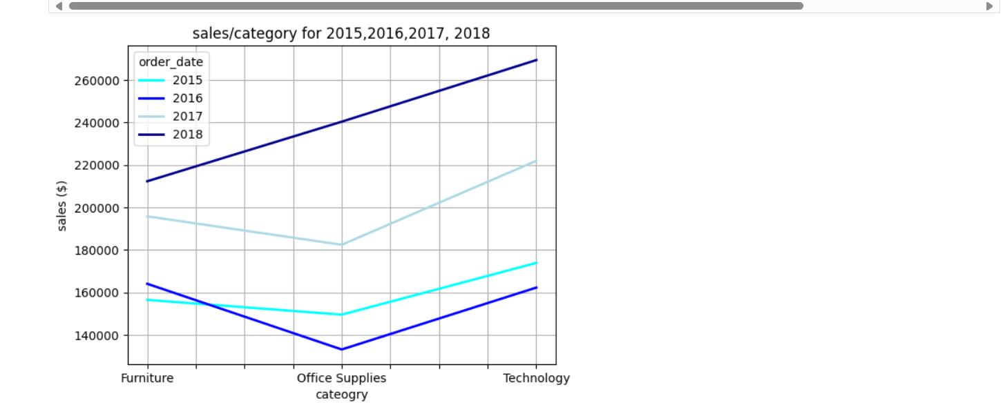

**13-Mention the Highest category by sales in the last quarter of 2018**

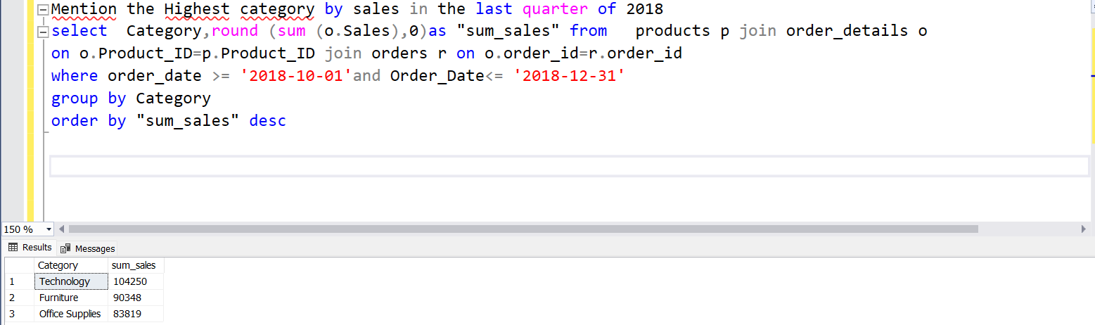

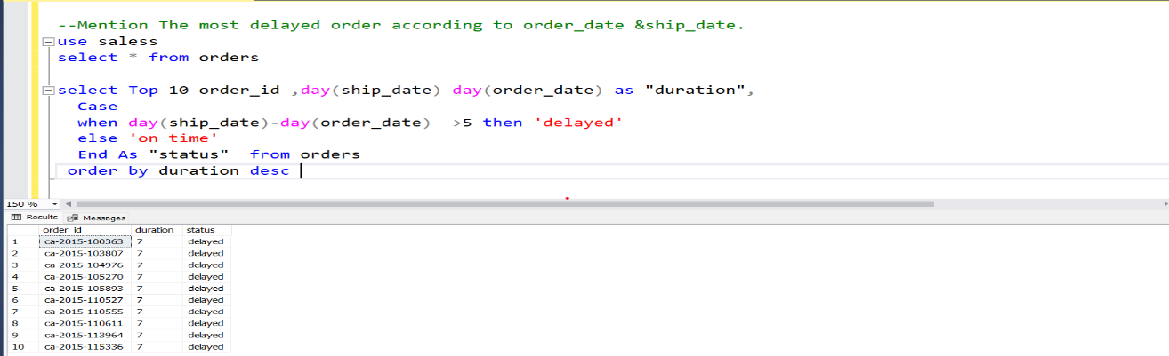**14- Mention The most delayed order according to order_date &ship_d**ate

**create 2 columns (duration, delayed_order)**

df['order_date'] = pd.to_datetime(df['order_date'])

df['ship_date'] = pd.to_datetime(df['ship_date'])

# Calculate the duration between order_date and ship_date

df['duration'] = (df['ship_date'] - df['order_date']).dt.days

# Create a new column 'delayed_order' to flag delayed orders (duration > 5 days)

df['delayed_order'] = df['duration'] > 5

# Show the resulting DataFrame

print(df)

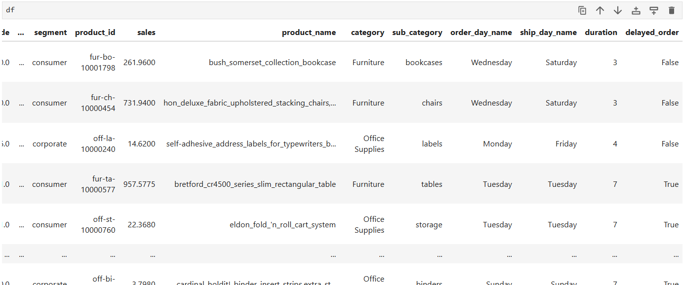

order_id order_date ship_date ship_mode customer_id \

0 ca-2017-152156 2017-11-08 2017-11-11 second_class cg-12520

1 ca-2017-152156 2017-11-08 2017-11-11 second_class cg-12520

2 ca-2017-138688 2017-06-12 2017-06-16 second_class dv-13045

3 us-2016-108966 2016-10-11 2016-10-18 standard_class so-20335

4 us-2016-108966 2016-10-11 2016-10-18 standard_class so-20335

... ... ... ... ... ...

9794 ca-2017-125920 2017-05-21 2017-05-28 standard_class sh-19975

9795 ca-2016-128608 2016-01-12 2016-01-17 standard_class cs-12490

9796 ca-2016-128608 2016-01-12 2016-01-17 standard_class cs-12490

9797 ca-2016-128608 2016-01-12 2016-01-17 standard_class cs-12490

9798 ca-2016-128608 2016-01-12 2016-01-17 standard_class cs-12490

loc_id country city state postal_code ... \

0 1 united_states henderson kentucky 42420.0 ...

1 1 united_states henderson kentucky 42420.0 ...

2 2 united_states los_angeles california 90036.0 ...

3 3 united_states fort_lauderdale florida 33311.0 ...

4 3 united_states fort_lauderdale florida 33311.0 ...

... ... ... ... ... ... ...

9794 27 united_states chicago illinois 60610.0 ...

9795 214 united_states toledo ohio 43615.0 ...

9796 214 united_states toledo ohio 43615.0 ...

9797 214 united_states toledo ohio 43615.0 ...

9798 214 united_states toledo ohio 43615.0 ...

segment product_id sales \

0 consumer fur-bo-10001798 261.9600

1 consumer fur-ch-10000454 731.9400

2 corporate off-la-10000240 14.6200

3 consumer fur-ta-10000577 957.5775

4 consumer off-st-10000760 22.3680

... ... ... ...

9794 corporate off-bi-10003429 3.7980

9795 corporate off-ar-10001374 10.3680

9796 corporate tec-ph-10004977 235.1880

9797 corporate tec-ph-10000912 26.3760

9798 corporate tec-ac-10000487 10.3840

product_name category \

0 bush_somerset_collection_bookcase Furniture

1 hon_deluxe_fabric_upholstered_stacking_chairs,... Furniture

2 self-adhesive_address_labels_for_typewriters_b... Office Supplies

3 bretford_cr4500_series_slim_rectangular_table Furniture

4 eldon_fold_'n_roll_cart_system Office Supplies

... ... ...

9794 cardinal_holdit!_binder_insert_strips,extra_st... Office Supplies

9795 bic_brite_liner_highlighters,_chisel_tip Office Supplies

9796 ge_30524ee4 Technology

9797 anker_24w_portable_micro_usb_car_charger Technology

9798 sandisk_cruzer_4_gb_usb_flash_drive Technology

sub_category order_day_name ship_day_name duration delayed_order

0 bookcases Wednesday Saturday 3 False

1 chairs Wednesday Saturday 3 False

2 labels Monday Friday 4 False

3 tables Tuesday Tuesday 7 True

4 storage Tuesday Tuesday 7 True

... ... ... ... ... ...

9794 binders Sunday Sunday 7 True

9795 art Tuesday Sunday 5 False

9796 phones Tuesday Sunday 5 False

9797 phones Tuesday Sunday 5 False

9798 accessories Tuesday Sunday 5 False

[9799 rows x 22 columns]

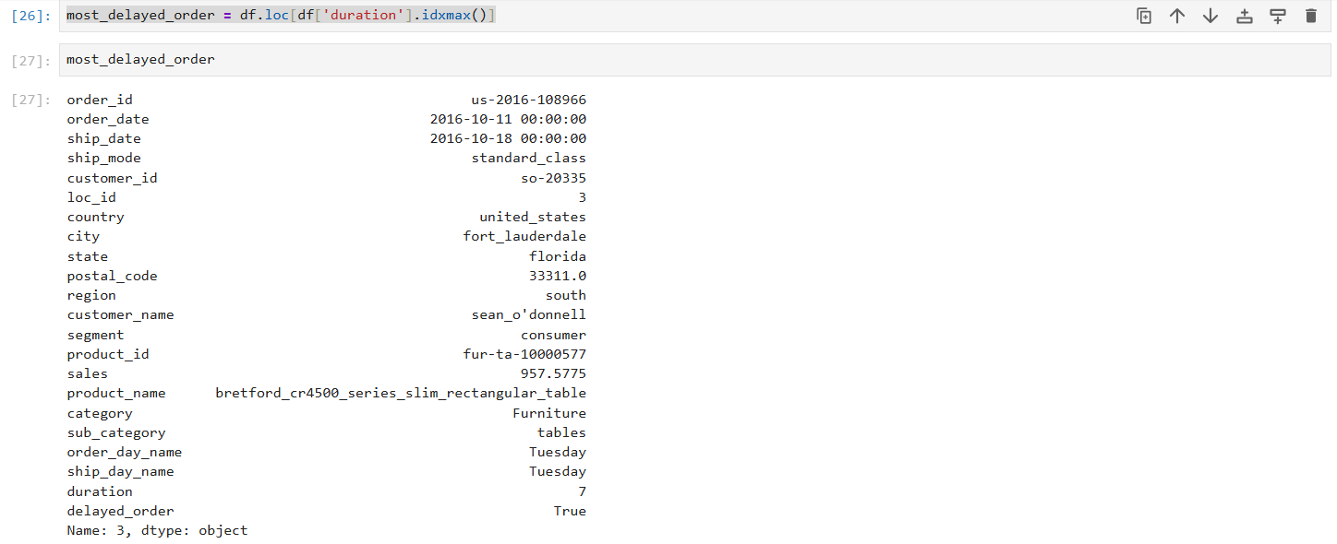

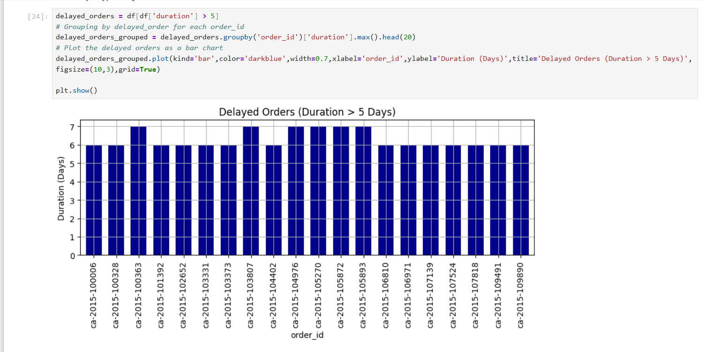

15- Mention the sales targeted / weekday .

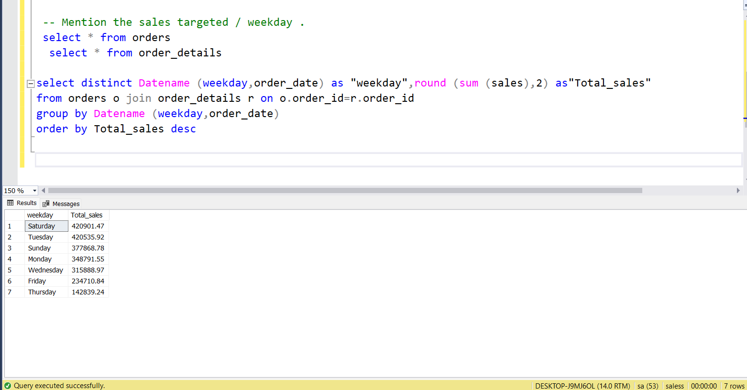

order_day_name_sales = df.groupby('order_day_name')['sales'].sum()

order_day_name_sales = order_day_name_sales.sort_values(ascending=False)

# Plotting the barchart

order_day_name_sales.plot(kind='bar',color='darkblue',width=0.7,xlabel='order_day_name',ylabel='sales ($)',title='sales/order_day_name',grid=True)

# Display values

for i, value in enumerate(order_day_name_sales):

plt.text(i, value + 100, f"{value:,.2f}", ha='center', fontsize=9, fontweight='bold')

plt.show()

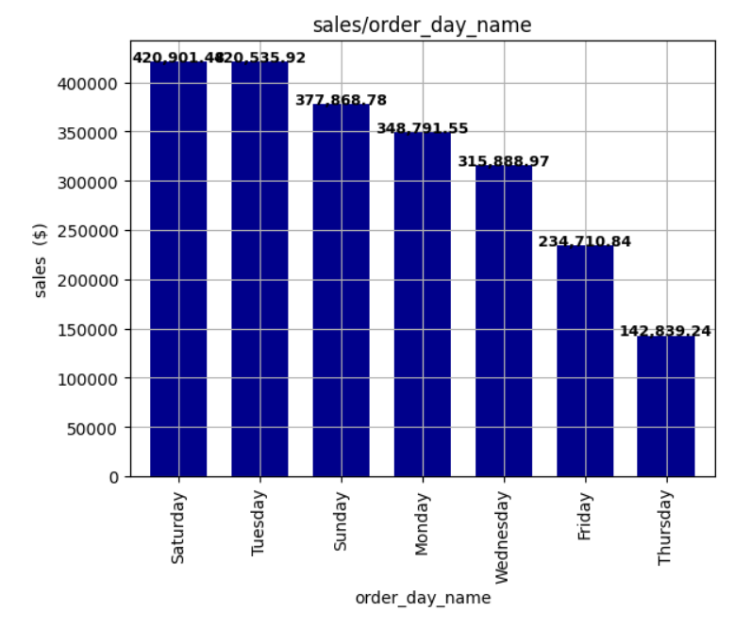

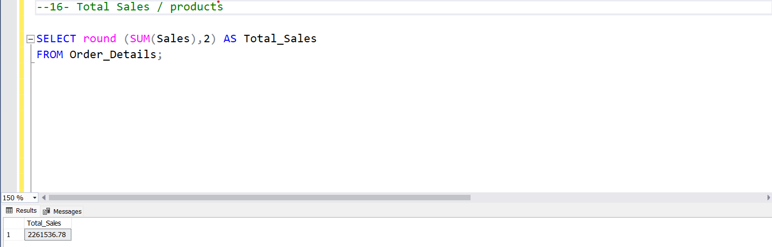

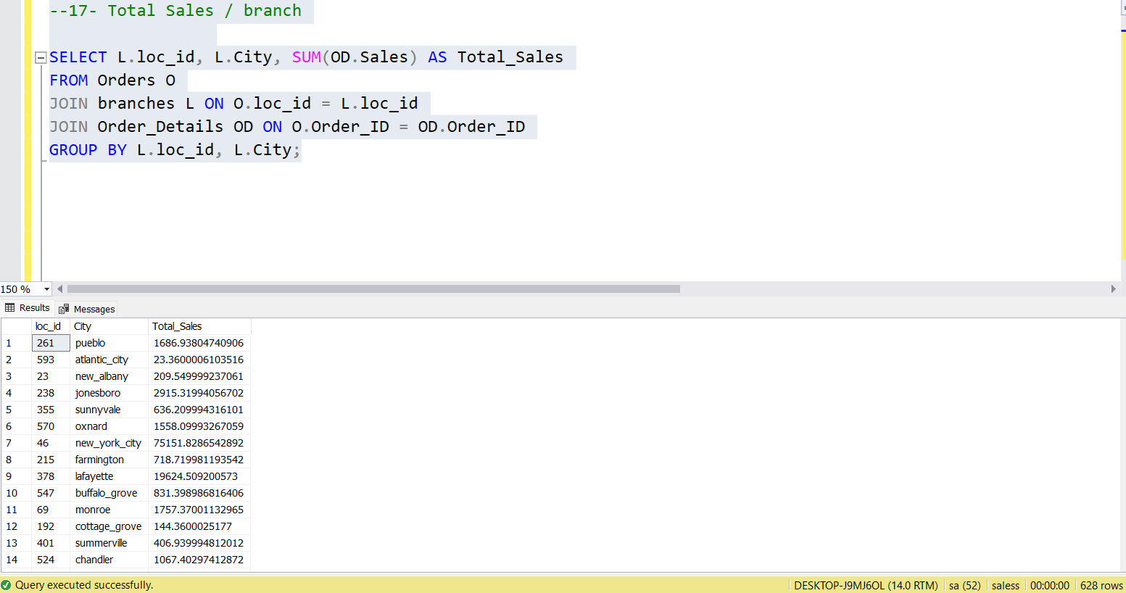

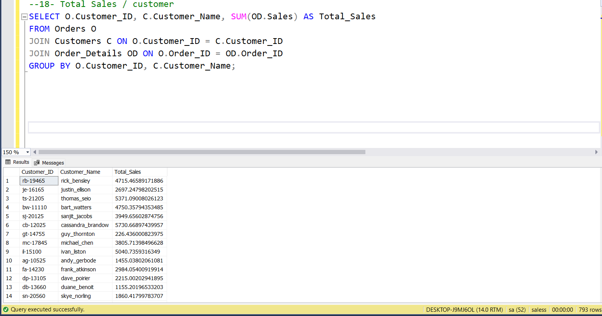

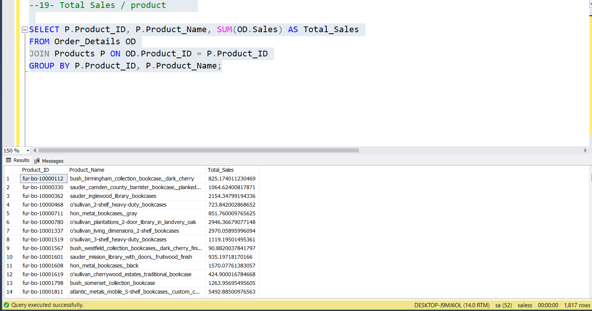

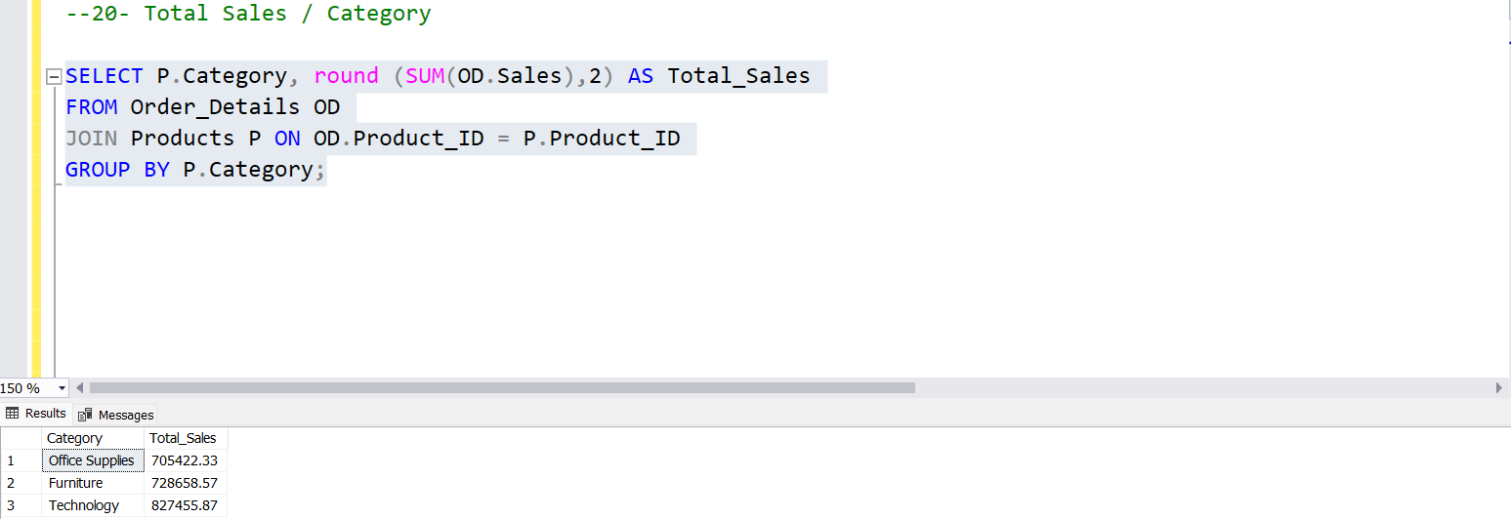

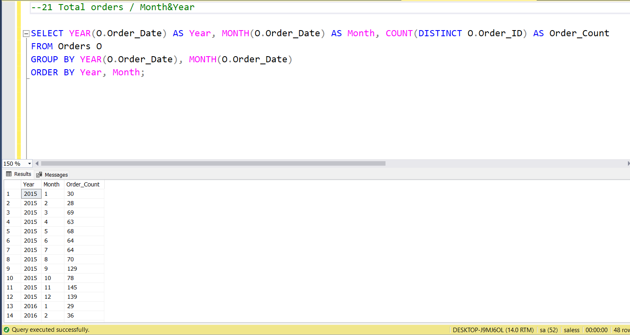

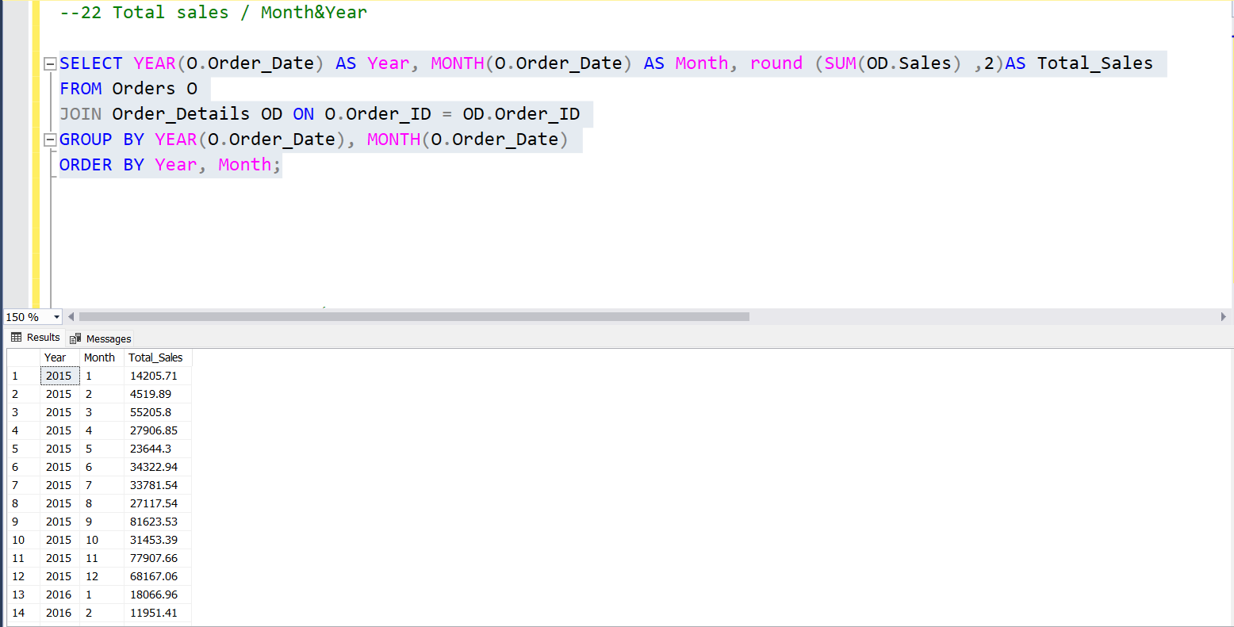

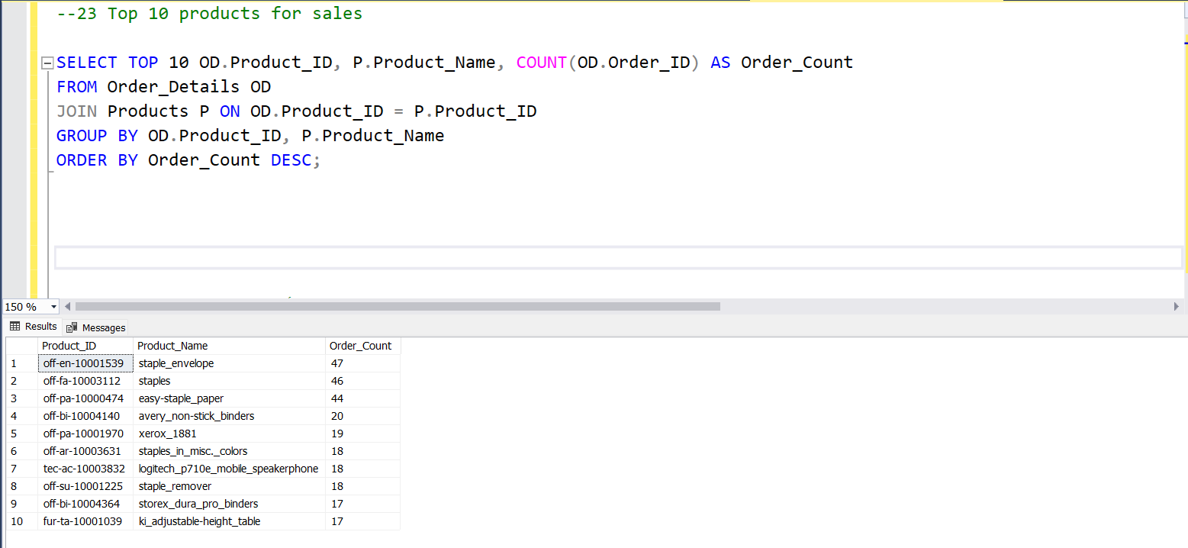

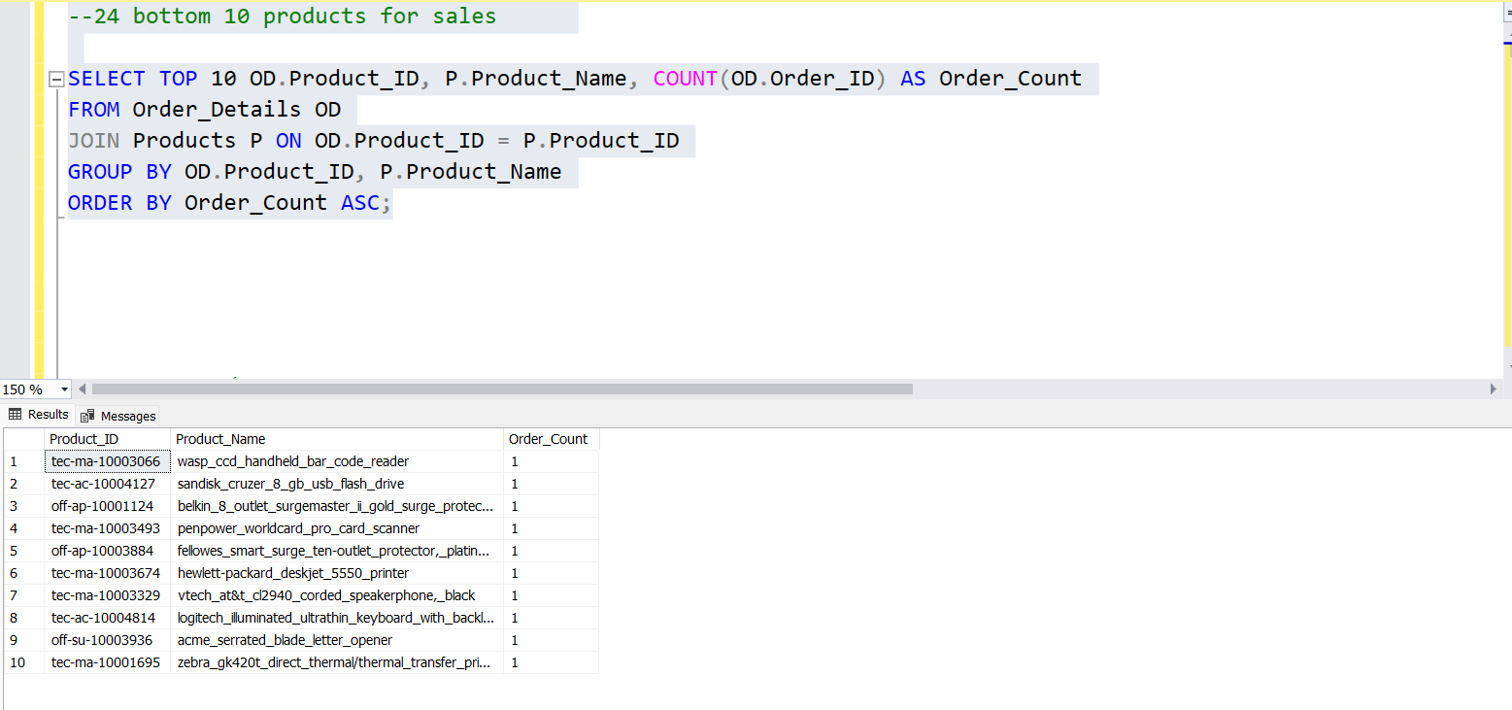

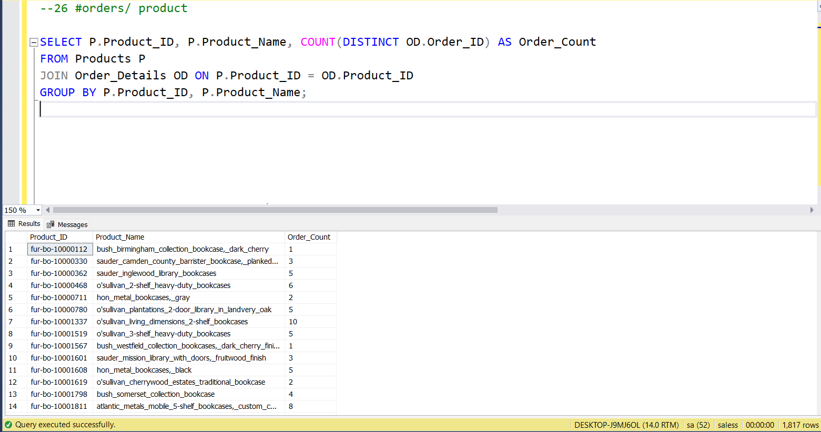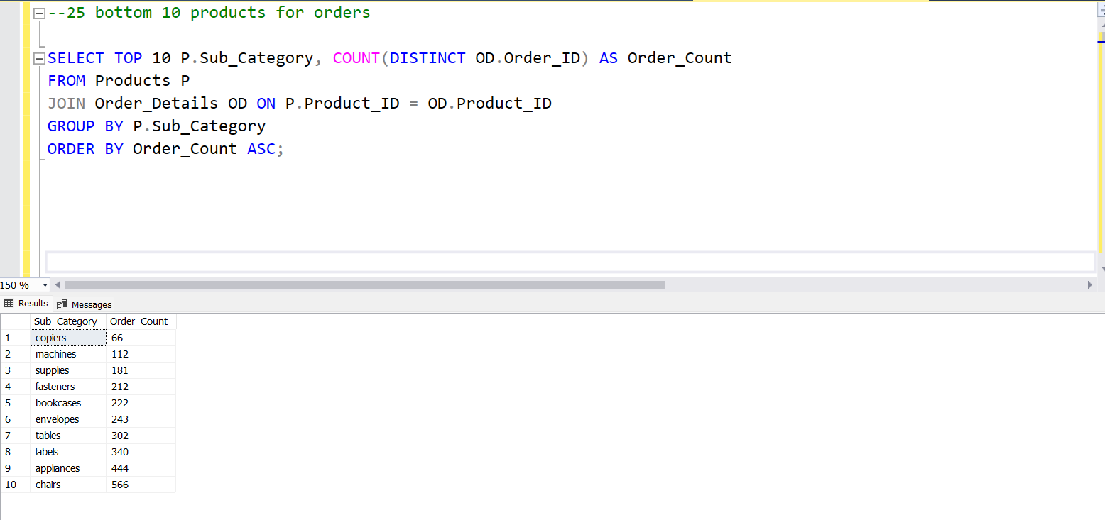

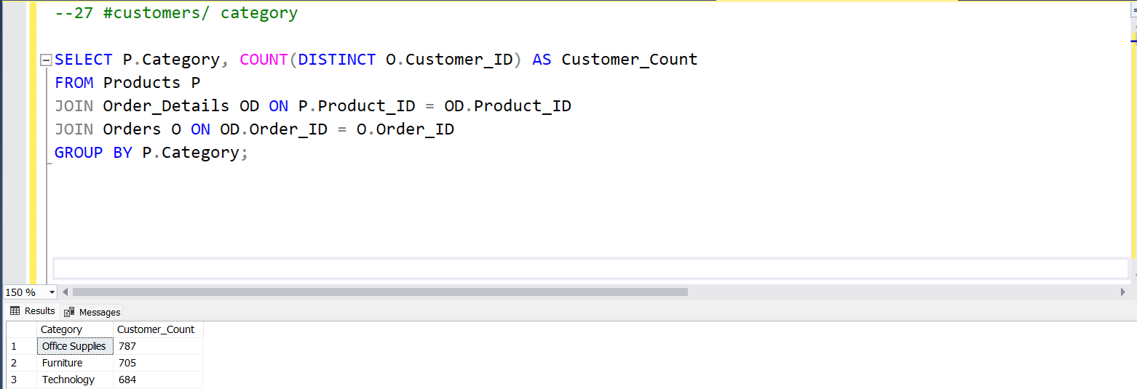

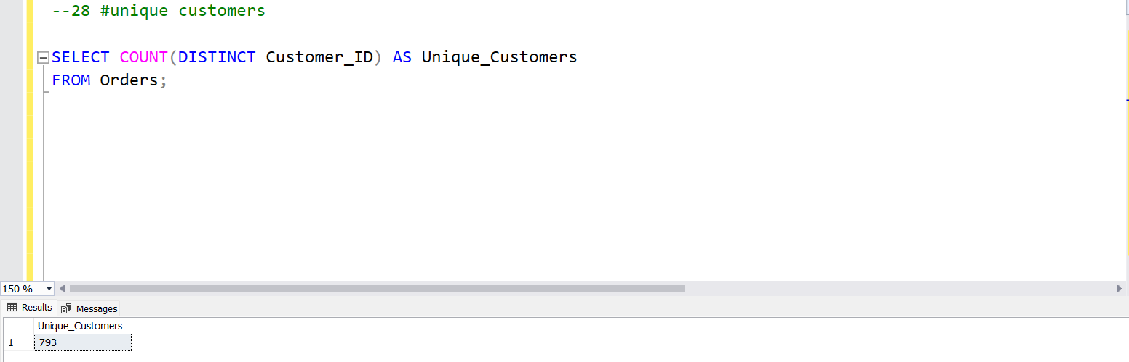

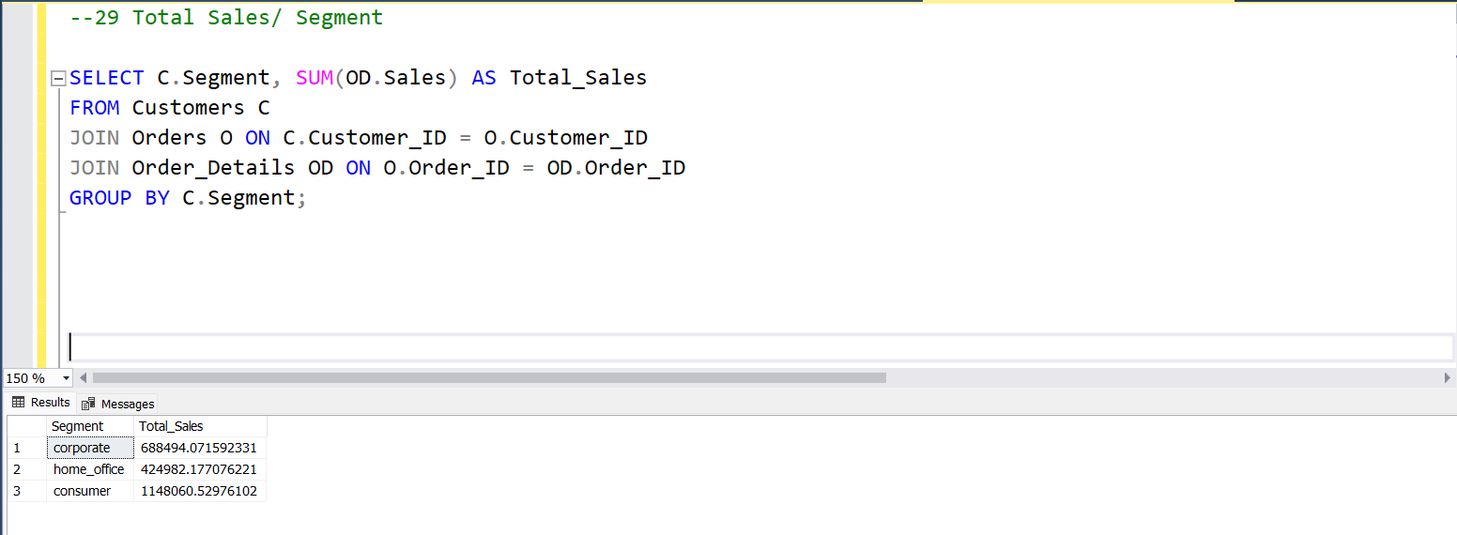

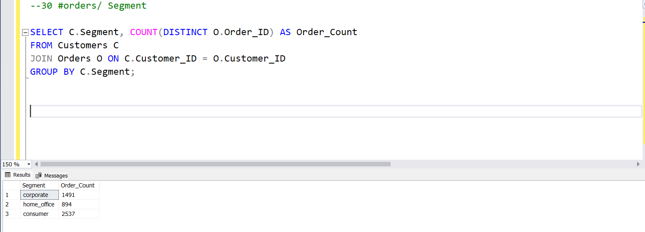

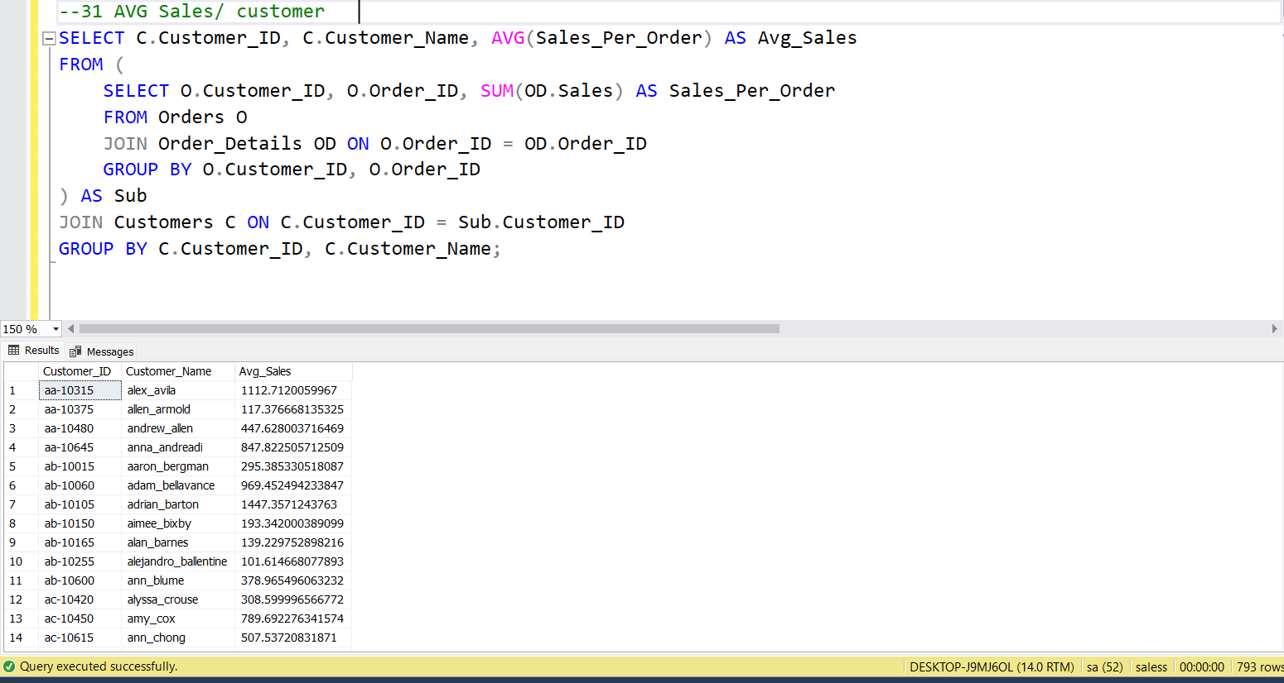

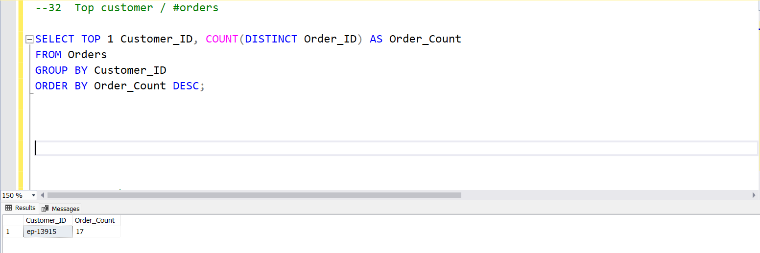

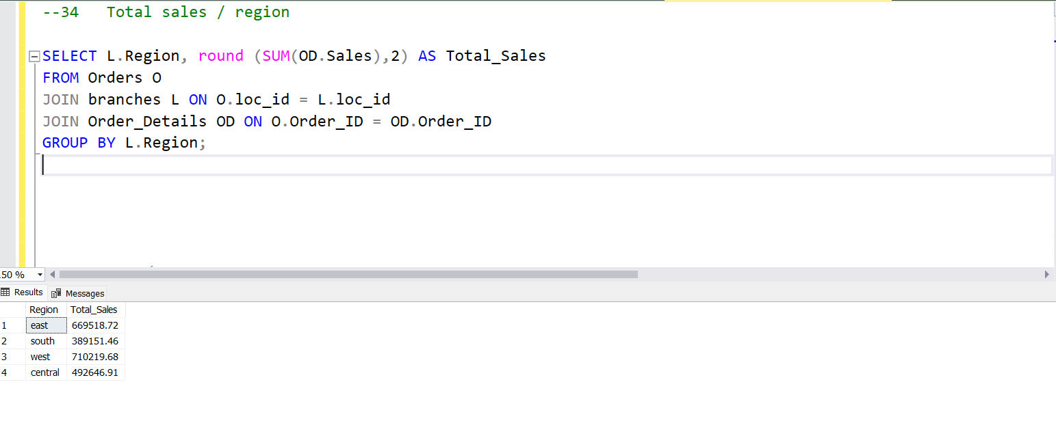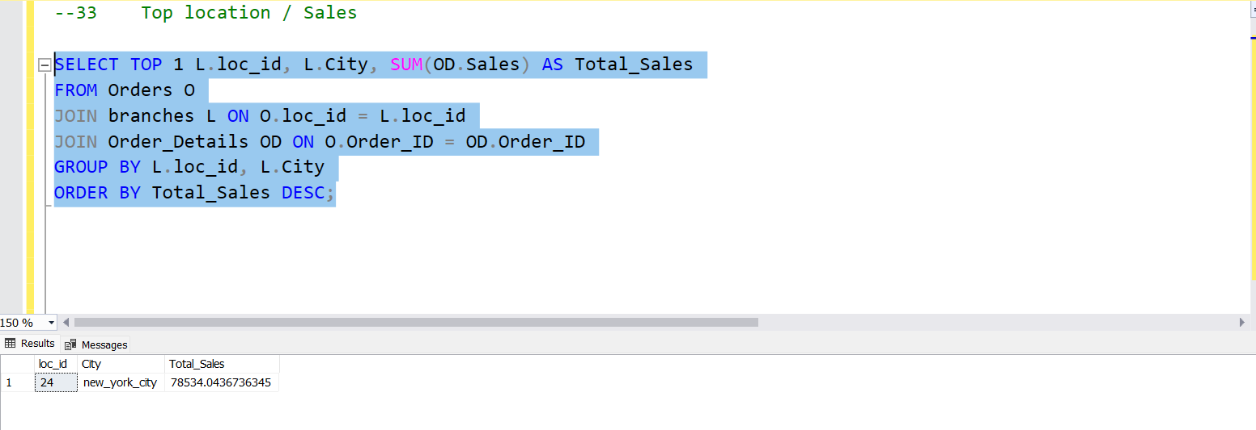

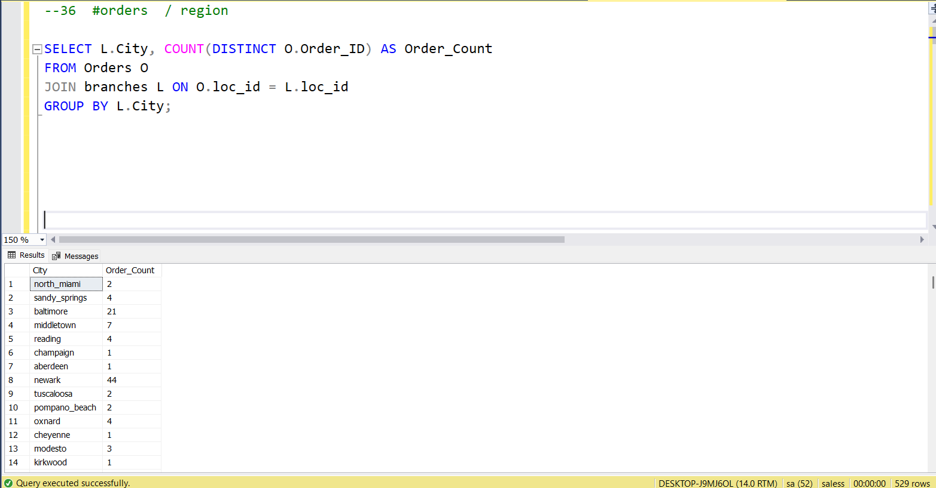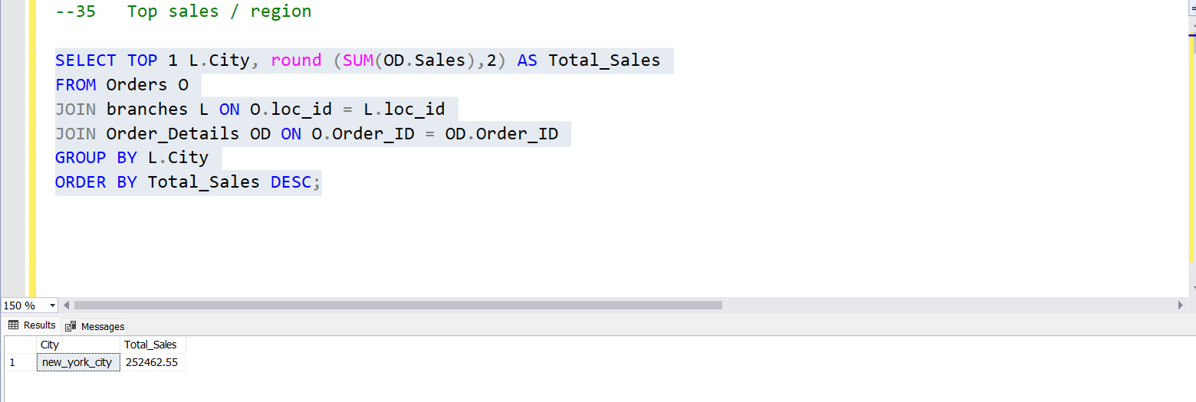

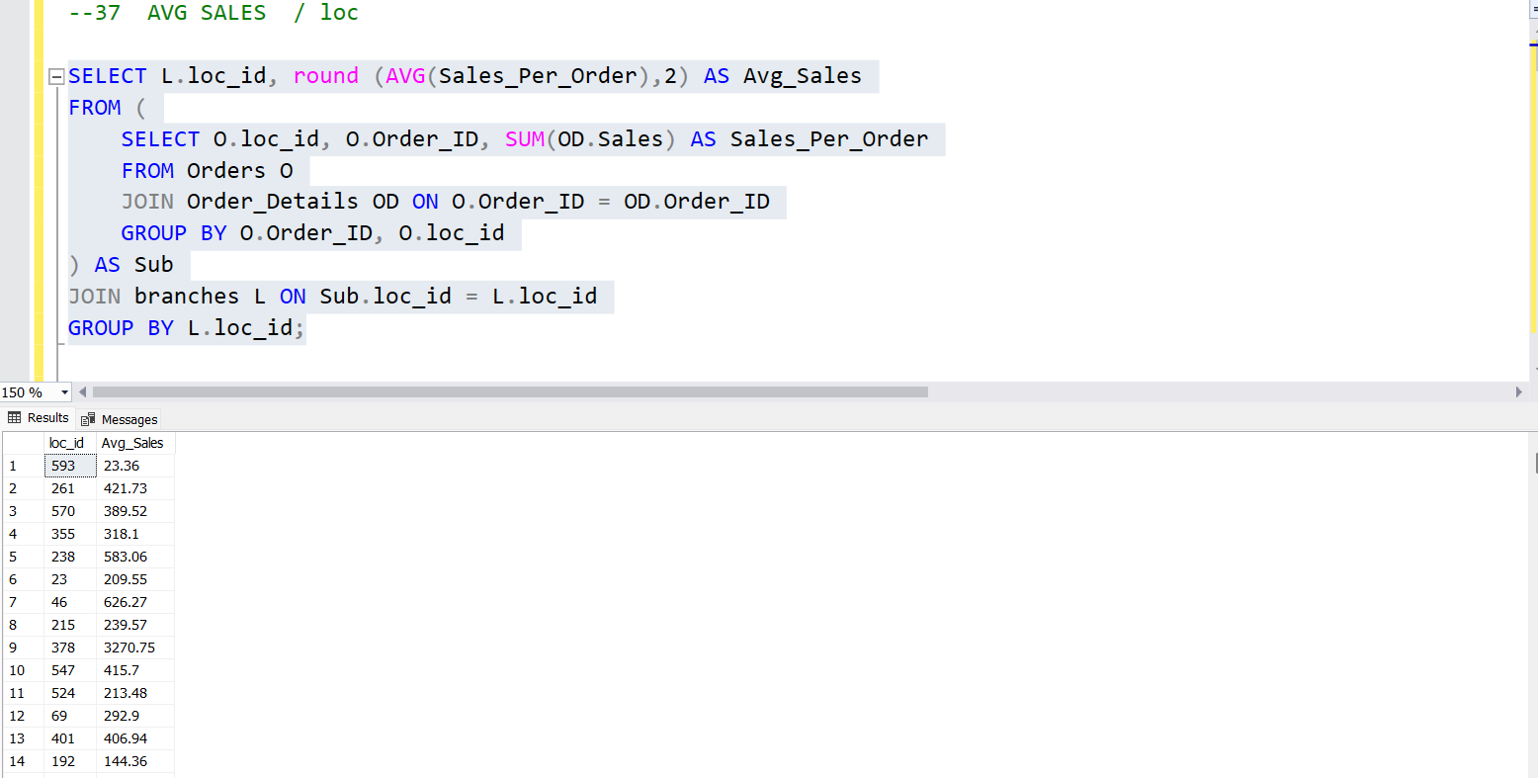

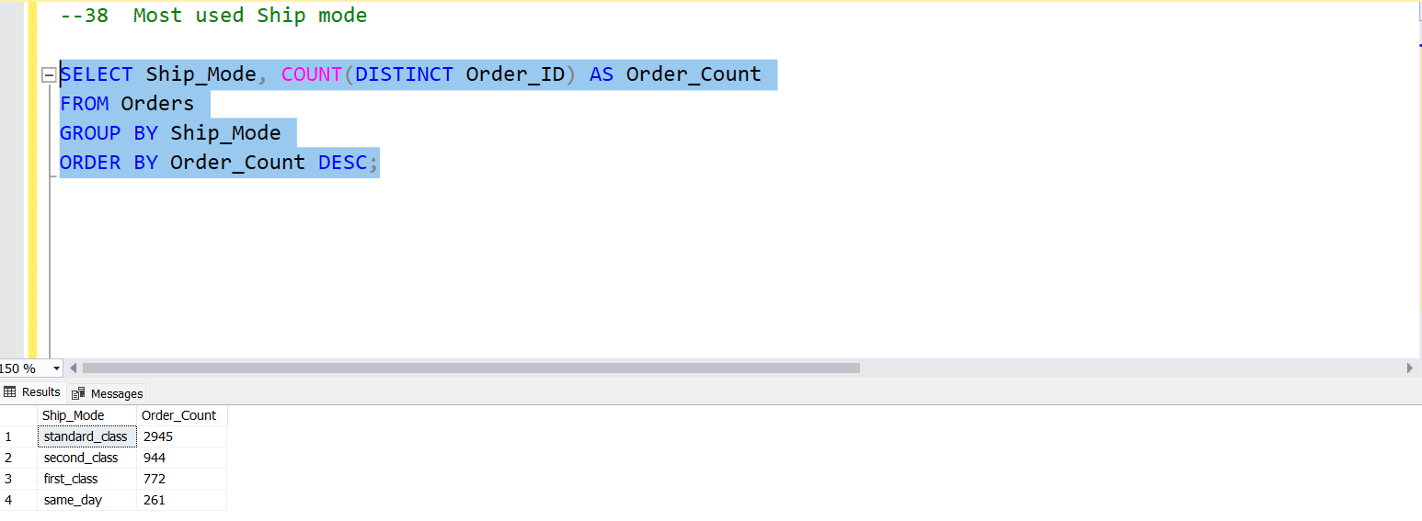

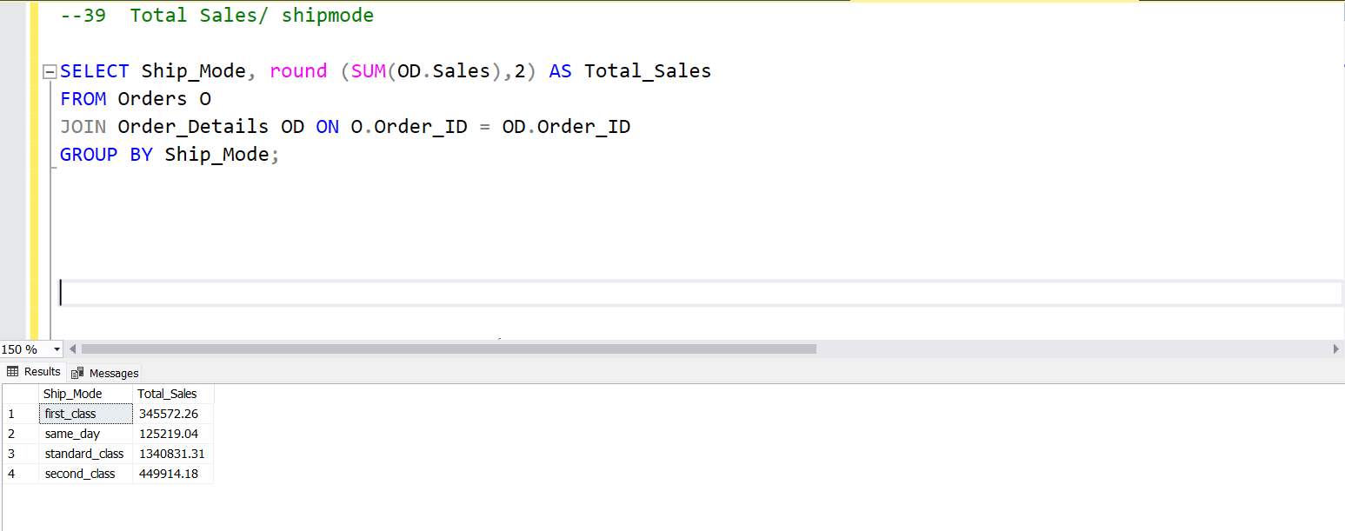

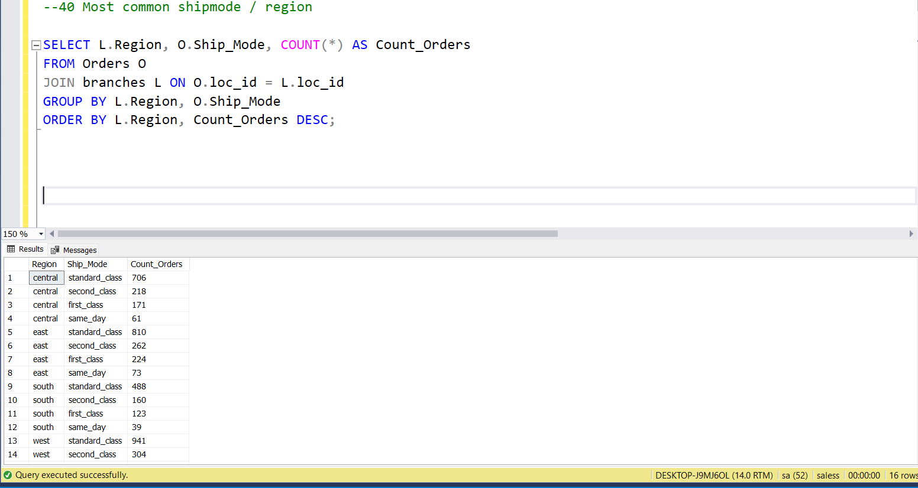

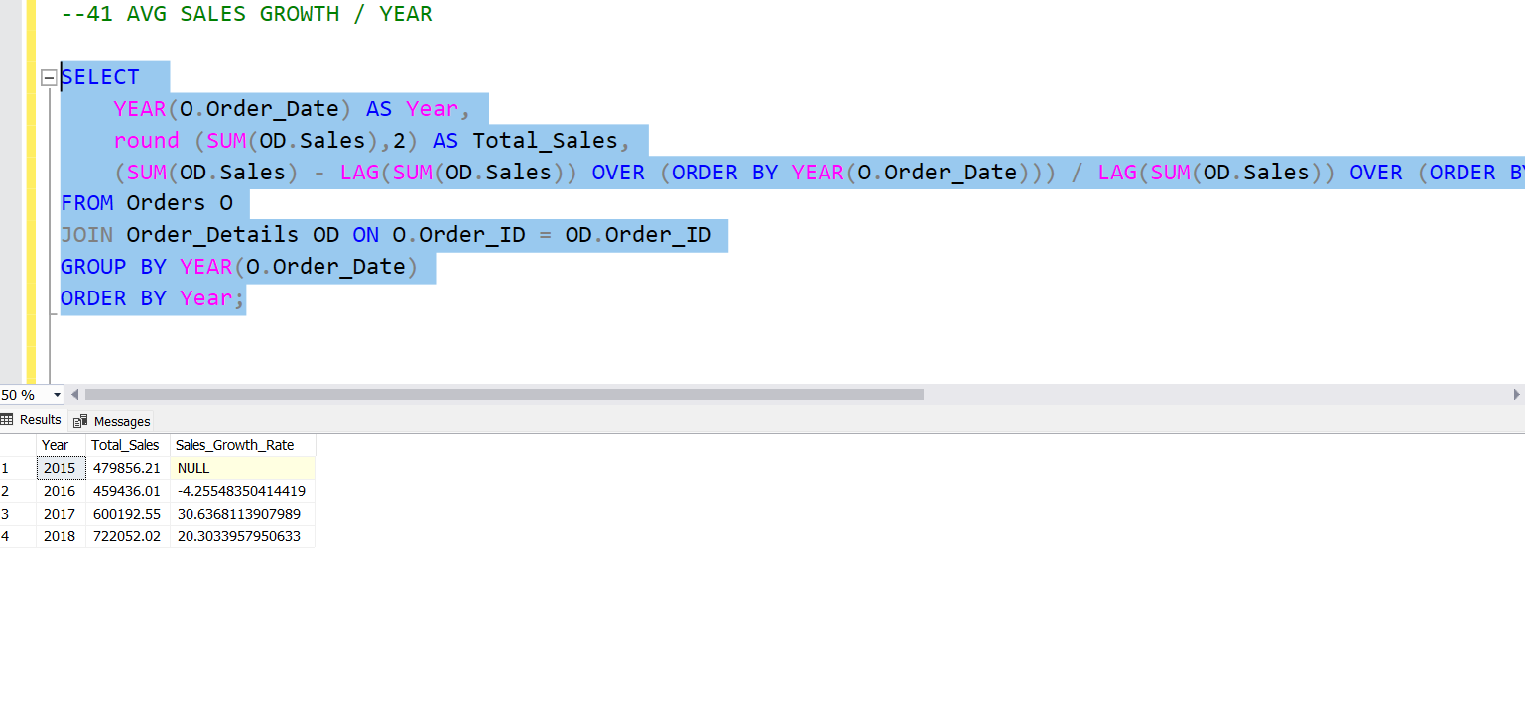

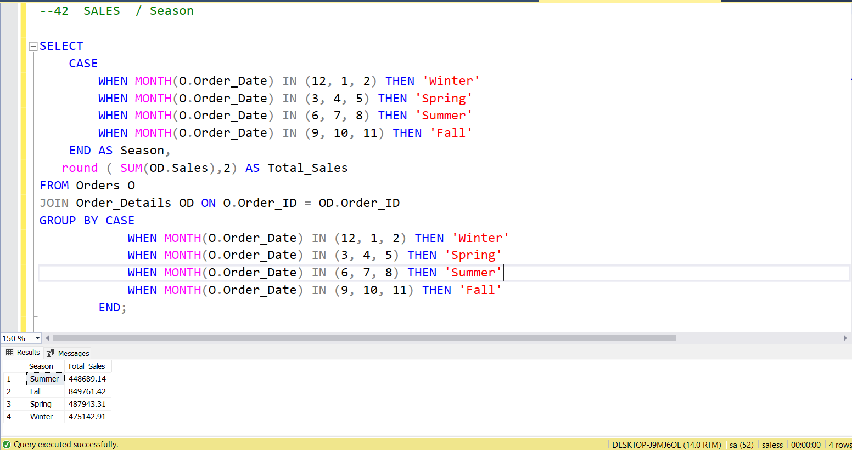

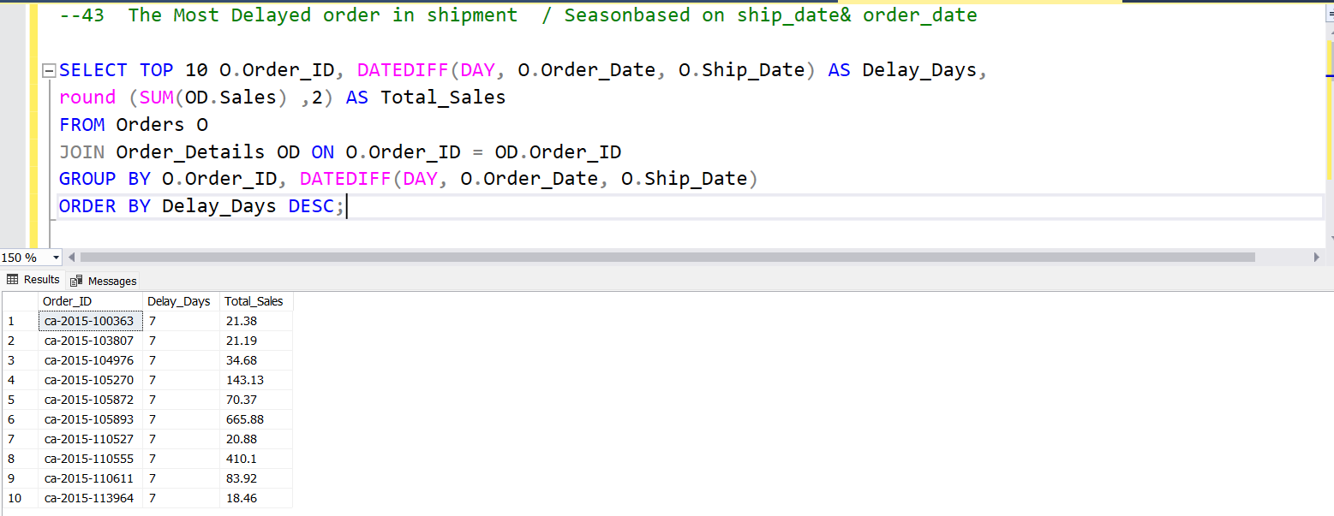

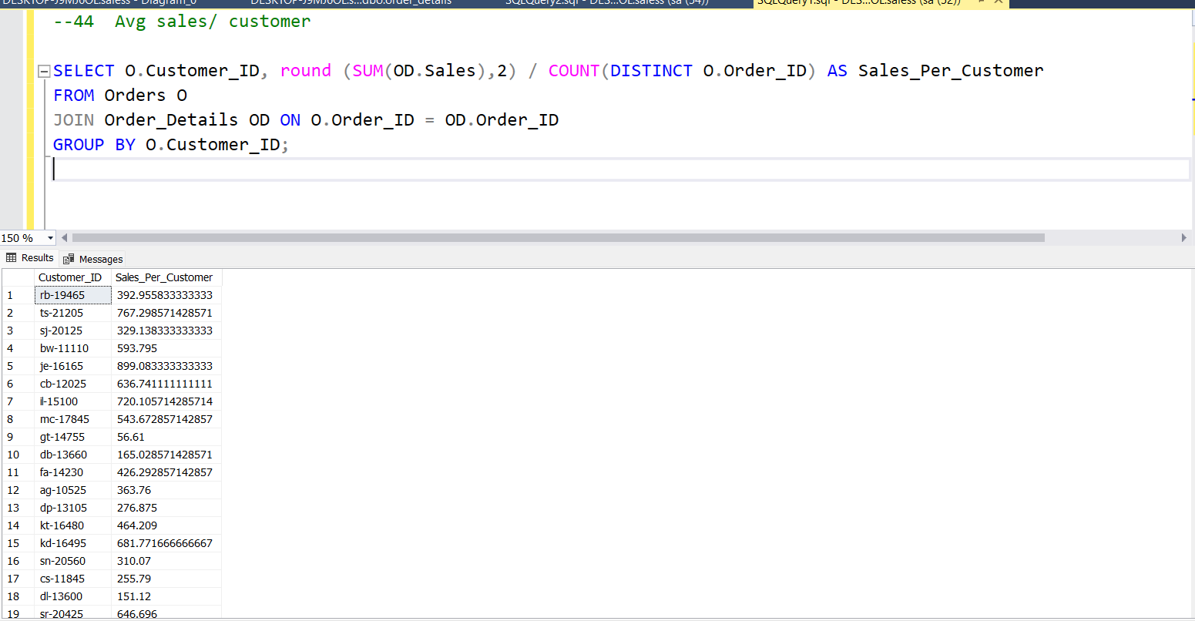

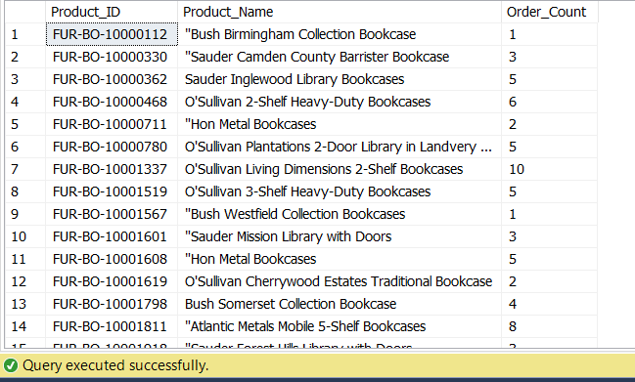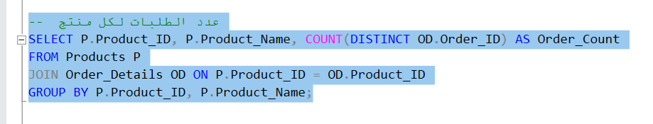

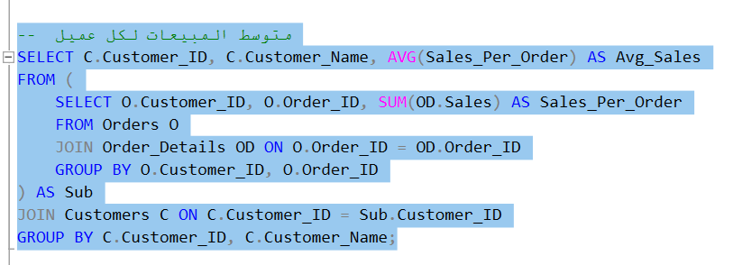

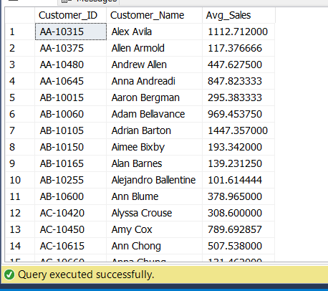

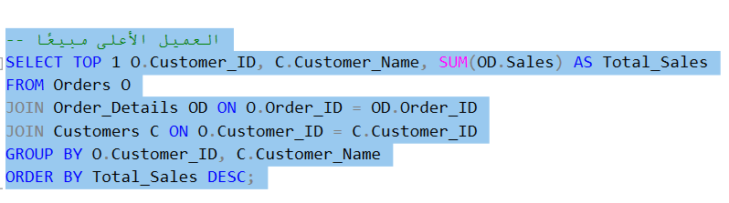**Query: Highest Spending Customer**

**Output:**

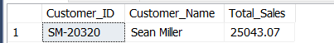

**Explanation: Returns the customer who generated the highest total sales.**

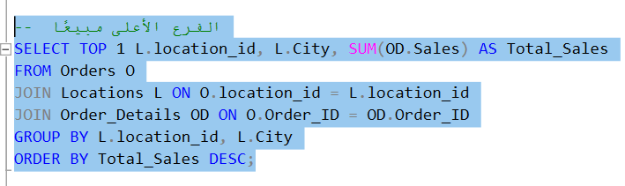**Query: Top-Selling Branch**

**Output:**

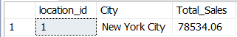

**Query: Total Sales by Region**

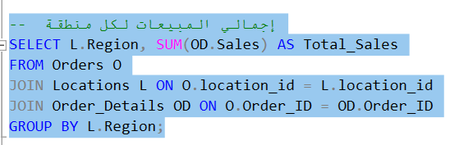

**Output:**

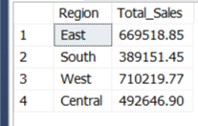

**Explanation: Displays total sales aggregated by each region.**

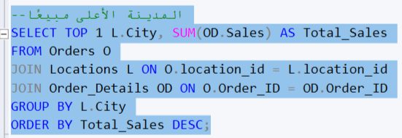**Query: Top-Selling City**

**Output:**

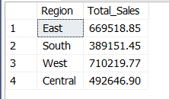

**Query: Number of Orders per City**

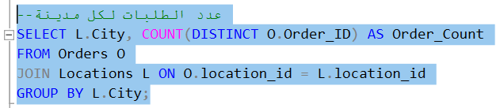

**Output:**

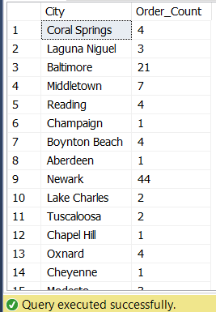

**Explanation: Counts the number of orders made in each city.**

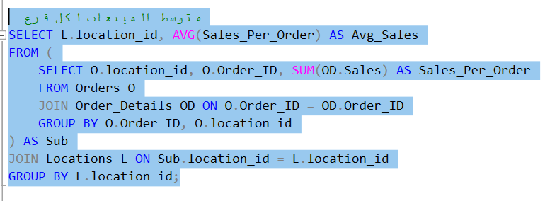**Query: Average Sales per Branch**

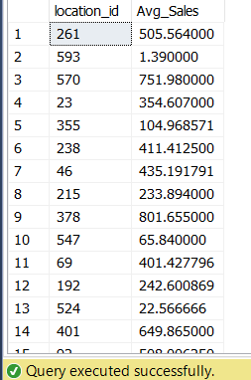

**Output:**

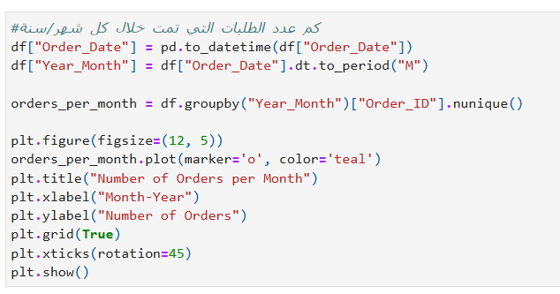**How many orders were placed each month/year?**

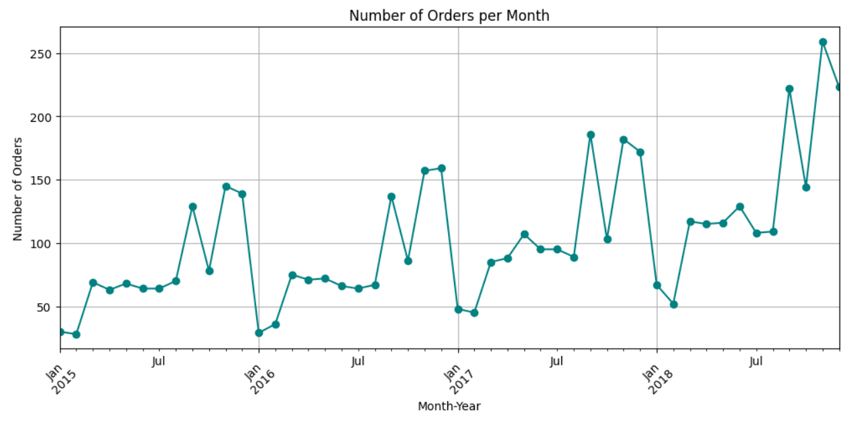**Output:**

**Explanation:**

**This code is useful because it calculates and visualizes the number of unique orders made in each month over time. It helps identify trends in customer demand, seasonal patterns, and overall sales activity, which supports forecasting and strategic planning**

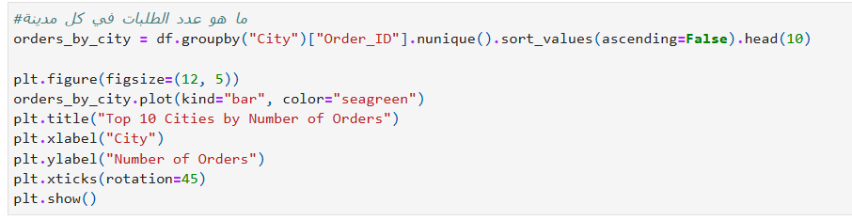**What is the number of orders in each city?**

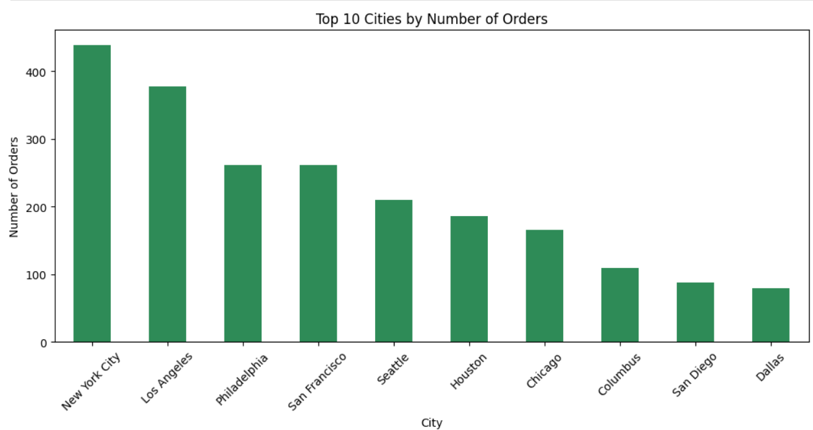**Output:**

**Explanation:**

**This code is useful because it shows the top 10 cities with the highest number of unique orders. It helps identify areas with high customer activity, guiding decisions related to marketing, logistics, and business expansion in the most active regions**

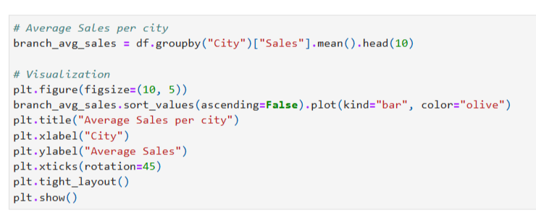**What is the average sales per city?**

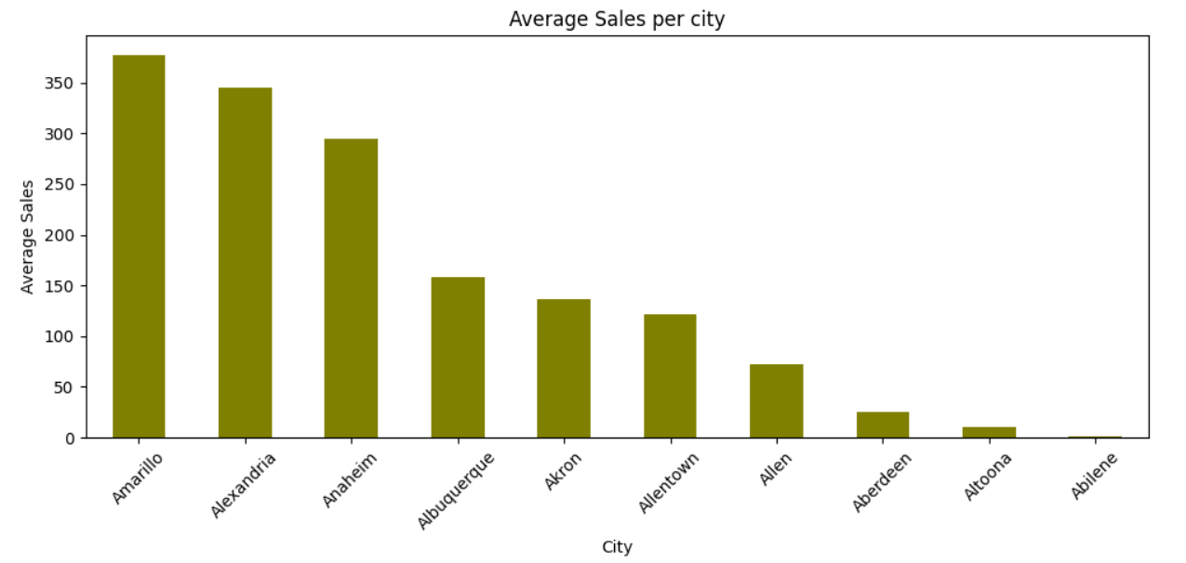**Output:**

**Explanation:**

**This code is useful because it calculates and visualizes the average sales value per city. It helps identify cities with high-value transactions, which can guide targeted marketing, resource allocation, and regional performance analysis**

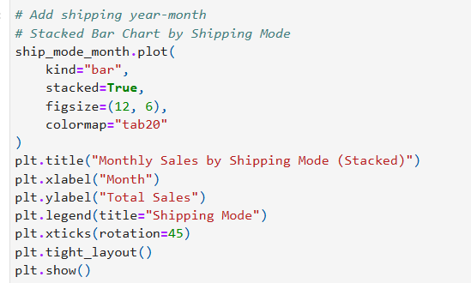**How do monthly sales vary by shipping mode?**

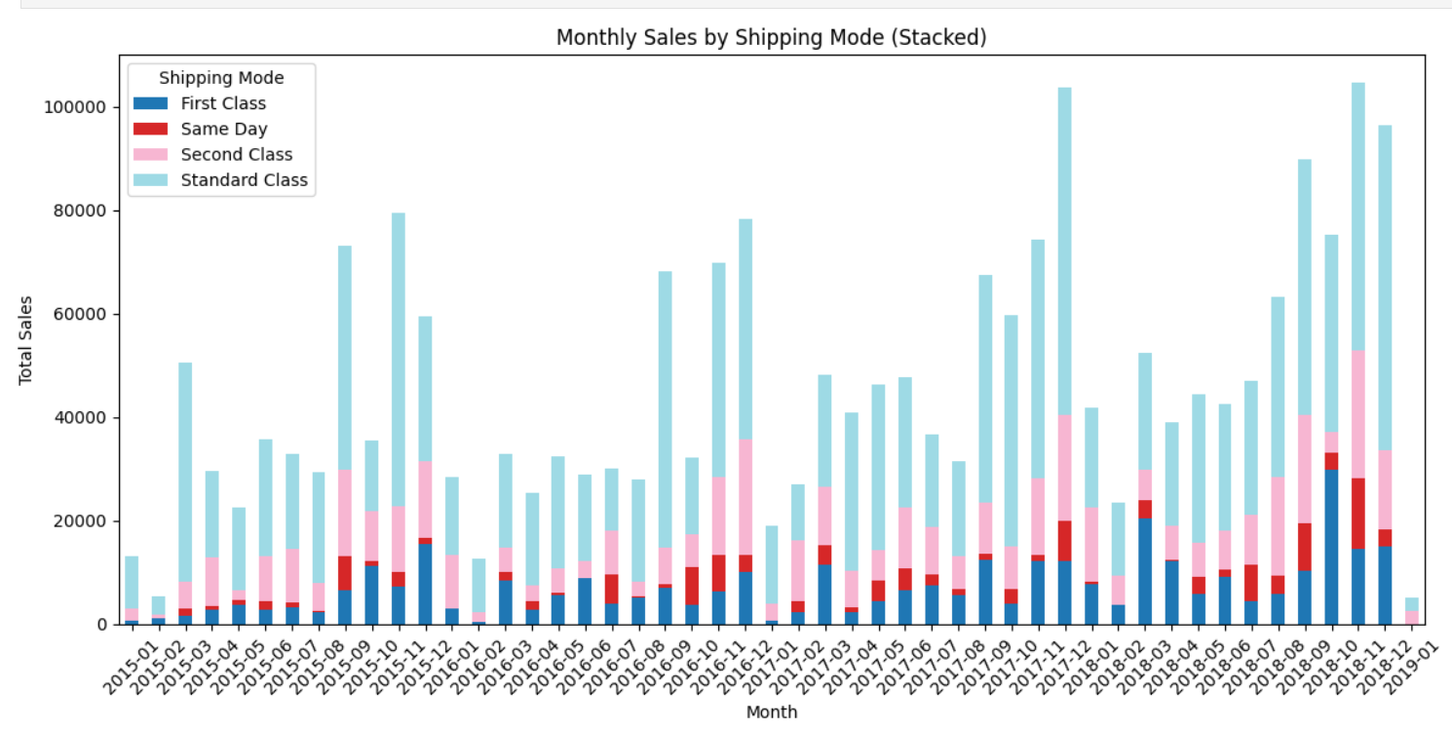**Output:**

**Explanation:**

**This code is useful because it visualizes total sales per month categorized by shipping mode using a stacked bar chart. It helps analyze how different shipping methods contribute to monthly sales, offering insights for optimizing logistics and customer delivery preferences**





# Grouping by sub_category and AVG Sales for each sub_category

sub_category_AVG = df.groupby(['sub_category','category'])['sales'].mean()

sub_category_AVG = sub_category_AVG.sort_values(ascending=False)

sub_category_AVG.plot(kind='bar',color='darkblue',width=0.7,xlabel='sub_categoryand category',ylabel='AVG/SALES($)',title='Avgsales/sub_category',

figsize=(14,5),grid=True)

# Display values

for i, value in enumerate(sub_category_AVG):

plt.text(i, value + 100, f"{value:,.2f}", ha='center', fontsize=10, fontweight='bold')

plt.show()



# Grouping by sales for each Top 10 product_idtop_10_product_sales_counts = df.groupby(['product_id','sub_category'])['sales'].sum()

top_10_product_sales_counts = top_10_product_sales_counts.sort_values(ascending=False).head(10)

# Plotting the bar chart

top_10_product_sales_counts.plot(kind='bar',color='darkblue',width=0.7,xlabel='product_id and cateogry',ylabel='sales($)',title='sales($)/Top10 product_id',figsize=(12,4),grid=True)

# Display values

for i, value in enumerate(top_10_product_sales_counts):

plt.text(i, value + 100, f"{value:,.2f}", ha='center', fontsize=10, fontweight='bold')

# Display the plot

plt.show()

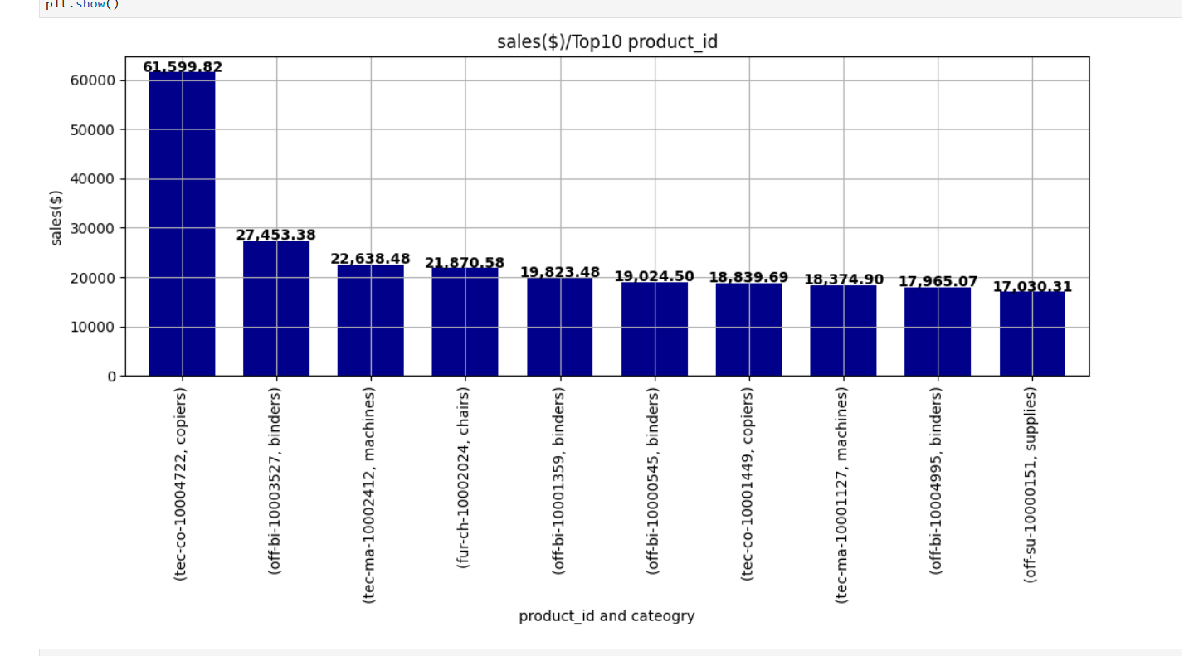

# Grouping by sales for each Top 10 product_id

bottom_10_product_sales_counts = df.groupby(['product_id','sub_category'])['sales'].sum().head(10)

# Sorting the data in ascending order

bottom_10_product_sales_counts = bottom_10_product_sales_counts.sort_values(ascending=True)

# Plotting the bar chart

bottom_10_product_sales_counts.plot(kind='bar',color='darkblue',width=0.7,xlabel='product_id and cateogry',ylabel='sales($)',

title='sales($)/bottom10 product_id',figsize=(12,4),grid=True)

# Display values

for i, value in enumerate(bottom_10_product_sales_counts):

plt.text(i, value + 100, f"{value:,.2f}", ha='center', fontsize=10, fontweight='bold')

# Display the plot

plt.show()

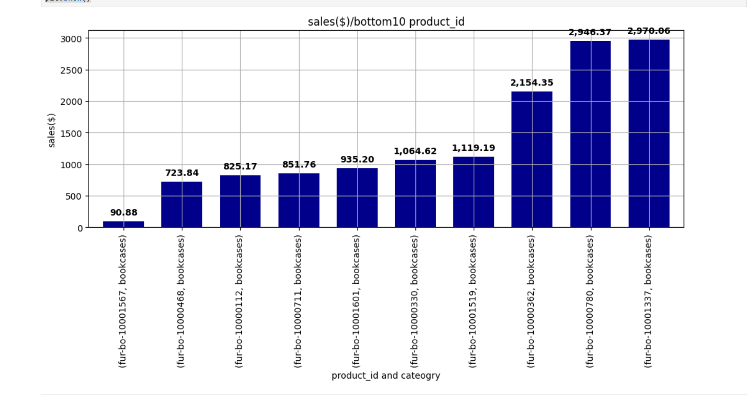

# Grouping by product_id and counting the order_id for each product_id

product_category_counts = df.groupby(['product_id','sub_category'])['order_id'].count()

bottom_10_product_category_counts = product_category_counts.sort_values(ascending=True).tail(10)

# Plotting the bar chart

bottom_10_product_category_counts.plot(kind='bar',color='darkblue',width=0.7,xlabel='product_id and cateogry',ylabel='#order',figsize=((12,4)),

title='#order/bottom10 product_id',grid=True)

# Display the plot

plt.show()

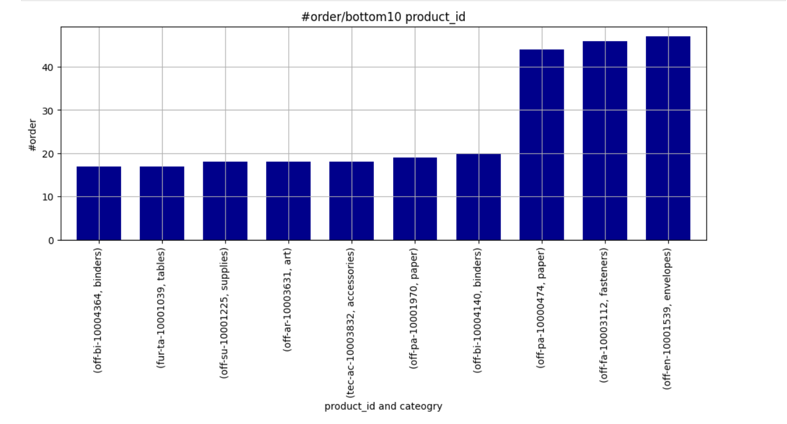

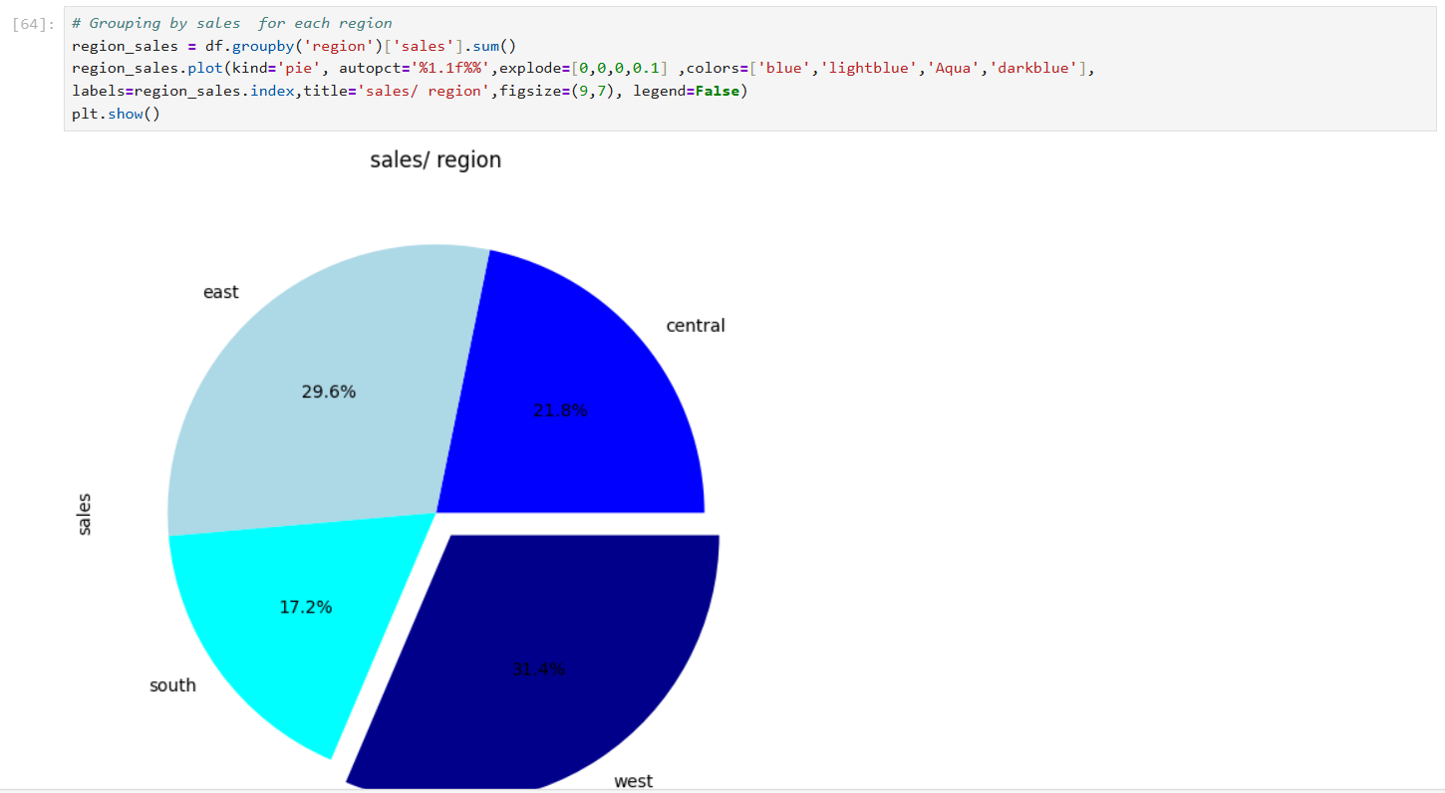

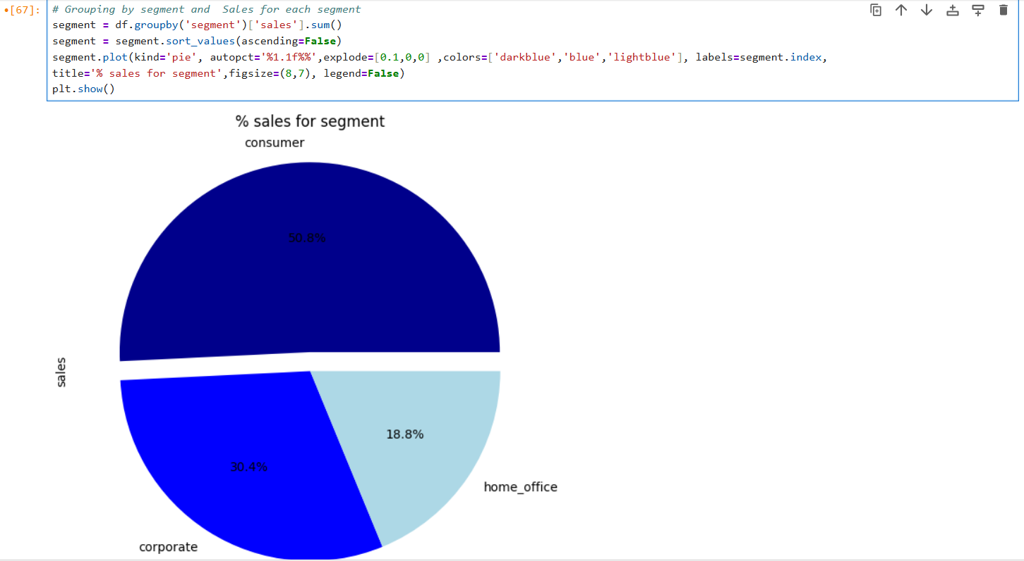

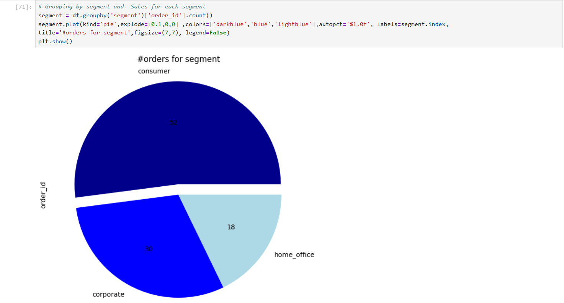

# Grouping by loc_id and city and total sales for each loc_id and city

loc_id_city_Sales = df.groupby(['loc_id','city'])['sales'].sum()

top_10_loc_id_city_Sales = loc_id_city_Sales.sort_values(ascending=False).head(10)

# Plotting the bar chart

top_10_loc_id_city_Sales.plot(kind='bar',color='darkblue',width=0.7,xlabel='loc_id and city',ylabel='sales($)',title='Top10loc_id and city/sales',

figsize=(12,4),grid=True)

# Display values

for i, value in enumerate(top_10_loc_id_city_Sales):

plt.text(i, value + 100, f"${value:,.2f}", ha='center', fontsize=9, fontweight='bold')

plt.show()

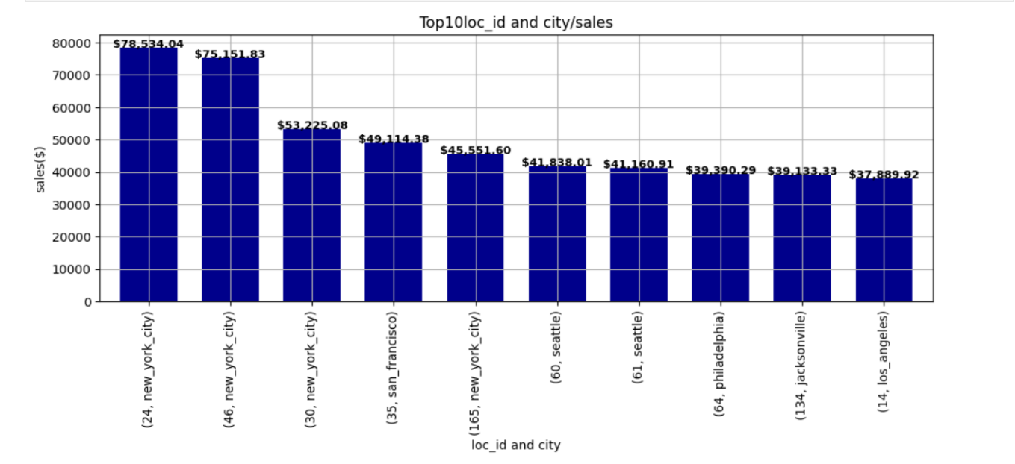

# Grouping by customer_id and total sales for each customer_id

customer_Sales = df.groupby(['customer_id','customer_name'])['sales'].sum()

top_10_customer_Sales = customer_Sales.sort_values(ascending=False).head(10)

# Plotting the bar chart

top_10_customer_Sales.plot(kind='bar',color='darkblue',width=0.7,xlabel='customer_id',ylabel='sales ($)',title='Top10customer_id/sales',

figsize=(10,4),grid=True)

# Display values

for i, value in enumerate(top_10_customer_Sales):

plt.text(i, value + 100, f"${value:,.2f}", ha='center', fontsize=9, fontweight='bold')

# Display the plot

plt.show()

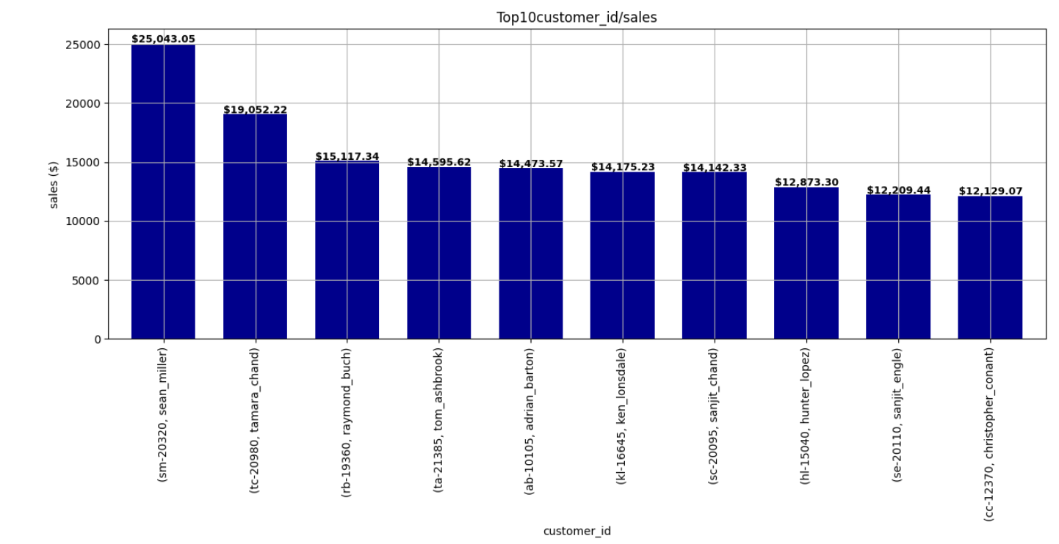

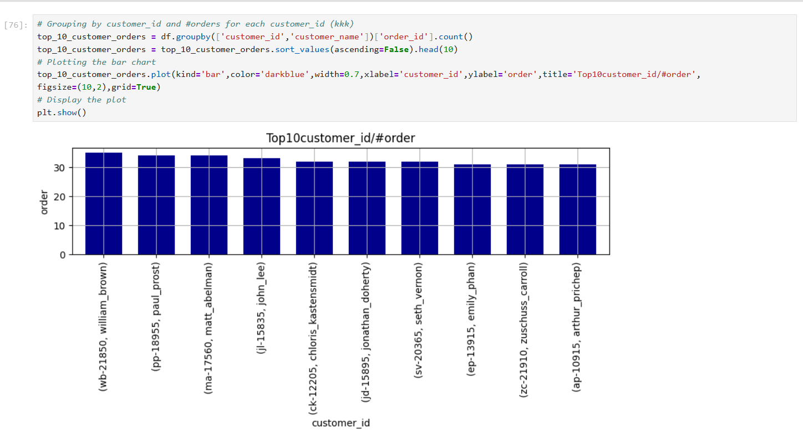

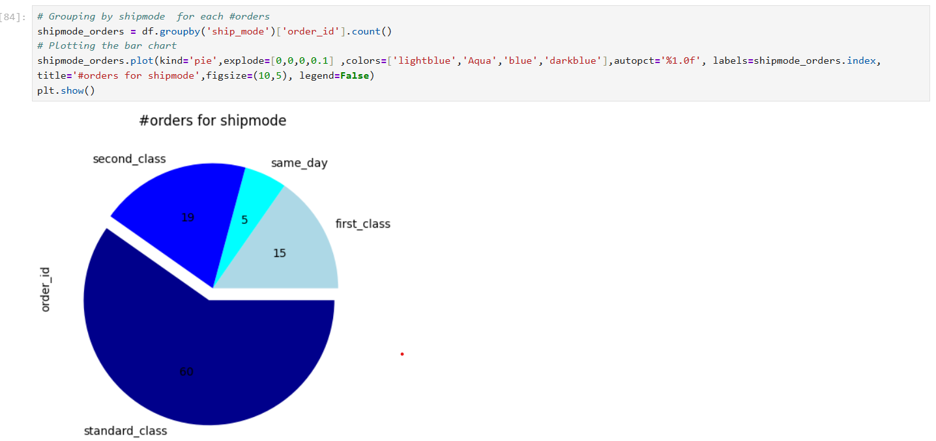

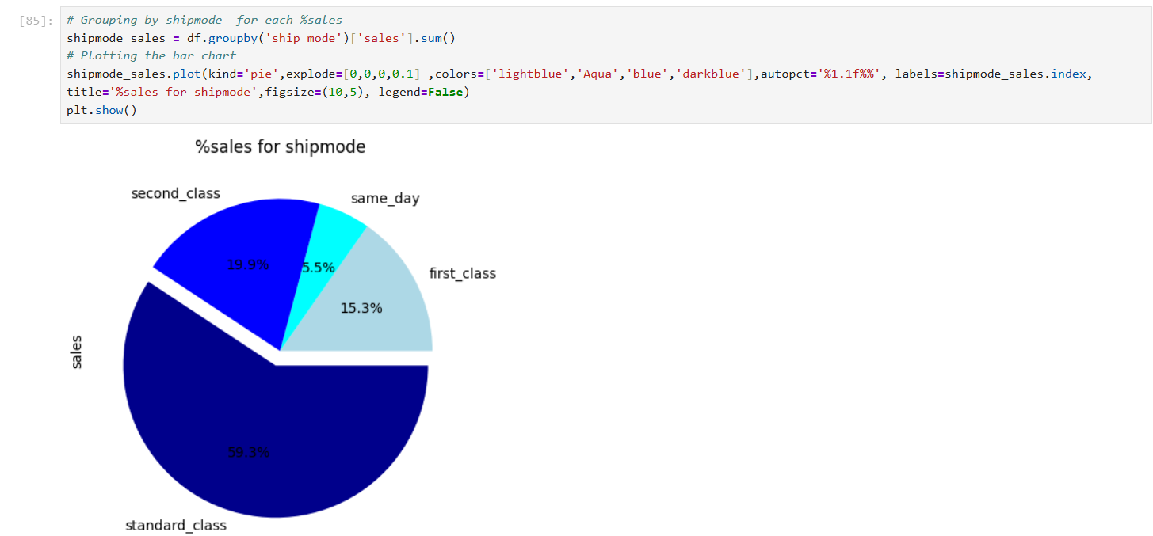

# Grouping by state for each #ship_mode

shipmode_state = df.groupby('state')['ship_mode'].count()

shipmode_state = shipmode_state.sort_values(ascending=False)

# Plotting the bar chart

shipmode_state.plot(kind='bar',color='darkblue',width=0.7,xlabel='state',ylabel='#ship_mode',title='#ship_mode/state',figsize=(18,7),grid=True)

# Display the plot

plt.show()

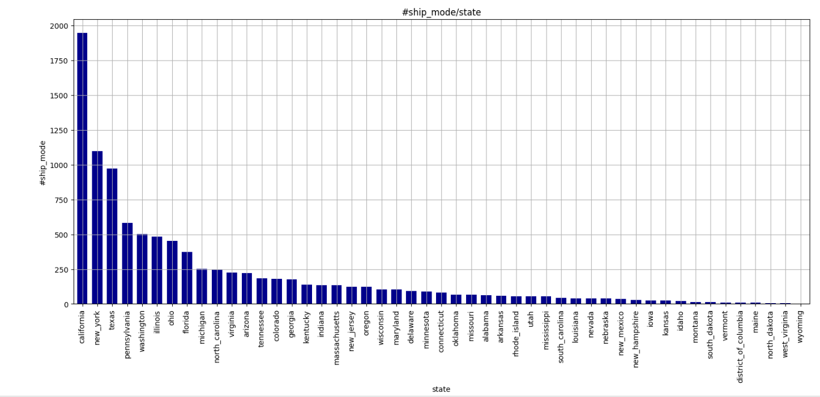

Grouping by state for each sales (kkk)

state = df.groupby('state')['sales'].sum()

state = state.sort_values(ascending=False)

# Plotting the bar chart

state.plot(kind='bar',color='darkblue',width=0.8,xlabel='state',ylabel='sales($)',title='sales/state',figsize=(18,7),grid=True)

# Display the plot

plt.show()

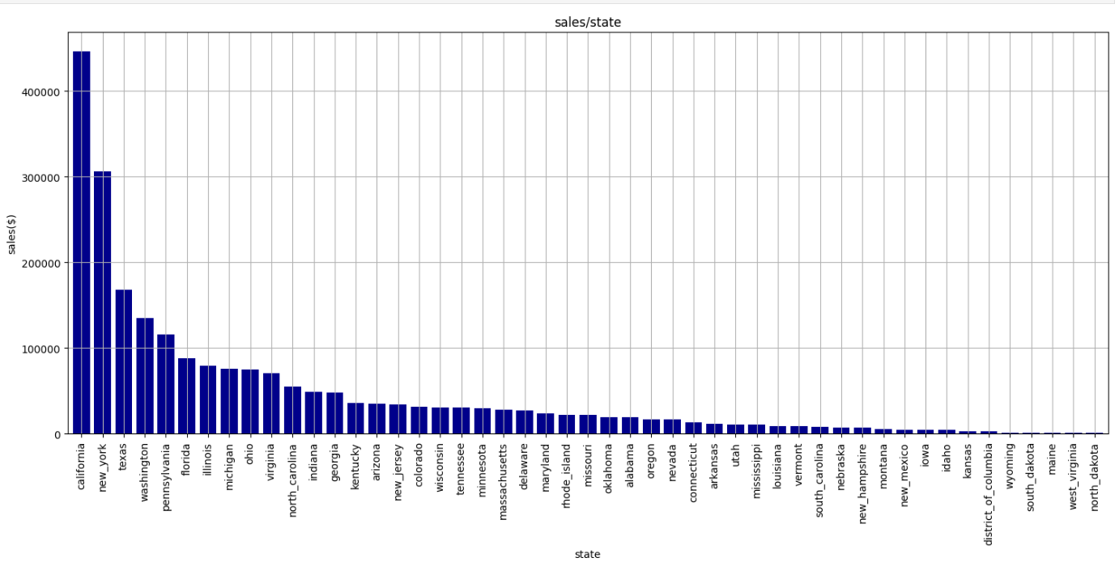

# Grouping by dayofweek for each #orders

city_order = df.groupby('state')['order_id'].count()

city_order = city_order.sort_values(ascending=False).head(10)

# Plotting the bar chart

city_order.plot(kind='bar',color='darkblue',width=0.7,xlabel='state',ylabel='#orders',title='#orders/city',figsize=(18,7),grid=True)

# Display the plot

plt.show()

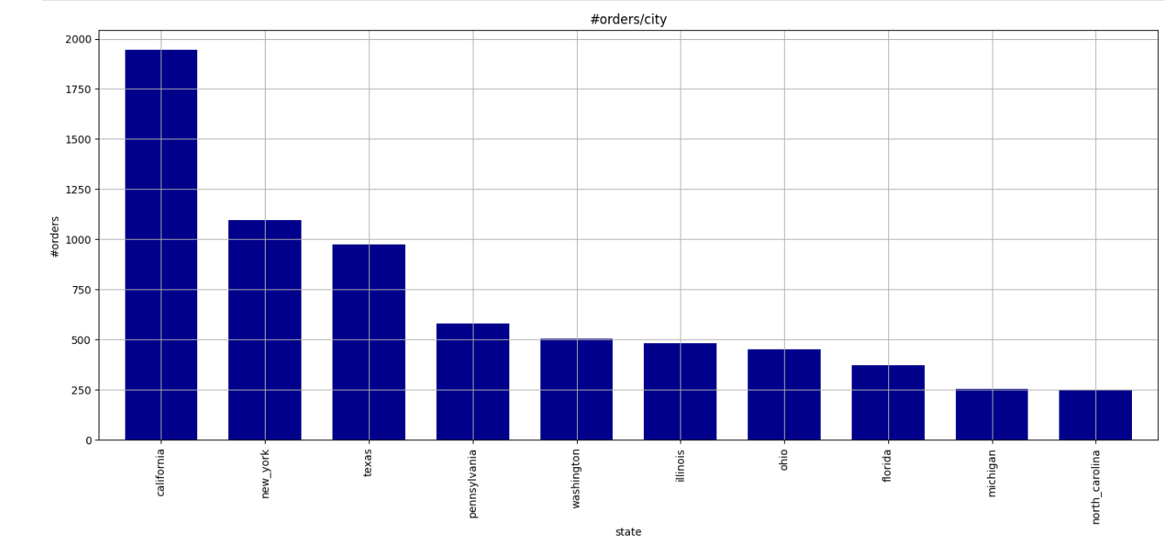

**#create a new column (seson)**

# Assuming df is your DataFrame with 'order_date' as a column

# Convert 'order_date' to datetime if it's not already

df['order_date'] = pd.to_datetime(df['order_date'])

# Function to map months to seasons

def get_season(month):

if month in [12, 1, 2]:

return 'Winter'

elif month in [3, 4, 5]:

return 'Spring'

elif month in [6, 7, 8]:

return 'Summer'

elif month in [9, 10, 11]:

return 'Fall'

# Create a new column 'season' based on 'order_date'

df['season'] = df['order_date'].dt.month.apply(get_season)

# Show the updated dataframe with the new 'season' column

print(df)

order_id order_date ship_date ship_mode customer_id \

0 ca-2017-152156 2017-11-08 2017-11-11 second_class cg-12520

1 ca-2017-152156 2017-11-08 2017-11-11 second_class cg-12520

2 ca-2017-138688 2017-06-12 2017-06-16 second_class dv-13045

3 us-2016-108966 2016-10-11 2016-10-18 standard_class so-20335

4 us-2016-108966 2016-10-11 2016-10-18 standard_class so-20335

... ... ... ... ... ...

9794 ca-2017-125920 2017-05-21 2017-05-28 standard_class sh-19975

9795 ca-2016-128608 2016-01-12 2016-01-17 standard_class cs-12490

9796 ca-2016-128608 2016-01-12 2016-01-17 standard_class cs-12490

9797 ca-2016-128608 2016-01-12 2016-01-17 standard_class cs-12490

9798 ca-2016-128608 2016-01-12 2016-01-17 standard_class cs-12490

loc_id country city state postal_code ... \

0 1 united_states henderson kentucky 42420.0 ...

1 1 united_states henderson kentucky 42420.0 ...

2 2 united_states los_angeles california 90036.0 ...

3 3 united_states fort_lauderdale florida 33311.0 ...

4 3 united_states fort_lauderdale florida 33311.0 ...

... ... ... ... ... ... ...

9794 27 united_states chicago illinois 60610.0 ...

9795 214 united_states toledo ohio 43615.0 ...

9796 214 united_states toledo ohio 43615.0 ...

9797 214 united_states toledo ohio 43615.0 ...

9798 214 united_states toledo ohio 43615.0 ...

product_id sales \

0 fur-bo-10001798 261.9600

1 fur-ch-10000454 731.9400

2 off-la-10000240 14.6200

3 fur-ta-10000577 957.5775

4 off-st-10000760 22.3680

... ... ...

9794 off-bi-10003429 3.7980

9795 off-ar-10001374 10.3680

9796 tec-ph-10004977 235.1880

9797 tec-ph-10000912 26.3760

9798 tec-ac-10000487 10.3840

product_name category \

0 bush_somerset_collection_bookcase Furniture

1 hon_deluxe_fabric_upholstered_stacking_chairs,... Furniture

2 self-adhesive_address_labels_for_typewriters_b... Office Supplies

3 bretford_cr4500_series_slim_rectangular_table Furniture

4 eldon_fold_'n_roll_cart_system Office Supplies

... ... ...

9794 cardinal_holdit!_binder_insert_strips,extra_st... Office Supplies

9795 bic_brite_liner_highlighters,_chisel_tip Office Supplies

9796 ge_30524ee4 Technology

9797 anker_24w_portable_micro_usb_car_charger Technology

9798 sandisk_cruzer_4_gb_usb_flash_drive Technology

sub_category order_day_name ship_day_name duration delayed_order season

0 bookcases Wednesday Saturday 3 False Fall

1 chairs Wednesday Saturday 3 False Fall

2 labels Monday Friday 4 False Summer

3 tables Tuesday Tuesday 7 True Fall

4 storage Tuesday Tuesday 7 True Fall

... ... ... ... ... ... ...

9794 binders Sunday Sunday 7 True Spring

9795 art Tuesday Sunday 5 False Winter

9796 phones Tuesday Sunday 5 False Winter

9797 phones Tuesday Sunday 5 False Winter

9798 accessories Tuesday Sunday 5 False Winter

[9799 rows x 23 columns]

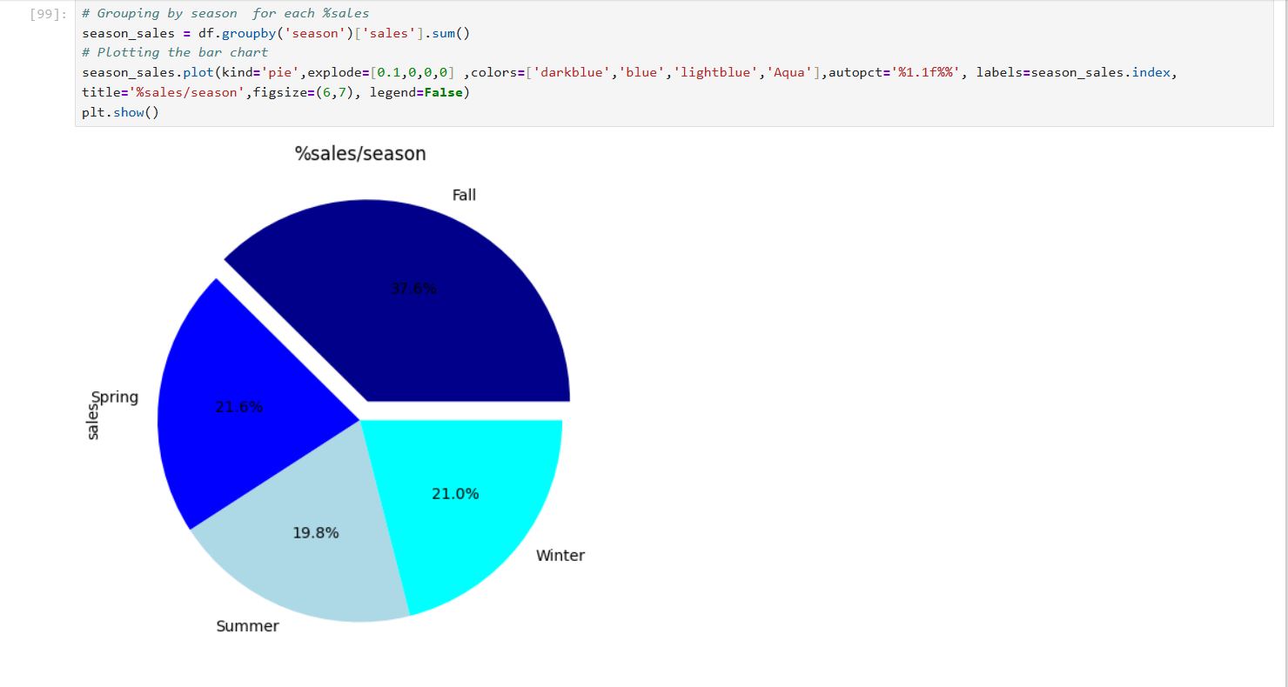

# Assuming 'df' is your DataFrame with 'order_date' and '#orders' columns

# Convert the 'order_date' column to datetime if it's not already

df['order_date'] = pd.to_datetime(df['order_date'])

# Filter the data for only the year 2018

df_filtered = df[df['order_date'].dt.year.isin ([2015,2016,2017,2018])]

# Group by '#orders'

top_10_orders_year= df_filtered.groupby(df_filtered['order_date'].dt.year)['order_id'].count()

# Plotting the line chart for the highest #orders in 2015,2016,2017,2018

top_10_orders_year.plot(kind='line',linewidth=2, color='darkblue',xlabel='year',ylabel='order_id_count',title='#orders/yearfor 2015,2016,2017, 2018',figsize=(15,7),grid=True)

plt.show()

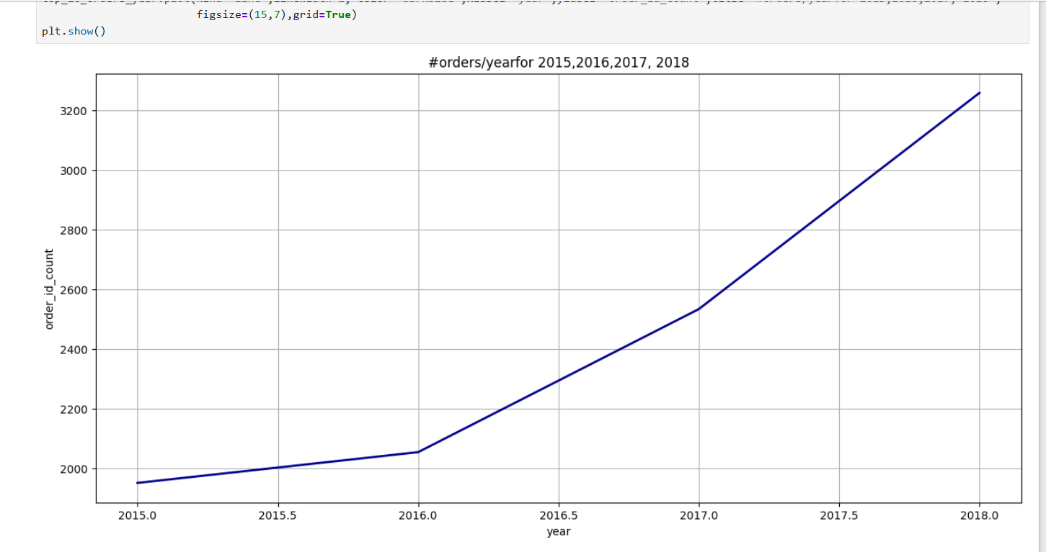

**Visualization TOOL: BY “Tableau”**

**Tableau**

**Tableau** is a powerful data visualization tool used in data analysis to create interactive and shareable dashboards. It enables users to connect to various data sources, visualize trends, and generate insights through dynamic graphs, charts, and maps. Tableau’s user-friendly interface allows both technical and non-technical users to explore and analyze data visually, making it an essential tool for data-driven decision-making.

**The Story of The assembled Dashboards**

**Link :** [**https://public.tableau.com/shared/CQNRYNX4G?:display_count=n&:origin=viz_share_link**](https://public.tableau.com/shared/CQNRYNX4G?:display_count=n&:origin=viz_share_link)

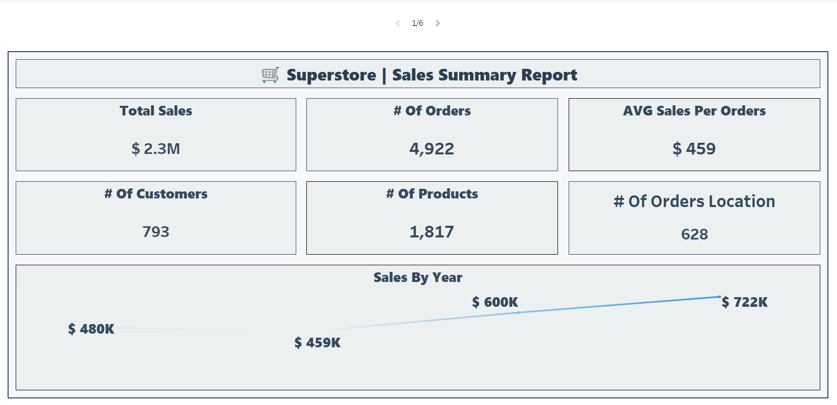

**Analysis Insights included 4 Dashboards divided into:**

1. **SALES DASHBOARD**

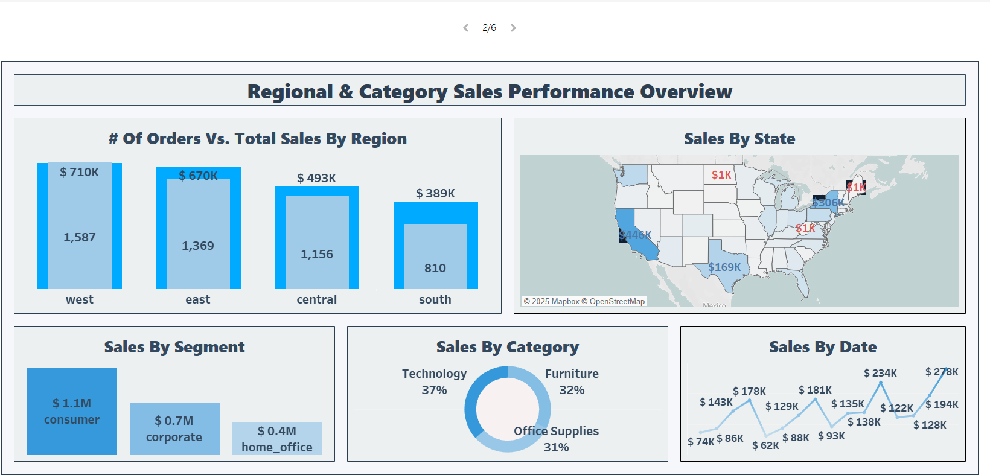

* **Through Dashboard we get insights of:**

**1- what is the sales for each category/Subcategory of products?**

**(To get The Highest One for Sales)**

**2- What is the achieved sales/ Segment?**

**3- What is the achieved sales/ State?**

**4-Tracking Sales by date.**

**5- Comparison between # orders vs Total Sales/ Region.**

1. **PRODUCTS DASHBOARD**

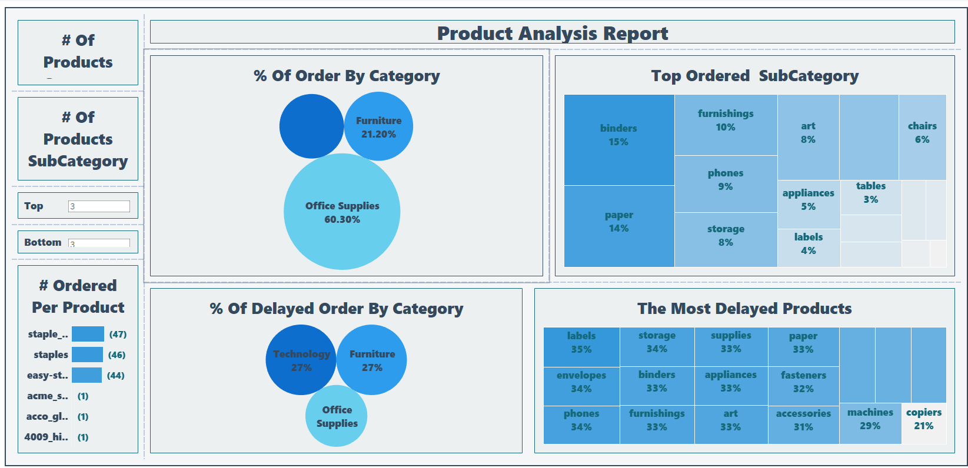

* **Through Dashboard we get insights of:**

**1- identify # orders/ category& subcategory of Products.**

**2- Mention The Top (10) Products / # orders.**

**3- Define % delayed orders/ category.**

**4-Mention The Most delayed order/Products.**

**5- identify Top Ordered/ subcategory**

1. **CUSTOMER DASHBOARD**

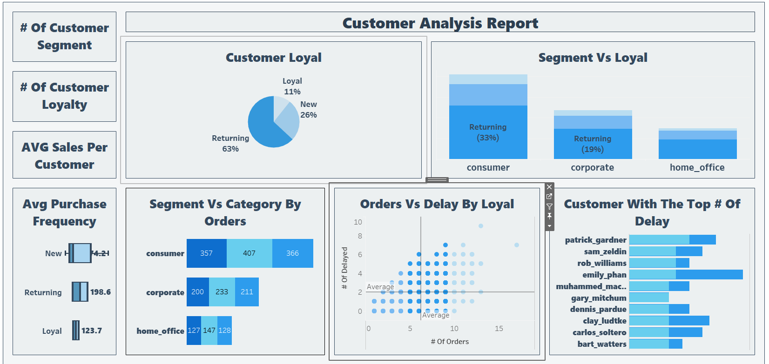

* **Through Dashboard we get insights of:**

**1-Create a Classification showing %The Loyalty of Customer through Ranks:**

**(Loyal customer-New customer-Returning customer)**

**2- What is the AVG sales/ Customers’ Rank?**

**3- Define %Customer loyalty’s Rank in each Segment**

**4-Mention # on time orders vs # delayed orders through loyalty’s Rank**

**5- Provide a Comparison between # orders vs Total Sales/ Region.**

1. **SHIPPING&GEO DASHBOARD**

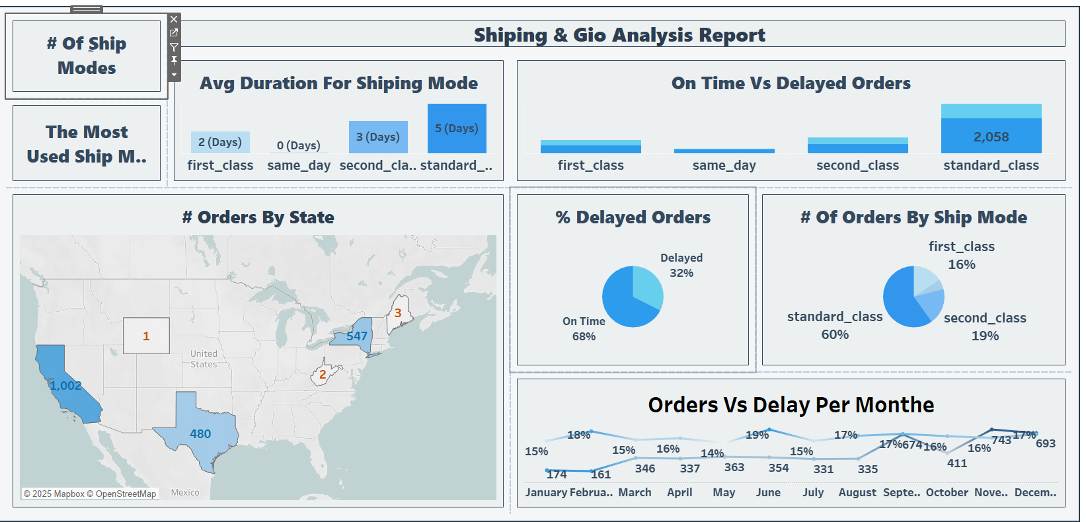

* **Through Dashboard we get insights of:**

**1-Create a Classification of The Duration of Receiving Orders by:**

**( on time orders- Delayed orders) .**

**2- Mention The Duration of Receiving Orders/ Ship mode .**

**3- Define #orders/ ship mode.**

**4- identify #orders/ states.**

**5-Provide a Comparison between # on time orders vs Delayed orders/ship mode.**

**6- Track #orders & % Delayed orders in each Month.**

**Forecasting**

**Chapter 3: Data Prediction**

**Data Prediction (What will happen)**

**Predictive data** uses historical data and algorithms to forecast future events or trends. It helps identify patterns to make informed decisions, such as predicting customer behavior, sales, or risks. helps you to draw conclusion & Form projections.

Forecasting

1.Prepare the Data for Forecasting

|  |  |
| --- | --- |
| *# Ensure 'order_date' is in datetime format*  df['order_date'] = pd.to_datetime(df['order_date'])  *# Aggregate sales by month*  monthly_sales = df.groupby(df['order_date'].dt.to_period('M')) ['sales'].sum().reset_index()  monthly_sales['order_date'] =  monthly_sales['order_date'].dt.to_timestamp()  *# Display the aggregated data*  print(monthly_sales.head())   |  | | --- | | order_date sales 0 2015-01-01 14205.707 1 2015-02-01 4519.892 2 2015-03-01 55205.797 3 2015-04-01 27906.855 4 2015-05-01 23644.303 | |

2. Visualize the Time Series

|  |
| --- |
| *# Plot monthly sales*  plt.figure(figsize=(12, 6))  plt.plot(monthly_sales['order_date'], monthly_sales['sales'], marker='o')  plt.title("Monthly Sales Over Time")  plt.xlabel("Date")  plt.ylabel("Sales")  plt.grid(True)  plt.show() |

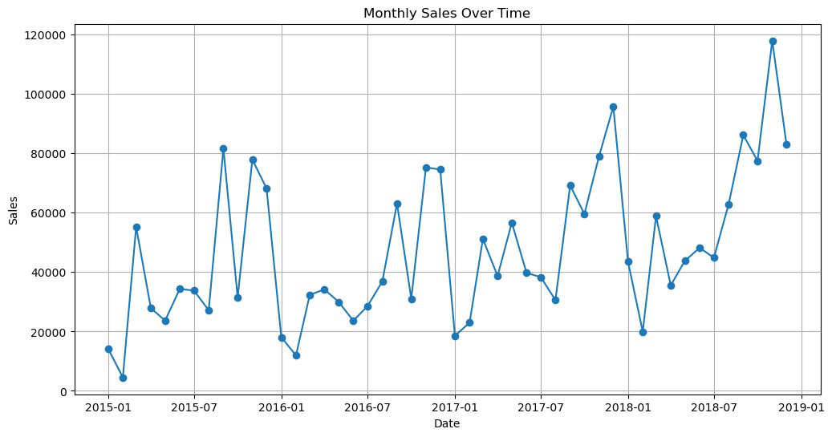

3. Decompose the Time Series

|  |
| --- |
| from statsmodels.tsa.seasonal import seasonal_decompose  *# Decompose the time series*  result = seasonal_decompose(monthly_sales.set_index('order_date') ['sales'], model='additive', period=12)  *# Plot the decomposed components*  result.plot()  plt.show() |

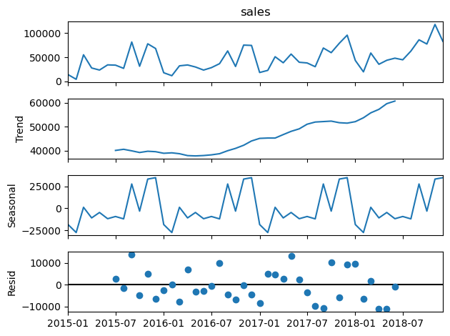

4. Choose a Forecasting Model

1: ARIMA

|  |
| --- |
| from statsmodels.tsa.arima.model import ARIMA import numpy as np  *# Fit ARIMA model*  model = ARIMA(monthly_sales['sales'], order=(5, 1, 0)) *# (p, d, q) parameters*  model_fit = model.fit()  *# Forecast next 12 months*  forecast = model_fit.forecast(steps=12) print(forecast)  48 77882.535842  49 82080.050366  50 78363.673696  51 77562.297662  52 90178.601100  53 84479.482539 |

|  |
| --- |
| 54 83175.392773  55 85201.846388  56 82194.773321  57 81241.336983  58 84496.723791  59 83333.201659  Name: predicted_mean, dtype: float64 |

|  |  |
| --- | --- |
| from prophet import Prophet  *# Prepare data for Prophet*  prophet_data = monthly_sales.rename(columns={'order_date': 'ds', 'sales': 'y'})  *# Initialize and fit the Prophet model* model = Prophet()  model.fit(prophet_data)  *# Create a dataframe for future dates*  future = model.make_future_dataframe(periods=12, freq='ME') *# Use 'ME' instead of 'M'*  *# Make predictions*  forecast = model.predict(future)  print(forecast[['ds', 'yhat', 'yhat_lower', 'yhat_upper']].tail(12))  *# Plot the forecast*  model.plot(forecast)  plt.show()  07:58:24 - cmdstanpy - INFO - Chain [1] start processing 07:58:25 - cmdstanpy - INFO - Chain [1] done processing   |  | | --- | | ds yhat yhat_lower yhat_upper 48 2018-12-31 40916.277906 32079.723155 50033.914281 49 2019-01-31 27223.271177 18306.841836 37270.438986 50 2019-02-28 109599.772422 100221.641002 119031.926127 51 2019-03-31 37759.849273 28000.883626 47374.827107 52 2019-04-30 35918.504583 27079.151967 45935.890115 53 2019-05-31 69053.588624 59629.554166 79021.447420 54 2019-06-30 54169.807315 43813.193148 63948.371269 55 2019-07-31 46565.572090 37846.939554 56136.125441 56 2019-08-31 118629.732794 109226.249615 128112.005297 57 2019-09-30 65062.450646 56047.978340 75024.356860 58 2019-10-31 120758.788312 111499.504837 130341.695175 59 2019-11-30 76224.267374 66927.449033 85521.442275 | |

2: Prophet

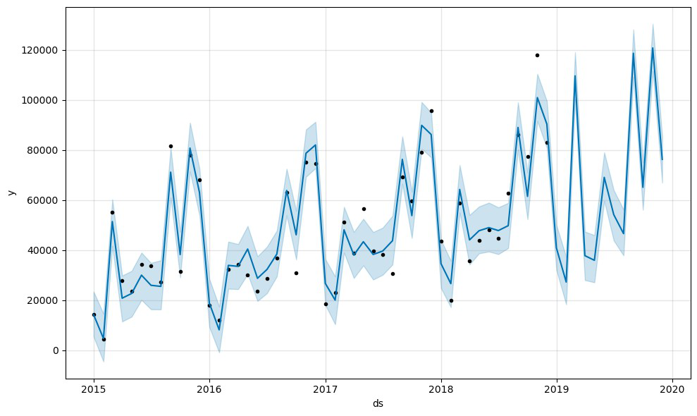

5.Evaluate the Model

|  |
| --- |
| from sklearn.metrics import mean_absolute_error  *# Split data into train and test sets*  train_size = int(len(monthly_sales) * 0.8)  train, test = monthly_sales[:train_size], monthly_sales[train_size:]  *# Fit ARIMA on training data*  model = ARIMA(train['sales'], order=(5, 1, 0)) model_fit = model.fit()  *# Forecast on test data*  predictions = model_fit.forecast(steps=len(test))  *# Calculate MAE*  mae = mean_absolute_error(test['sales'], predictions) print(f"Mean Absolute Error: {mae}")  Mean Absolute Error: 24071.07181000625 |

Data Transformation & Feature Engineering

1. Extract Date Features

*# Extract year, month, and day from order_date* df['order_year'] = df['order_date'].dt.year df['order_month'] = df['order_date'].dt.month df['order_day'] = df['order_date'].dt.day

*# Calculate shipping time (in days)*   
df['shipping_time_days'] = (df['ship_date'] - df['order_date']).dt.days

*# Display the new features*   
print(df[['order_date', 'ship_date', 'shipping_time_days', 'order_year', 'order_month','order_day']].head())

order_date ship_date shipping_time_days order_year  
order_month \   
0 2017-11-08 2017-11-11 3 2017 11

1 2017-11-08 2017-11-11 3 2017 11

2 2017-06-12 2017-06-16 4 2017 6

3 2016-10-11 2016-10-18 7 2016 10

4 2016-10-11 2016-10-18 7 2016 10

order_day  
0 8  
1 8  
2 12  
3 11  
4 11

2. Create Calculated Columns

*# Example: Calculate total sales per customer*   
customer_sales = df.groupby('customer_id')   
['sales'].sum().reset_index()   
customer_sales.rename(columns={'sales': 'total_customer_sales'}, inplace=True)

*# Merge back into the main DataFrame*   
df = df.merge(customer_sales, on='customer_id', how='left')

*# Display the new feature*   
print(df[['customer_id', 'total_customer_sales']].head())

|  |
| --- |
| customer_id total_customer_sales 0 cg-12520 1148.7800 1 cg-12520 1148.7800 2 dv-13045 1119.4830 3 so-20335 2602.5755 4 so-20335 2602.5755 |

**FORECASTING DASHBOARD**

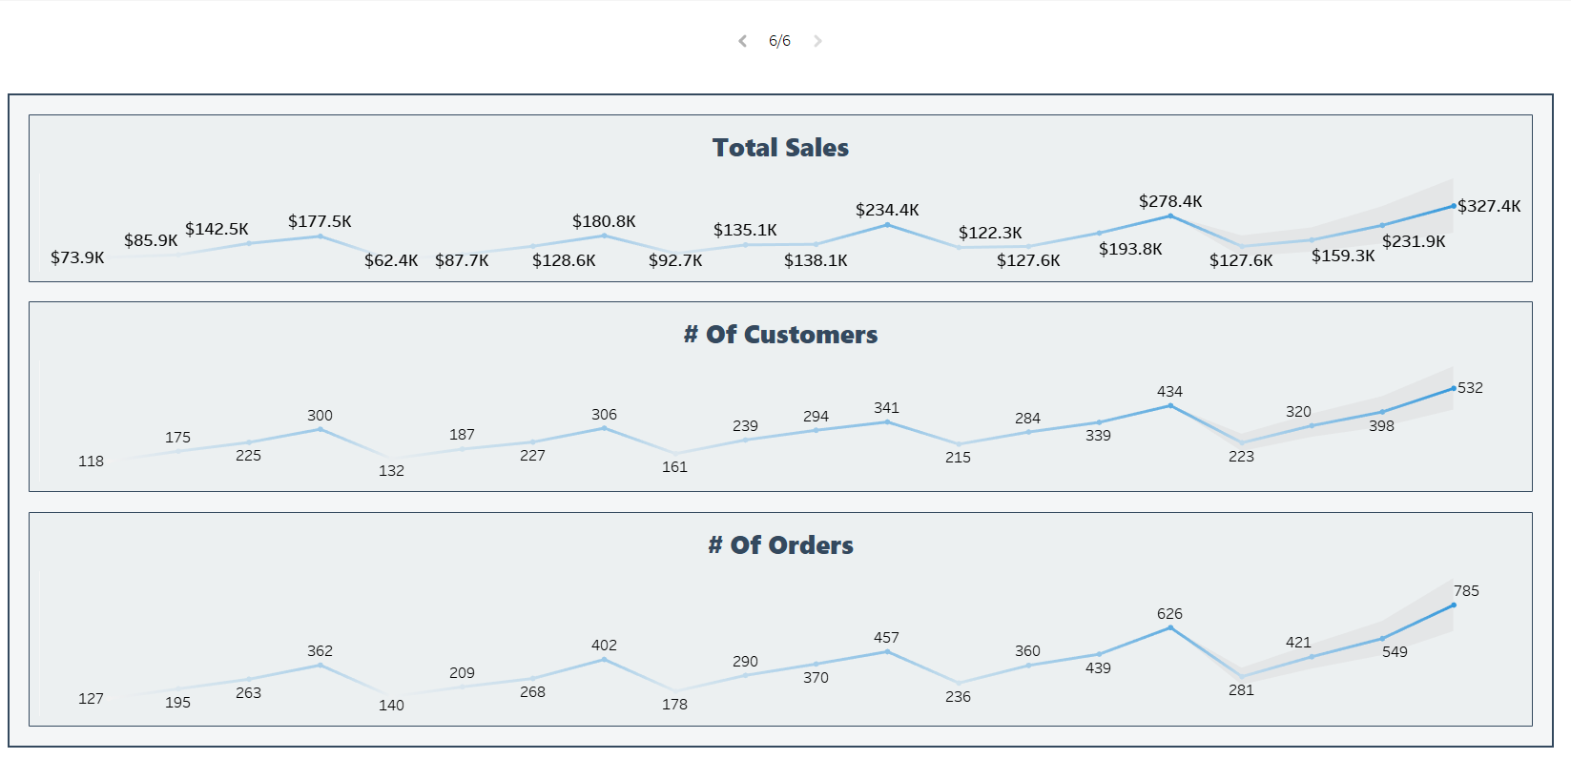

**Recommendation**

**Chapter 4: Data prescription**

**Data prescription (What should do)**

**Prescriptive data** analysis goes beyond predicting future outcomes by recommending actions to optimize results. It uses advanced algorithms, simulations, and optimization techniques to suggest the best course of action for a given situation, helping businesses make informed decisions to achieve desired outcomes.

**🔍 Insights:**

**📌 Summary Overview**

* Total sales and total number of customers and products are increasing.
* Sales are growing steadily, especially in Q4 each year.

**📍 Region & Category**

* The **West region** has the highest number of sales and orders.
* However, the **South** has a better **Sales-to-Order ratio**, suggesting more efficient sales performance.
* **California** leads all states in total sales.
* **Consumer segment** is the top-performing customer segment.
* **Technology** is the top-performing product category.

**🧭 Shipping & Geo**

* **Standard Class** is the most commonly used shipping method, but it also has the longest average delivery time (5 days).
* **Second Class** has the highest order delay rate.
* **California** places the most orders.
* **32% of orders are delayed**, with **June** being the month with the highest delay rate.

**👥 Customer Analysis**

* There are 3 customer types and 3 loyalty levels.
* The **average sales per customer is 2,852 $**.
* **Returning customers** contribute the most to sales.
* **Consumer segment** includes most loyal customers.
* **Loyal customers** have the shortest time between purchases.
* Higher number of orders correlates with higher delay rate.
* **Office Supplies** is the most ordered category.

**📦 Product Performance**

* 3 main product categories and 17 subcategories.
* **Binders** is the most ordered subcategory.
* **Staple Envelope** is the top-selling product.
* **Technology** category has the highest delay rate.
* **Labels** subcategory has the highest delay rate among subcategories.

**📈 Forecasting**

* Sales, customer count, and orders are expected to grow overtime.

**✅ Recommendations:**

**1-Improve shipping efficiency by analyzing root causes of delay in Standard and Second Class shipping methods.**

**2-Reducing the duration of Shipping Time to correspond Customer Satisfaction not Exceeded 5 Days at most.**

**3-Optimize operations & Improve Customer services in California to manage high order volume and delay rate.**

**4-Encourage loyalty programs specifically in “ Same_ day “ Ship mode to increase purchase frequency, especially among new customers.**

**5-Provide Facilities to “new customers “ in customer loyalty classification to let quickly join in Loyal Customer .**

**6-Increase inventory of top-performing products (like Staple Envelope and Binders) to meet demand.**

**7-Concern The Quality of Top Category ” Technology “as it contains The best Selling Products.**

**8-Handle The Reason for The most delayed products of “labels “with 35%& “storage “ with 34% in “Office Supplies“.**

1. **Target South region with promotions expand stores and supervising the Quality Control , as it has efficient sales per order but could use more volume.**

**10- Monitor June closely & specially in Q4 to prepare in advance to reduce seasonal delivery issues.**

**11-Develop customer segmentation campaigns to increase based on loyalty level and behavior.**

**12-Review performance of Technology and Labels categories to identify delay bottlenecks.**